 

180 Technology Parkway, Peachtree Corners, Ga. 30092 – Tel- 678.636.8400 – Fax- 678.321.5478 – [www.ashrae.org](http://www.ashrae.org/)

YYY-MM-DD

LOCAL EMBASSY ADDRESS

SUBJECT: LETTER OF INFORMATION for Ventilation 2022: 13th International Industrial Ventilation Conference for Contaminant Control

Toronto, ON, Canada June 22-24, 2022 Sheraton Centre Toronto Hotel

123 Queen St W,

Toronto, ON M5H 2M9, Canada

This will serve as a letter of information that, ATTENDEE NAME, Passport Number NUMBER has expressed interest in attending the ASHRAE (formerly the American Society of Heating, Refrigerating and Air-Conditioning Engineers) Ventilation 2022: 13th International Industrial Ventilation Conference for Contaminant Control. This meeting will take place in Toronto, ON, Canada, over the dates of June 22-24, 2022. The conference is primarily devoted to the dissemination of technical information through various educational programs.

The Immigration, Refugees and Citizenship Canada Special Event Code for this event is: 22VCCC

This correspondence confirms ATTENDEE’s request for a letter of invitation. We invite pronoun attendance, but this confirmation should not be construed as an endorsement or sponsorship of pronoun travel to Toronto, ON, Canada. All meeting-related fees will be paid by Attendee Name.

For those who may read this letter but are unacquainted with the activities of the Society, ASHRAE is an international organization dedicated to advancing the arts and sciences of heating, ventilation, air conditioning and refrigeration for the benefit of the public. ASHRAE consists of 55,000 members from 120 nations and is affiliated with 30 sister organizations in 26 countries.

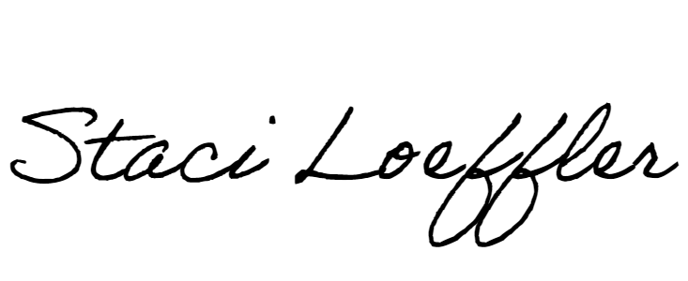If you require further information, please let us know.

Staci Loeffler, Coordinator Topical Conferences