For Young Engineers in ASHRAE – How can YOU get involved in ASHRAE’s technical committees?

This document was developed to help engage younger engineers in ASHRAE’s technical activities. Additional resources and tools are available to help through society groups such as Young Engineers in ASHRAE, local chapters, and the Student Activities Committee.

How to Find a Technical Committee
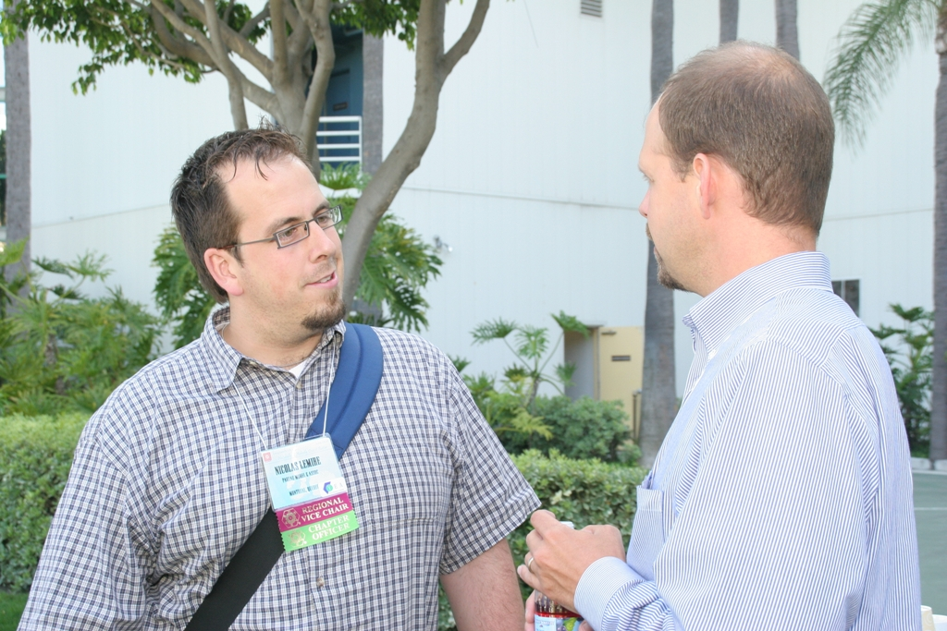
- Cruise the ASHRAE website, society meeting programs, ASHRAE staff, and members on other committees
- Make known particular interests and skills to ASHRAE leaders, including YEA, Student Activities, Regional, Committee, staff, etc
- Search out committees focused on areas of interest
- Review websites for minutes, agenda, schedules, deliverables, etc.

Meeting Activities:
- If possible, attend society meeting schedule for targeted committee that interests you.
- Show up early, stay late, talk to members about:
        - Recent / expected projects by committee
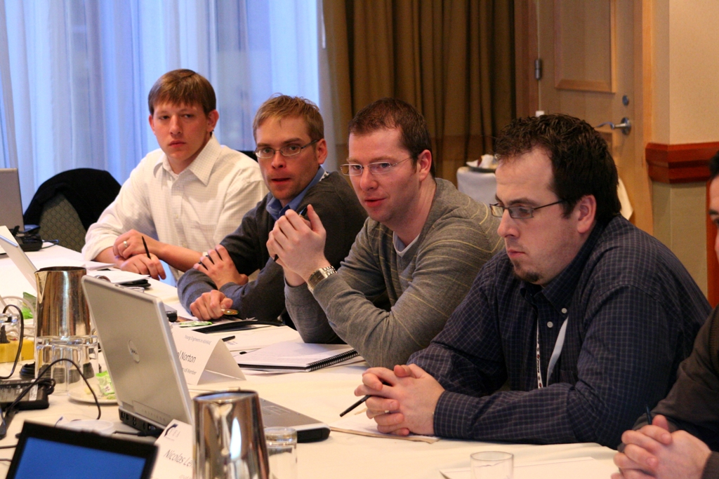
        - Committee organization and membership
        - Typical on-site and remote access meeting schedules
        - How best to contribute to current activities
        - Potential holes in skill sets / interests of current membership that new participant might be able to fill
        - Ask for a mentor
- Volunteer – you don’t have to be a voting member to participate. Offer to help with committee activities to help you learn what the TC does. It will also get your name before the committee as someone who is interested in advancing the objectives of the group.

- Capitalize on your strengths – Web navigation is often more challenging for older members. Offer to help update, improve sites, develop navigation tools, develop on-line mechanisms to support committee activities.

Outside Meetings:
- Actively correspond with committee leadership and / or assigned mentor
- Offer to support web updates
- Offer to provide updates to ASHRAE groups outside of TC (consider YEA, SA, regional membership, CTTC, etc)
- Offer to participate in any web-based meetings or events.
- Get on the corresponding member list as soon as you can. This list is submitted at the winter meeting, and usually just involves giving the TC secretary your name and contact info. They can have an unlimited number of corresponding members, and you will get e-mail announcements, minutes, etc. to know what is going on.

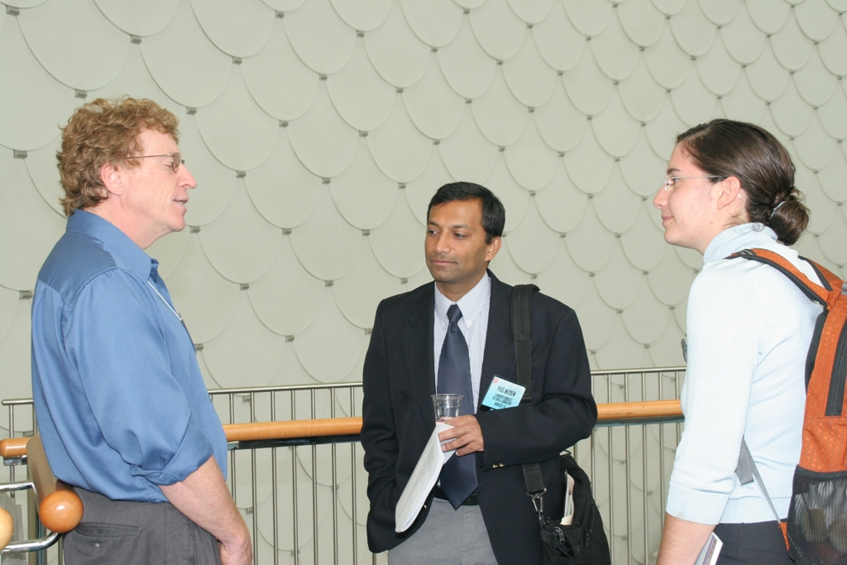

Intended results are to generate motivated young participants in support of ASHRAE’s technical activities and goals.

