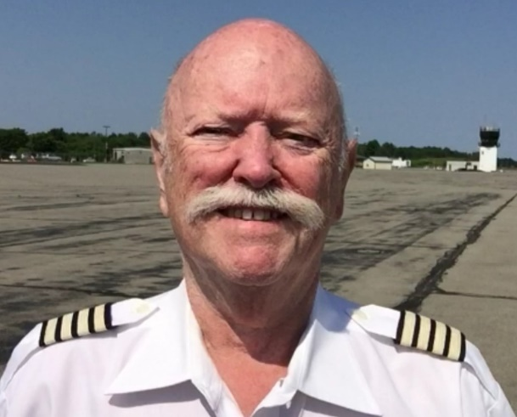

Mike Newman 1942 – 2020

**A Memorial Tribute to H. Michael Newman, a.k.a. “The Father of BACnet”**

Steven T. Bushby

H. Michael (Mike) Newman was born in 1942 in New York City. He grew up with his parents and three sisters in Norwalk, CT. After high school Mike attended Cornell University, graduating “with distinction” in 1965 with a bachelor’s degree in Engineering Physics. A year later he was awarded a master’s degree in the same field and began his post graduate work in astrophysics at the NASA Center for Radiophysics and Space Research in Ithaca, NY.

Mike was a man of many talents and interests. One of his lifelong interests was aviation. After leaving NASA, Mike changed directions and began a ten-year career in aviation. He became a pilot and flight instructor earning advance ratings including an airline transport pilot certificate, the highest level of pilot certification. Mike started an air charter business. Years later he loved to reminisce with me (also a pilot) about some of the interesting clients he came to know including: astrophysicist Carl Sagan, media executive and philanthropist Roy H. Park, Nobel Laureate David Lee, and celebrity chef Graham Kerr, the “Galloping Gourmet.” Among the many thousands of miles that Mike and I travelled together, part of it was by private aircraft. Sometimes we were both together in whatever twin-engine aircraft Mike had at the time. On other occasions we would each fly separately and meet up at our destination airport. We would usually joke to the locals who would pick us up that the “BACnet Air Force” had arrived.

One consequence of the Arab oil embargos of the 1970s was a steep decline in the use of charter aircraft for travel. It was considered unpatriotic to travel by means that were not fuel-efficient. Although Mike never gave up his love for aviation, he changed career paths again and returned to his beloved Cornell University to take charge of the installation and development of the University’s new computerized energy management and control system. This was an advanced system for its time that linked an IBM System/7 diskless minicomputer to existing manual control centers in order to remotely start and stop equipment.

The 1980s brought a revolution to the building controls industry in the form of micro-processor based direct digital controls. Cornell University was quick to embrace this new technology and, as Mike would say, “The trouble soon began.” Each company making products using this technology developed their own proprietary communication protocol to integrate the separate parts of the distributed system. This created a problem because it was not possible to link products made by different manufacturers. At Cornell (and elsewhere) this was an unacceptable situation. Cornell refused to buy building automation products unless the manufacturer provided them with the proprietary protocol so that they could write their own translators to enable the desired integration. This worked, after a fashion, but after doing this a few times Mike concluded that this was a crazy situation! His personal conviction that this was not the way the world should be drove him to take up the challenge of changing the industry.

*A leader takes people where they want to go. A great leader takes people where they don’t necessarily want to go, but ought to be*. — Rosalynn Carter

On the advice of a colleague, Mike joined ASHRAE because ASHRAE was the place where an industry standard protocol could be developed to solve this problem. Mike joined Technical Committee 1.4 Control Theory and Application, started learning the workings of ASHRAE, and began agitating for ASHRAE to take up the cause of developing a standard protocol for the building automation industry. The overwhelming conventional wisdom of the time was that this was a fool’s errand. Mike was tilting at windmills! He persevered and, in January 1987, ASHRAE committed to forming a standard project committee to develop such an industry standard and appointed Mike as its chair. This is when I first met Mike and our personal relationship began.

*“Never give in. Never give in. Never, never, never, never–in nothing great or small, large or petty–never give in, except to convictions of honour and good sense. Never yield to force. Never yield to the apparently overwhelming might of the enemy.”* — Winston Churchill

The process of creating a standard began amongst a mixture of bright lights, intense industry media coverage, a committee of people with diverse agendas who largely did not know each other, and onlookers and critics galore who wanted to “watch the show.” Before the very first meeting ever took place, Mike and a very small group of us who shared his vision banded together to make a plan of action to ensure a productive start. Anyone who participated in the first meeting of ASHRAE Standard Project Committee 135P in Nashville, Tennessee in June of 1987 will never forget it. With a calm steady hand, a firm resolve, and a welcoming demeanor, Mike assumed his leadership role and started the group down a path that caused a worldwide change to the building control industry.

It took a long time. It was hard. Important industry players actively obstructed progress. Public reviews resulted in comments from many countries and in numbers that were unprecedented at the time. After 8½ years and three public reviews, what we know of today as BACnet was born. Mike recounts some of the details in his book, BACnet, The Global Standard for Building Automation and Control Networks, published in 2013.

After publication of the standard, the technical work of adding new features and capabilities continued, and still continues to this day. A new phase also began – the “BACnet missionary years.” This involved travel to many parts of the world to educate the industry about the new standard and engagement with the International Organization for Standardization (ISO). As a result, BACnet is today a truly global standard and is the dominant technology used by building automation and control products in buildings around the world. More than a thousand companies make and sell BACnet products and, astonishingly, the number continues to grow.

Mike earned a long list of distinguished accolades: ASHRAE Fellow, ASHRAE Standards Achievement, BACnet Hall of Fame, Broome Chapter of the New York Society of Professional Engineers Engineer of the Year, and many others. As dramatically important as Mike’s leadership and technical accomplishments are, it is impossible to do him justice without some comments about who he was as a person.

Mike was a brilliant and curious man with many interests that have not been captured here. He was optimistic and cheerful, always eager to make a new friend. He was a polyglot, speaking several languages fluently and around a dozen with enough skill to chat with a cab driver, hotel clerk, or waitperson in their native tongue. For every country that we traveled to together, if he didn’t already know the language he would study ahead of time and learn enough to be able to use it on the trip. Mike was calm and diplomatic. He was a great mentor and always ready to encourage someone to join him in a common cause or to pursue one of their own. He was quick to recognize the accomplishments of others and to offer a word of praise and encouragement.

Mike could find humor or joy in amazing places. He was also humble and self-deprecating. For example, he wrote an inscription to me in my copy of his book, Direct Digital Control of Building Systems. In part it says, “…so I hope you find it useful – better yet that you find the humor in it. It is, after all, “DDC-BS!”

The opportunity to spend decades working closely with Mike, traveling the world together, and most importantly, earning the right to call him my dear friend has been one of the greatest honors of my life. I feel quite confident that many others in the BACnet community and in other parts of Mike’s life share that feeling. The world is a smaller place without him. His legacy will endure, but he will be sorely missed, especially by those of us who worked closely with him in the BACnet community.

Steven Bushby David Robin Carl Neilson Bernhard Isler Mike Osborne

BACnet Chair BACnet Chair BACnet Chair BACnet Chair BACnet Chair

2000 – 2004 2008 – 2012 2012 – 2015 2015 – 2018 2018 – present

