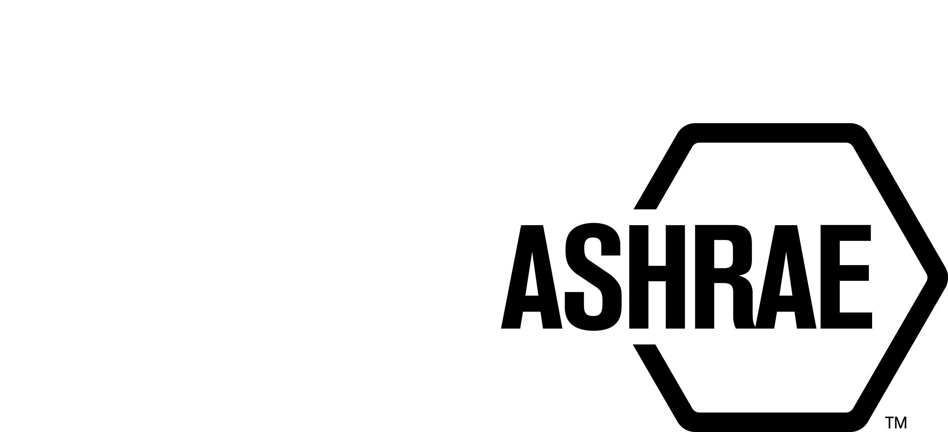

PLANNING, POLICY, AND INTERPRETATIONS SUBCOMMITTEE (PPIS)

MINUTES

JW Marriott – Indianapolis, IN
June 21, 2024

NOTE: These draft minutes have not been approved and are the unofficial record by PPIS.

TABLE OF CONTENTS
1. Call to Order/Introductions and Review of Agenda 3
2. Chairman’s Report 3
3. Staff Report 3
4. Approval of Minutes 3
5. Review of Action Items/Unfinished Business 3
6. Planning – New Projects 3
7. Policy – Procedural Changes 5
8. Interpretations 6
9. New Business 6
10. Adjournment 7

Action Items Assigned Winter 2023 and Spring 2024
AI#1 | Action | Assigned To | Status
1 | PPIS to investigate why we changed our voting requirement from two thirds to majority.  Answer: These proposed changes were submitted by Staff and approved by PPIS and StdC in an effort to streamline our procedures (June 2022).  PPIS to investigate why we changed our voting requirement from two thirds to majority.  3/18 PPIS Discussion – pros and cons were discussed and it was decided that we need more data, we should monitor the success or failure of the voting rule and report back. | PPIS | CLOSED
1a  (spring) | In an effort to get data, Bill Walter to work with Justin Prosser (SPLS Chair) to create a short survey to retrieve feedback about the new voting rule. | Bill W./Justin P. | ONGOING
2 | It has been requested that ASHRAE develop procedures for a non-ANSI path (ASHRAE ONLY) and also develop a checklist for consideration. PPIS plans to propose drafts to Standards Committee at the Spring 2024 meeting.  See Item 7A | PPIS | CLOSED

1. Call to Order/Introductions and Review of Agenda

Call to Order/Chairman’s Report

The Planning, Policy, and Interpretations Subcommittee (PPIS) meeting was called to order on June 21, 2024, at 2:00 p.m. at JW Marriott, Indianapolis.

Introductions

Chairman Bill Walter greeted members.

PPIS Members  Bill Walter, Chair  Drake Erbe  Kelley Cramm  Julie Majurin  Karl Peterman | PPIS Members Absent  Christopher Seeton  Guests  Doug Fick | Staff  Tanisha Meyers-Lisle, A-MOS  Stephanie Reiniche, DOT  Ryan Shanley, S-MOS

2. Chairman’s Report
Chairman greeted guests and read the ASHRAE Value Statement, the ASHRAE Code of Ethics, Anti-Trust Guidelines, and the prohibition of recording meetings.

3. Staff Report
Staff provided updates to the 62.2j (hearing scheduled with ANSI on September 17, 2024) and 189.1ak (Appeals Panel decided to uphold and deny in part) appeals. Staff also advised PPIS that PASA was reaccredited by ANSI on May 24, 2024.

4. Approval of Minutes
PPIS Spring Minutes were approved via the OCD – closed May 31, 2024.
Vote was 6-0-0, CV.

5. Review of Action Items/Unfinished Business
5A. Action Items
A list of action items was presented to members for review. An update of the action items is presented on page 2. PPIS members will continue to review their assigned action item(s).

6. Planning – New Projects
It was moved by Kelley Cramm and seconded by Drake Erbe,

1 That the following Title, Purpose and Scope (TPS) be approved and a new Standard Project Committee be formed:

Title: Sustainability Assessment for Mechanical, Electrical, and Plumbing Products

- Purpose: This standard specifies the process for developing a lifecycle assessment-based product claim for Mechanical, Electrical, and Plumbing assemblies.

2. Scope:
2.1 This standard applies to product assemblies in which multiple raw materials are combined or processed into a single unit.
2.2 This standard is intended for use by manufacturers and by ANSI-accredited program operators and independent verifiers participating in the preparation of a lifecycle assessment-based product claim.
2.3 The process includes:
(a) creating or adopting the necessary product category rules (PCRs)
(b) performing a life-cycle assessment (LCA) in accordance with the PCRs
(c) reporting the LCA results in the product claim document
(d) registering the product claim document for public access
(e) updating PCRs and re-assessing products as needed
2.4 This document is intended to supplement ISO 14025 and related standards where an existing product claim is 1) unavailable for individual components or 2) incompatible with the documentation requirements of the final assembly.

Background: This TPS will also have to be approved by Technology Council. This TPS was submitted by Bill McQuade for consideration at the Annual meeting. PPIS assigned the TC 7.6, Building Energy Performance as the cognizant committee. Ivan Rydkin was recommended as the Chair of the proposed new project committee. There are at least five members willing to volunteer. Staff is discussing the possibility of both CSA and AHRI co-sponsoring the standard.
Secretary’s note: Staff to reach out to IEEE and ASPE to make them aware of the new proposed standard and encourage them to apply for membership.

MOTION 1 PASSED: 4-0-0, CNV

It was moved by Kelley Cramm and seconded by Drake Erbe,

2 That the following Title, Purpose and Scope (TPS) be approved and a new Standard Project Committee be formed:

Title: Acceptable Performance Standard for District Cooling Systems

Purpose:
- To establish the minimum acceptable performance requirements of district cooling system, for siting, design, construction, and operation and maintenance of components including, plant systems, distribution systems and energy transfer stations.

- To minimize emissions from district cooling plants and plant systems, conserve water resources, materials, and resources, and construction and plans for operation.

Scope:
This standard provides:

  - minimum energy-efficient requirements for the design and construction, and a plan for operation and maintenance of
  - new district cooling plants, equipment and their component systems,
  - new portions of district cooling plants and their component systems,
  - new equipment or component systems specifically identified in this standard that are part of a site, and
  - new components, systems and equipment for existing district cooling plants.
  - criteria for determining compliance with these requirements.
  - establish minimum criteria for the design of critical components.
  - The provisions of this standard do not apply to:
        - low rise residential, single-family houses
- district cooling plants that do not serve more than one building or are not defined as district cooling.
- Industrial focused process cooling plants that are do not supply space cooling for human comfort applications.
  - Where specifically noted in this standard, certain other plants or elements of plants or sites shall be exempt.
  - This standard shall not be used to circumvent any safety, health, or environmental
requirements of the final assembly.

Background: This TPS will also have to be approved by Technology Council. This TPS was submitted by Stephanie Reiniche for consideration at the Annual meeting. PPIS assigned TC 6.02, District Energy as the cognizant committee. Steve Tredinnick was recommended as the Chair of the proposed new project committee. There are at least five members willing to volunteer. Empower has agreed to fund the efforts to expedite the standard. This would include paying for transportation for members (as determined by Staff), providing meeting room support, funding meals if in person meetings, and offsetting staff overhead

MOTION 2 PASSED: 4-0-0, CNV

7. Policy – Procedural Changes
It was moved by Kelley Cramm and seconded by Drake Erbe,

3 That the Project Committee Guide to PASA be approved as shown below:

APPROVAL OF ASHRAE-ONLY STANDARDS

Obtaining an ANSI (American National Standards Institute) designation for your standard offers a multitude of advantages. Foremost, it grants immediate recognition and credibility, as ANSI is globally esteemed for its rigorous standards development and accreditation processes. This recognition not only enhances trust among stakeholders but also facilitates market access, as ANSI standards are often adopted by regulatory bodies and industry associations. By adhering to ANSI guidelines, organizations mitigate risks associated with product performance and safety, while also gaining a competitive edge in the marketplace. Overall, an ANSI designation signifies a commitment to quality, reliability, and adherence to industry best practices, positioning standards-holders as leaders in their respective fields. This is the preferred path.

If you opt to not pursue the ANSI/ASHRAE path, you have the option of following an ASHRAE only path. The Standards Committee is responsible for the establishment of project committees. that are approved as ASHRAE. To gain approval as an ASHRAE standard, the request must fulfill specific criteria. The submitter must complete the Form for Proposing a Standard or Guideline. A project need and work plan shall be submitted. Justification for working outside of the ANSI/ASHRAE path must be clearly stated. There shall be financial resources available to support the development of the standard. The project committee shall be balanced. A call for members shall be issued upon the approval of the project committee. The project committee shall adhere to the rules stipulated in PASA Sections 7.4.1 – 7.4.3. The public review comment period for ASHRAE standards shall be up to 45 days. All comments to the public review drafts shall be submitted electronically via the online comment database. An exception to this rule may be granted by the MOS if the commenter can demonstrate that he/she does not have ready access to the internet. The PC Chair or his/her designee shall submit responses to commenters electronically via the OSR, or in special cases, in the medium specified by MOS. Public Review Comments received during open public review shall be reported to all members of the PC. Prompt consideration shall be given to all public review comments.

An effort to resolve all negative public review comments should be made, but each negative commenter shall be advised in writing (including electronic communication) of the disposition of the objections and reasons therefor. Any substantive changes in the draft must be approved and voted on by the PC for publication public review. (See substantive change in PASA Annex A). The PC may consider any public review comments received after the close of the public review period or shall consider them as a new proposal.

ASHRAE standards shall be exempt from the appeals process.

Background: An action item was assigned to PPIS to develop procedures for ASHRAE-Only Standards. Staff presented a draft at the PPIS Spring meeting and it was determined that we should also include benefits of going the ANSI/ASHRAE path. It is recommended that these procedures be placed in the PC Guide to PASA. Note: Highlighted notes will be hyperlinked to specific form. This new section will be added to page 6, after How are Requests for New TPSs evaluated. The New-Std-Gdl form (see Att A) will also be revised to align with the new procedures.

MOTION 3 PASSED: 4-0-0, CNV
(Secretary’s note: the editorial deletion was recommended at Standards Committee. This new section will be added to page 6, after How are Requests for New TPSs evaluated and twill update The New-Std-Gdl form.)

8. Interpretations
None.

9. New Business
It was moved by Drake Erbe and seconded by Kelley Cramm,

4 To approve the form to Propose a New Standard or Guideline.

Background: An action item was assigned to PPIS to develop procedures for ASHRAE-Only Standards. Staff presented a draft at the PPIS Spring meeting and it was determined that we should also include benefits of going the ANSI/ASHRAE path. The New-Std-Gdl form will be revised to align with the new procedures (Motion 3).

MOTION 4 PASSED: 4-0-0, CNV

It was moved by Drake Erbe and seconded by Kelley Cramm,

5 That ICC be approved as a cosponsor of Proposed ASHRAE Standard 242P, Standard Method for Calculation of Building Operational Greenhouse Gas Emissions, with ASHRAE as the lead.

Background: The SPC 240 leadership team, including ICC, was approached as we were developing the proposed TPS for Standard 242 to solicit potential members for the soon to be developed committee. Shortly after that conversation, ICC approached ASHRAE staff to request that they be added as a cosponsor to the standard. This would allow for consistent requirements across already cosponsored standards (189.1 and 242) plus 90.1 and the IECC. ICC understands that the initial standard will be an ASHRAE only standard and the intent is to submit it for ANSI consideration once published. ICC also understands that it is a condensed (proposed 18 month) timeline and agrees with that. They’ve approved the proposed roster on the good faith this request will move forward. This will follow our proposed ASHRAE process and ASHRAE will be the lead. This will also help defer some meeting costs as this will now also open DC as a potential meeting location for the committee. This has also been communicated with the proposed Chair and Vice Chair of the committee.

MOTION 5 PASSED: 4-0-0, CNV

10. Adjournment
PPIS adjourned at 1:45 pm. The scheduled June 25th meeting was cancelled.

