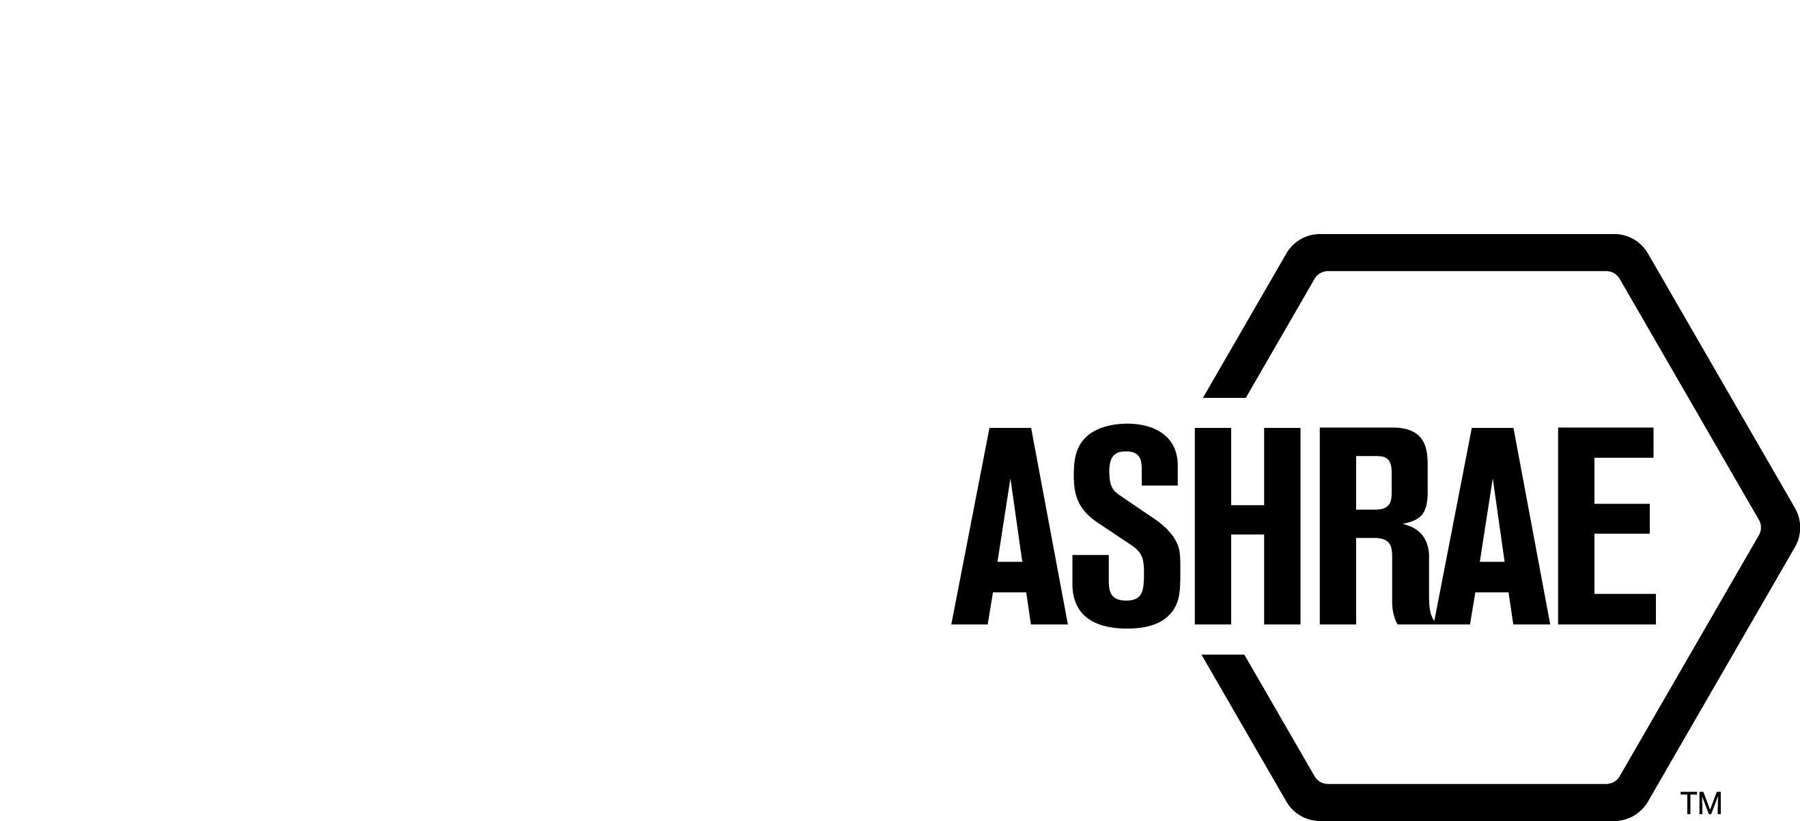

PLANNING, POLICY AND INTERPRETATIONS SUBCOMMITTEE (PPIS)

MINUTES

Fall Meeting
Conference Call
Meeting of September 20, 2024

NOTE: These draft minutes have not been approved and are the unofficial record by PPIS.

TABLE OF CONTENTS
1. Call to Order/Introductions and Review of Agenda 3
2. Chairman’s Report 3
3. Staff Report 3
4. Approval of Minutes 3
5. Review of Action Items/Unfinished Business 3
6. Planning – New Projects 3
7. Policy – Procedural Changes 4
8. Interpretations 4
9. New Business 4
10. Recess 5

ACTION ITEMS ASSIGNED SPRING MEETING 2024
AI# | Action | Assigned To | Status
1 | PPIS to investigate why we changed our voting requirement from two thirds to majority.  Answer: These proposed changes were submitted by Staff and approved by PPIS and StdC in an effort to streamline our procedures (June 2022).  PPIS to investigate why we changed our voting requirement from two thirds to majority.  3/18 PPIS Discussion – pros and cons were discussed and it was decided that we need more data, we should monitor the success or failure of the voting rule and report back. | PPIS | ONGOING
1a  (Spring) | In an effort to get data, Bill Walter to work with Justin Prosser (SPLS Chair) to create a short survey to retrieve feedback about the new voting rule. | Bill W/Justin P | COMPLETED

1. Call to Order/Introductions and Review of Agenda

Call to Order/Chairman’s Report

The Planning, Policy and Interpretations Subcommittee (PPIS) meeting was called to order on Friday, September 20, 2024, at 9:15 a.m. via teleconference.

Introductions

Chairman Bill Walter greeted members and guests.

PPIS Members  William (Bill) Walter, Chair  Kelley Cramm  Drake Erbe  Christopher Seeton | PPIS Members Absent  Julie Majurin  Karl Peterman  Guests  Richard Fox  Max Sherman | Staff  Tanisha Meyers-Lisle, AMOS-A  Ryan Shanley, Sr-MOS

2. Chairman’s Report
Chairman greeted guests and discussed the ASHRAE Code of Ethics, Anti-Trust Guidelines and the prohibition of recording meetings.

3. Staff Report
The ANSI Appeals Board reversed the ANSI ExSC decision to dismiss the complaint and has asked the ANSI ExSC to hold a hearing. The ANSI Appeals Board observed the current records and were insufficient in determining whether ASHRAE violated its procedures. The hearing was scheduled September 17, 2024.

ASHRAE is presently undergoing our 6 year ANSI audit cycle.

4. Approval of Minutes
Minutes were approved via OSR – 5-0-1, CV.

5. Review of Action Items/Unfinished Business
5A. Action Items
A list of action items was presented to members for review. An update of the action items is presented on page 2. PPIS members will continue to review their assigned action item(s).

6. Planning – New Projects
It was moved by Drake Erbe and seconded by Kelley Cramm that:

1 The following Title, Purpose and Scope be approved and a new Guideline Project Committee be formed:

TITLE: Operational Best Practices for Air Quality within Commercial Aircraft

- PURPOSE: This guideline serves as a companion to ASHRAE Standard 161 by describing operational best practice recommendations to assist air carriers to meet or exceed Standard 161 requirements.

2. SCOPE:

2.1 This guideline applies to commercial passenger air-carrier aircraft carrying 20 or more passengers and certified under Title 14 CFR Part 25.

2.2 This guideline considers cabin air contaminants, thermal conditions, and related factors such as humidity and pressure that may affect air quality.

DISCUSSION: PPIS members commended the submitter and the write up of the TPS form. This form should be listed as an example of how to complete the form.

BACKGROUND: This TPS will also have to be approved by Technology Council. This TPS was submitted by Judith Anderson for consideration at the Fall meeting. PPIS assigned the TC 9.3 as the cognizant technical committee and SSPC 161 will be the cognizant project committee. Ben Thiesse was recommended as the Chair of the proposed new project committee. There are at least five members willing to volunteer.

MOTION 1 PASSED: 4-0-0, CV
Secretary’s note: Julie Majurin and Karl Peterman were absent.

7. Policy – Procedural Changes
None.

8. Interpretations
A request for interpretation of the PC Guide to PASA was submitted by Max Sherman. Max questions the vote calculation for Non Standards Actions votes. PPIS determined further discussion is required and tabled this item until Orlando.

9. New Business
2 It is recommended that IBPSA be approved as a cosponsor of Proposed ASHRAE Standard 229P, Protocols for Evaluating Ruleset Application in Building Performance Models, with ASHRAE as the lead.

BACKGROUND: IBPSA cosponsors ASHRAE standards 209, 140 and 232P.

MOTION 2 PASSED: 4-0-0, CV

3 There was an action assigned to Bill Walter and Justin Prosser to create a short survey to retrieve feedback about the new majority voting rule. The survey was distributed to all PC Chairs and the response deadline is November 1, 2024.

4 Karl Peterman requested guidance on whether or not a document for terminology is necessary. Since Karl Peterman was not present at the meeting, PPIS decided to table the discussion until Orlando.

10. Recess
PPIS adjourned at 10:24 am.

