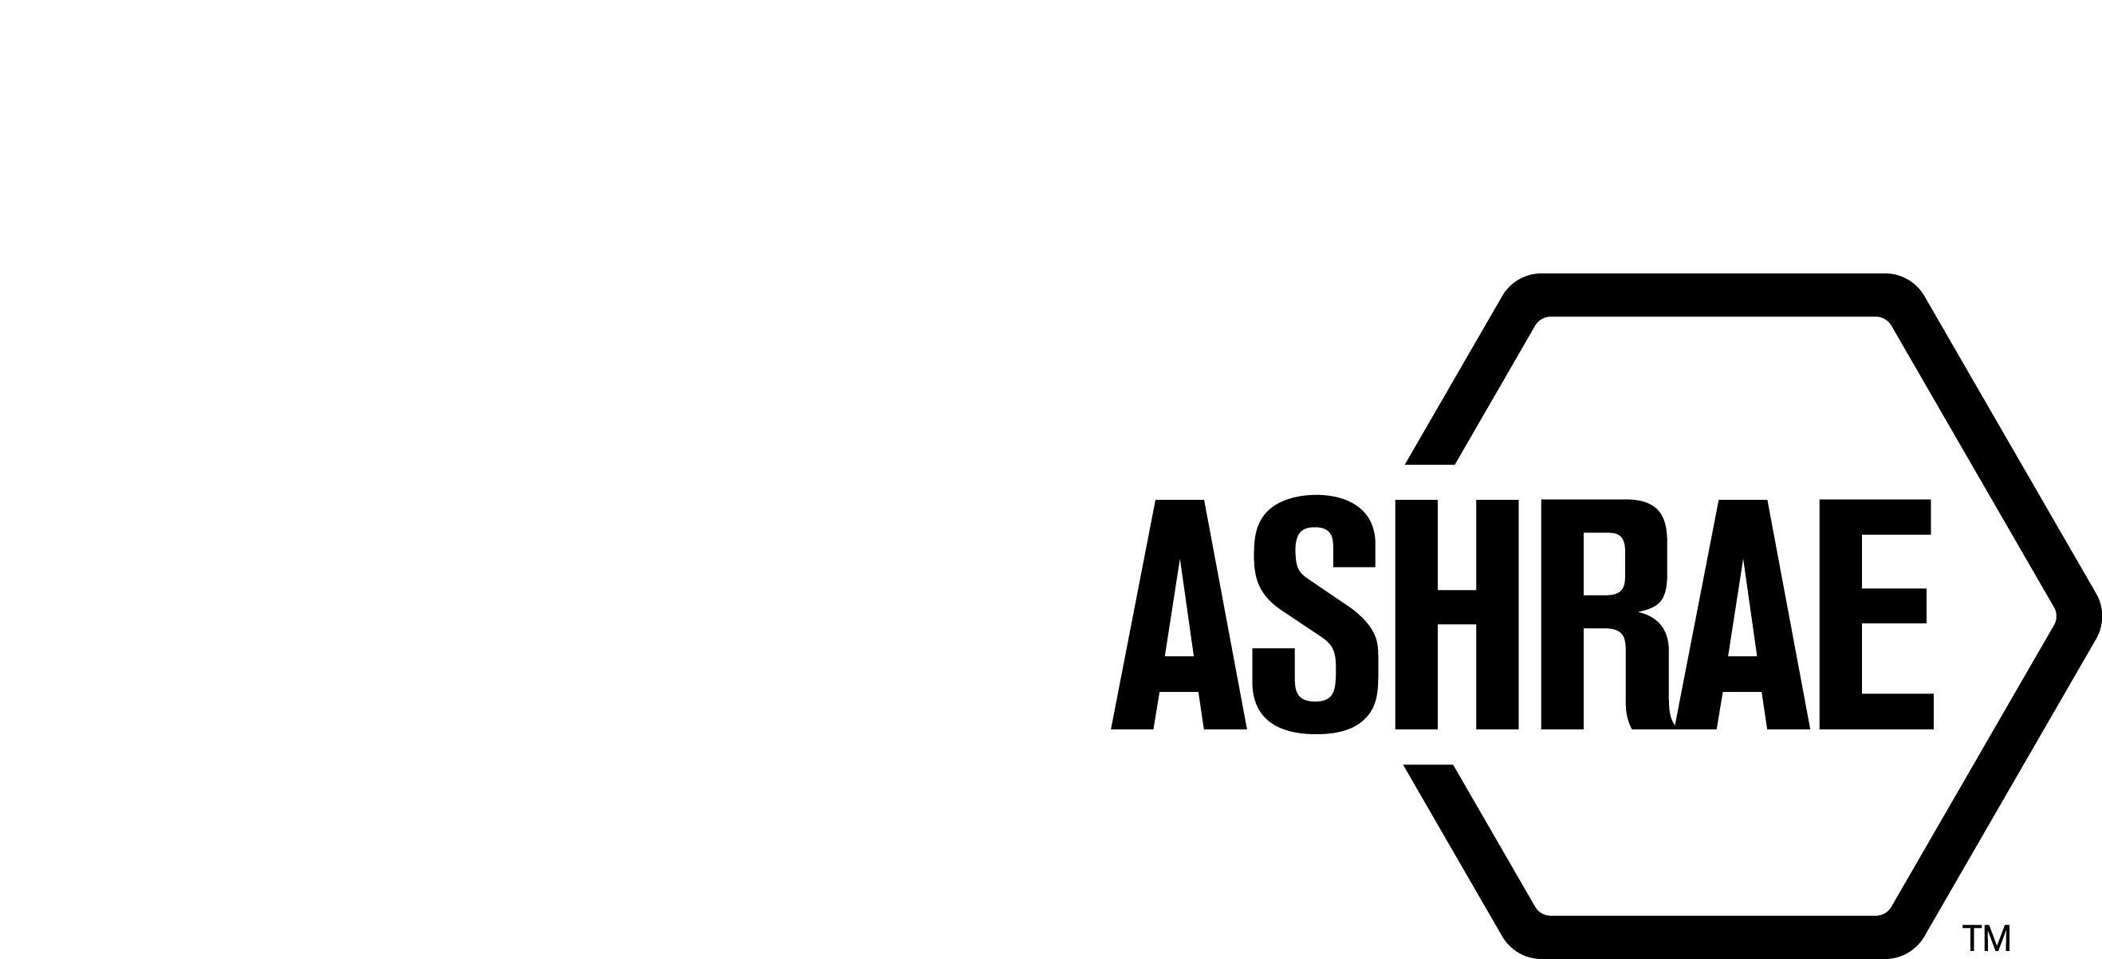

PLANNING, POLICY AND INTERPRETATIONS SUBCOMMITTEE (PPIS)

MINUTES

Spring Meeting
Conference Call
Meeting of March 3, 2021

NOTE: These draft minutes have not been approved and are the unofficial record by PPIS.

TABLE OF CONTENTS
1. Call to Order/Introductions and Review of Agenda 4
2. Chairman’s Report 4
3. Staff Report 4
4. Approval of Minutes 4
5. Review of Action Items/Unfinished Business 4
6. Planning – New Projects 5
7. Policy – Procedural Changes 6
8. Interpretations 8
9. New Business 8
10. Recess 8

ACTION ITEMS ASSIGNED WINTER MEETING 2020
AI# | Action | Assigned To | Status
1 | Action item proposed by StdC (Walter Grondzik) to look at the implications of Globalization in PASA and relevant documents. | PPIS as lead in conjunction with CIS/ILS/ISAS | OPEN –  ASHRAE standards should be considered for globalization at the time of reaffirmation, revision, withdrawal, and including newly proposed standards, guidelines or portions thereof. Workplans for all standards and guidelines should also consider globalization. Because of the magnitude of this effort, we will review ASHRAE documents and report an update at the next conference in Austin, TX.  Assignments:  PASA – Steve Sill  PC Guide to PASA – Srinivas Katipamula  StdC Mop – Bob Burkhead  StdC RM – Will assign to 2 members  ROB Vol 1-4 – Rick Heiden  Update 10/19/2020: Bob will follow up with Rick Heiden. Srinivas needs help with condensing his comments in the report. Srinivas to connect with Bob for assistance. Els needs additional time but should be able to complete by year end.  Update 1/8/2021: Bob will assign Els Baert assignment to new members. We will continue to work on these items as ILS transitions from reporting to Standards Committee to TAC. (motion has not yet been approved by StdC/Board) See Attachment A for additional guidance.  3/3/2021 – Bob to ask Dennis Knight to take over former member, Els Baert assignment.
ACTION ITEMS SPRING MEETING 2021
AI# | Action | Assigned To | Status
2 | PPIS accepted an action item from SPLS to determine appropriate action to remove a PC member when ethics violations may be involved. | Staff and SPLS Chair | OPEN -  PPIS assigned an action item to Staff to work with the SPLS Chair to identify other areas in the procedures that will address a process for removal for cause.

1. Call to Order/Introductions and Review of Agenda

Call to Order/Chairman’s Report

The Planning, Policy and Interpretations Subcommittee (PPIS) meeting was called to order on Wednesday, March 3, 2021, at 9:00 a.m. via teleconference.

Introductions

Chairman Bob Burkhead greeted members and guests. .

PPIS Members  Bob Burkhead, Chair  Michael Gallagher  Srinivas Katipamula  Dennis Knight  Cesar Lim  Dave Robin  Steve Sill  Theresa Watson | PPIS Members Absent  Guests  Katja Auer  Henry Greist  Susanna Hanson  Rick Heiden  Jim Kelsey  Gerald Kettler  Linda Lee  Stephen Martin | Staff  Connor Barbaree, Sr. MOS  Susan LeBlanc, SA  Tanisha Meyers-Lisle, Procedures Administrator  Stephanie Reiniche, Dir.

2. Chairman’s Report
Chairman greeted guests and discussed the ASHRAE Code of Ethics, Anti-Trust Guidelines and Recording of meetings prohibition.

3. Staff Report
Staff welcomed new member Michael Gallagher to PPIS.

4. Approval of Minutes
The PPIS Minutes from the Winter Meeting 2021 was presented to members for approval.

It was moved by Srinivas Katipamula and seconded by Cesar Lim:

- That the PPIS Minutes from the Winter Meeting 2021 be approved as
written.

MOTION 1 PASSED: 7-0-0, CNV

5. Review of Action Items/Unfinished Business
5A. Action Items
A list of action items was presented to members for review. An update of the action items is presented on page 2. PPIS members will continue to review their assigned action item(s).

6. Planning – New Projects
It was moved by Dennis Knight and seconded by Cesar Lim that

2 That the following Title, Purpose and Scope be approved and a new Guideline Project Committee be formed:

TITLE: Method of testing in-room devices and systems for microorganism removal or inactivation in a chamber.

1. PURPOSE:
The standard establishes a method of test for evaluating in-room devices and systems for microorganism removal or inactivation in a chamber.

2. SCOPE:
2.1.The method of test specifies selected indicator microorganisms in the test chamber and defines procedures for generating the bioaerosols required for the method of test.

2.2 This standard provides a method for counting the number of viable microorganisms in the chamber to calculate the elimination efficiency for each microorganism.

2.3 This standard establishes minimum performance specifications for the equipment required to conduct the tests, defines methods of calculating and reporting results obtained from the test data, and establishes a reporting system to be applied to in-room devices and systems covered herein.

2.4 This standard does not address the health and safety effects of operating devices and systems in an occupied room.

BACKGROUND: This TPS will also have to be approved by the Board. This TPS was originally submitted by Stephen Martin for consideration at the Winter PPIS meeting. PPIS assigned TC 2.9, Ultraviolet Air and Surface Treatment as the cognizant committee. Dr. Linda Lee was recommended as the Chair of the proposed new project committee. There are at least five members willing to volunteer.

At the Standards Committee Winter Meeting, there were a few members who expressed concern in regards to specific exclusion of “health and safety” impacts, specific inclusion clarifications, definition and details of how best to accurately label “Microorganisms” with respect to “Viruses and dropping references to “and/or” as well as “/” in several locations. With guidance from Standards Committee members and the PPIS Chair, the submitter amended the document and it was brought forward to PPIS for reconsideration at the Spring Meeting. PPIS voted to approve the amended version.

MOTION 2 PASSED: 7-0-0, CNV

It was moved by Dennis Knight and seconded by Cesar Lim

3 That Title, Purpose and Scope be approved as shown below and SSPC 300 be responsible for developing the Guideline:

TITLE: Ongoing Commissioning Process for Buildings, Systems and Assemblies

- PURPOSE:
The purpose of this guideline is to describe an Ongoing Commissioning Process (OCx) for existing buildings, systems, and assemblies that have completed the new building or existing building commissioning process using the principles developed in ASHRAE Standards and Guidelines. This OCx process is intended to maintain and improve the facility operations performance achieved by the previous commissioning and continue to meet the current facility requirements.

2. SCOPE:
2.1 This guideline applies only to existing buildings, systems, and/or assemblies that were previously commissioned.

2.2 This guideline addresses the following:
a. Overview of Ongoing Commissioning Process (OCx) activities
b. Assembly of the OCx Team, review of the current facility requirements (CFR), and development of the OCx Plan.
c. Implementation of system/assembly performance measurements and verification processes.
d. Assessment of achievement of the CFR.
e. Investigation of unacceptable performance outcomes.
f. Development and implementation of tune-up recommendations and reverification.
g. Updating of the Systems Manual.
h. Updating of facility O&M plans and personnel training.
i. Development and delivery of the OCx Report.
j. Updating the OCx Plans.

BACKGROUND: This TPS will also have to be approved by the Board. This TPS was submitted by Gerald Kettler for consideration at the Spring PPIS meeting. PPIS assigned TC 7.9, Building Commissioning as the cognizant committee. SSPC 300 is the proposed project committee for drafting the guideline. Mr. Bruce Pitts was recommended as the Chair of the proposed new project committee. There are at least five members willing to volunteer.

MOTION 3 PASSED: 7-0-0, CNV

Secretary’s Note: There were two additional TPS’s that were tabled until next meeting.

7. Policy – Procedural Changes
4 It is recommended that the PC Guide to PASA, Membership Applications and Forms (p.8) be approved as shown below:

Membership Applications and Forms (See PASA 4.3.2)
To be considered for membership on a project committee, each potential member completes an application on the ASHRAE website here. These forms should be reviewed every year and updated with changes. If changes require a change in interest category this needs to be reviewed by the Chair of the PC. All applications are submitted to ASHRAE Staff, reviewed for completeness and forwarded to the Chair for consideration. (PC Chairs Recommendation Form, application page for all members)

It is the responsibility of project committee members to keep their bio information on the ASHRAE website up to date, including email, phone number, employer and report changes promptly to the PC chair. If the member has a change in employer or funding sources, a new membership submission form shall also be submitted, and the PC chair notified, even if the project committee member does not think their interest category has changed. The reasons for submitting an updated application should be explained in the “additional notes” section of the membership application. (i.e. change of employer, change in funding source, retirement)

BACKGROUND: A suggestion for a modification to the PC Guide to PASA, “Membership Applications and Forms” (pg. 8), was received from the Chair of 90.1. This change is being proposed to provide clarification for the new online membership process.

MOTION 4 PASSED: 7-0-0, CNV

5 It is recommended that the PC Guide to PASA, Removal for Cause (p.13) be approved as shown below:
Removal for Cause (See PASA 4.3.8 and PASA 4.3.9)
A sample letter for removal for cause can be found here: Sample Letter of Intent to Recommend Removal for Cause.
When a project committee member has not been participating in meetings or responding to letter ballots a PC Chair may recommend (with justification) that the member be removed from the PC roster. (See PASA 4.3.8) While understanding that things come up, members should inform the chair of conflicts or other difficulties. SPLS may also recommend removal for cause of members as well. (See PASA 4.3.9). A PC Chair may recommend removal of a PC member from the roster for due cause and must explain their reasoning for SPLS consideration. The following are some examples of why a PC member can be removed:
  - Member hasn’t attended 50% of scheduled PC meetings in 12 months
  - Member hasn’t responded to 60% of the letter ballots in 12 months.
  - Failure to disclose conflicts of interest; or
  - Violating Failure to maintain commitment to ASHRAE’s Code of Ethics
  - An organizational member wants to replace a representative on the PC.
Prior to submitting a recommendation for removal to the SPLS Liaison and MOS, the PC Chair is expected to notify the PC member in writing of his/her intent to recommend removal for cause and the reasons why (see example letter of intent below). An offer to the member to resign from the PC rather than be removed for cause is highly recommended. SPLS may or may not approve removal requests if the chair has not provided satisfactory documentation to support the removal.
The recommendation for removal is submitted to the SPLS Liaison and MOS via the PC Chair’s Membership Recommendation Form. The PC Chair shall complete the Removal of Member section of the PC Chair’s Membership Recommendation Form, and include documentation of the PC Chair’s communication to the member, his/her response, and written justification for the recommendation (e.g., copy of meeting minutes noting absences, letter ballot vote counts noting unreturned ballots, etc.). The recommendation will be acted on by SPLS.

BACKGROUND: PPIS accepted an action item from SPLS to determine appropriate action to remove a PC member when ethics violations may be involved. While procedures state violating ASHRAE Code of Ethics is a reason for recommending removal, the term violation as currently written presumes guilt, and does not address performance based issues. PPIS is recommending Standards Committee approve this language as other areas are identified. A comprehensive list of changes will come forward at the next meeting.

MOTION 5 PASSED: 7-0-0, CNV

8. Interpretations
The Interpretation Committee formed to respond to a request for Standard 180 met on February 8, 2021 and voted to approve the following interpretation:

9. New Business
None.

10. Recess
PPIS adjourned at 11:00 am.
ATTACHMENT A:
DOCUMENT REVIEW OBJECTIVES:

Subject - PPIS prime objective of “Globalization” of Policy and Procedures documents.

Tanisha reminded me that we have provided no real guidance in reviewing the guiding policy documents for the subject objective. Below is my take or how these documents should be reviewed – I do consider this a draft and would be open for modifications if so inclined.

The major documents under review should be screened for references that are solely domestic in nature and have clear need to coordinate with international organizations. Examples

- Standards
- Guidelines
- Code interaction
- Recommended practices

Specifically, any reference to these bodies and organizational structures should be considered as a potential area for us to broaden the scope to include the global of objectives.

It is clear that we may not have clear understanding of those objectives – an issue that I hope to talk through at each level as we progress through the goals.

Bob Burkhead
8 January 2021

