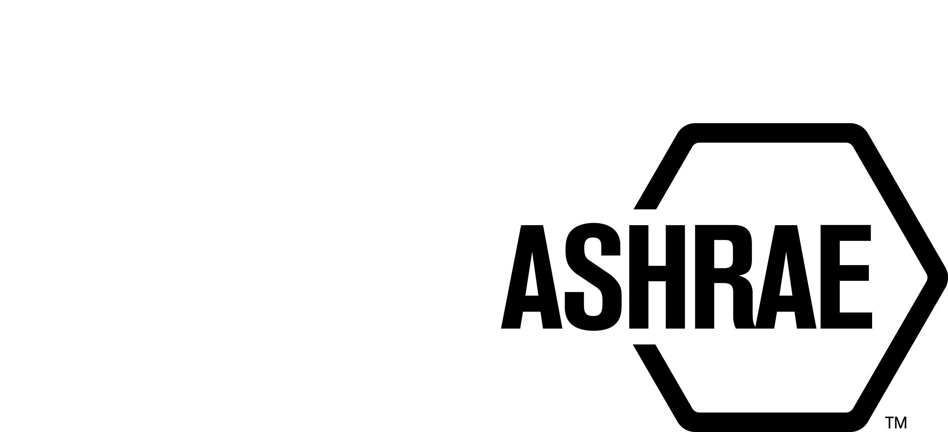

PLANNING, POLICY, AND INTERPRETATIONS SUBCOMMITTEE (PPIS)

MINUTES

Spring Meeting
March 18, 2024

NOTE: These draft minutes have not been approved and are the unofficial record by PPIS.

TABLE OF CONTENTS
1. Call to Order/Introductions and Review of Agenda 3
2. Chairman’s Report 3
3. Staff Report 3
4. Approval of Minutes 3
5. Review of Action Items/Unfinished Business 3
6. Planning – New Projects 4
7. Policy – Procedural Changes 4
8. Interpretations 5
9. New Business 5
10. Adjournment 5

ACTION ITEMS ASSIGNED SPRING MEETING 2024
1 | In an effort to get data, Bill Walter to work with Justin Prosser (SPLS Chair) to create a short survey to retrieve feedback about the new voting rule. | Bill Walter/Justin Prosser | OPEN
ACTION ITEMS ASSIGNED WINTER MEETING 2024
AI# | Action | Assigned To | Status
1 | PPIS to investigate why we changed our voting requirement from two thirds to majority.  PPIS Discussion – pros and cons were discussed and it was decided that we need more data, we should monitor the success or failure of the voting rule and report back. | PPIS | CLOSED
2 | It has been requested that ASHRAE develop procedures for a non-ANSI path (ASHRAE ONLY) and also develop a checklist for consideration. PPIS plans to propose drafts to Standards Committee at the Spring 2024 meeting. | PPIS | ONGOING

1. Call to Order/Introductions and Review of Agenda

Call to Order/Chairman’s Report

The Planning, Policy, and Interpretations Subcommittee (PPIS) meeting was called to order on March 18, 2024, at 12:00 p.m. via conference call.

Introductions

Chairman Bill Walter greeted members.

PPIS Members  Bill Walter, Chair  Drake Erbe  Kelley Cramm  Julie Majurin  Karl Peterman  Christopher Seeton | PPIS Members Absent  Guests  Doug Fick | Staff  Tanisha Meyers-Lisle, AMOS  Kai Nguyen, MOS-Int’l  Ryan Shanley, S-MOS

2. Chairman’s Report
Chairman greeted guests and discussed the ASHRAE Code of Ethics, Anti-Trust Guidelines, and the prohibition of recording meetings.

3. Staff Report
Staff discussed the status of the appeal to BSR/ASHRAE Addendum j to ANSI/ASHRAE Standard 62.2-2022, Ventilation and Acceptable Indoor Air Quality in Residential Buildings. The ANSI Appeals Board reversed the ANSI ExSC decision to dismiss the complaint and has asked the ANSI ExSC to hold a hearing. The ANSI Appeals Board observed the current records were insufficient in determining whether ASHRAE violated its procedures. The hearing has been tentatively scheduled for September 17, 2024.

4. Approval of Minutes
The PPIS Minutes from the Winter Meeting 2024 was presented to members for approval.

It was moved by Drake Erbe and seconded by Chris Seeton:

- That the PPIS Minutes from the Winter Meeting 2024 be approved as
written.

MOTION 1 PASSED: 4-0-1, CNV

5. Review of Action Items/Unfinished Business
5A. Action Items
A list of action items was presented to members for review. An update of the action items is presented on page 2. PPIS members will continue to review their assigned action item(s).

6. Planning – New Projects
None.

7. Policy – Procedural Changes
It was moved by Kelley Cramm and seconded by Chris Seeton that:

2 The Procedures for ASHRAE Standards Actions (PASA), Annex B, B7.4 Conflict of Interest, B8.3 Panel Consideration of Adjudicating the Appeal Without a Hearing and B8.5 Rebuttal be approved as shown below:

B7.4 Conflict of interest
A member of the ASHRAE Appeals Board shall act at all times in a manner that promotes confidence in the integrity and impartiality of ASHRAE’s processes and procedures and should avoid a conflict of interest or the appearance of a conflict of interest in connection with all ASHRAE Appeals activities. Should the Appeals Board Chair have a conflict of interest with any appeal he/she shall select another member of the Appeals Board to serve is his/her place with respect to consideration of that appeal.
A complete list of ASHRAE Appeals Board members potentially serving on the Panel shall be sent to both the appellant(s) and respondent(s) to identify any possible conflicts of interest. If a materially affected party (either the appellant or the respondent) asserts that it believes a member of the ASHRAE Appeals Board has a conflict of interest, that materially affected party is required to state the reason(s) for its belief. That information shall then be forwarded to the member of the ASHRAE Appeals Board identified as having a possible conflict for that person’s response. If that member disagrees with the assertion, then the Chair of the ASHRAE Appeals Board shall make a final determination as to whether a conflict of interest exists.
Members of the ASHRAE Appeals Board who are disqualified from a particular discussion shall not participate in the arguments, deliberations or decisions.

B8.3 Panel Consideration of Adjudicating the Appeal Without a Hearing
The Appeals Panel shall decide if the appeal shall be dismissed without a hearing. In order to assess whether or not the appeal should be dismissed the Appeals Panel Chair may provide a list of specific questions to the cognizant PC Chair and may also include any additional information to rebut the appeal. The responses shall be shared with the Appellant(s) prior to the issuance of a decision by the Appeals Panel. A written response from the appellant(s) is not permitted. The Appeals Panel Chair or the Chairs designee shall notify the ASHRAE President, the Appellant and the chair of the cognizant PC in writing of the decision. Non-compliance with Section B5 or lack of grounds for an appeal may be reasons for dismissal.

B8.5 Rebuttal
If the Panel determines that the action is not to be dismissed, the Panel will consider the responses and any additional information previously submitted from the cognizant PC Chair as a rebuttal of the written statement of appeal. , shall be submitted to the MOS by the Chair of the Standards Committee or his/her designee, or the Chair of the PC or his/her designee. The MOS shall distribute it to the Appeals Panel and to the Appellant. If during the adjudication period, the Appeals Panel does not request a list of specific questions from the cognizant PC Chair, a the rebuttal, from the Respondent(s) shall be due within 15 working days of the date on the letter of notification. The Chair of the Appeals Panel may grant an extension if requested prior to the close of the initial 15 working day period and if sufficient justification is provided. The rebuttal statement shall be sent to the MOS, who shall distribute it to the Appellant and the Appeals Panel. The Appeals Panel has the authority to announce a hearing schedule at the time the rebuttal is requested or wait until after the rebuttal is received.

BACKGROUND: The PASA changes that were approved in January 2024 were submitted to ANSI. ANSI initiated a public review which closed on March 11th. We received a few friendly amendments to Section B7.4 and Section B8.3. After further review, Staff suggested changes to section B8.5. If approved, these changes will be submitted to ANSI as editorial in nature. The ANSI ExSC will review to determine if it can be considered editorial.
.
MOTION 2 PASSED: 5-0-0, CNV

PPIS was tasked with developing procedures for a non-ANSI path (ASHRAE ONLY) standard development, as well as creating a checklist for evaluation purposes. A preliminary draft was presented by the staff for review, and following discussions, it was decided to revise the draft to incorporate the advantages of an ANSI/ASHRAE path compared to an ASHRAE path. Additionally, modifications have been made to the TPS form, which will be presented for approval at the Annual Meeting.

8. Interpretations
None.

9. New Business
A discussion to approve the ICC cosponsorship request to Standard 242P was tabled until the next meeting.

10. Adjournment
PPIS adjourned at 2:00 pm.

