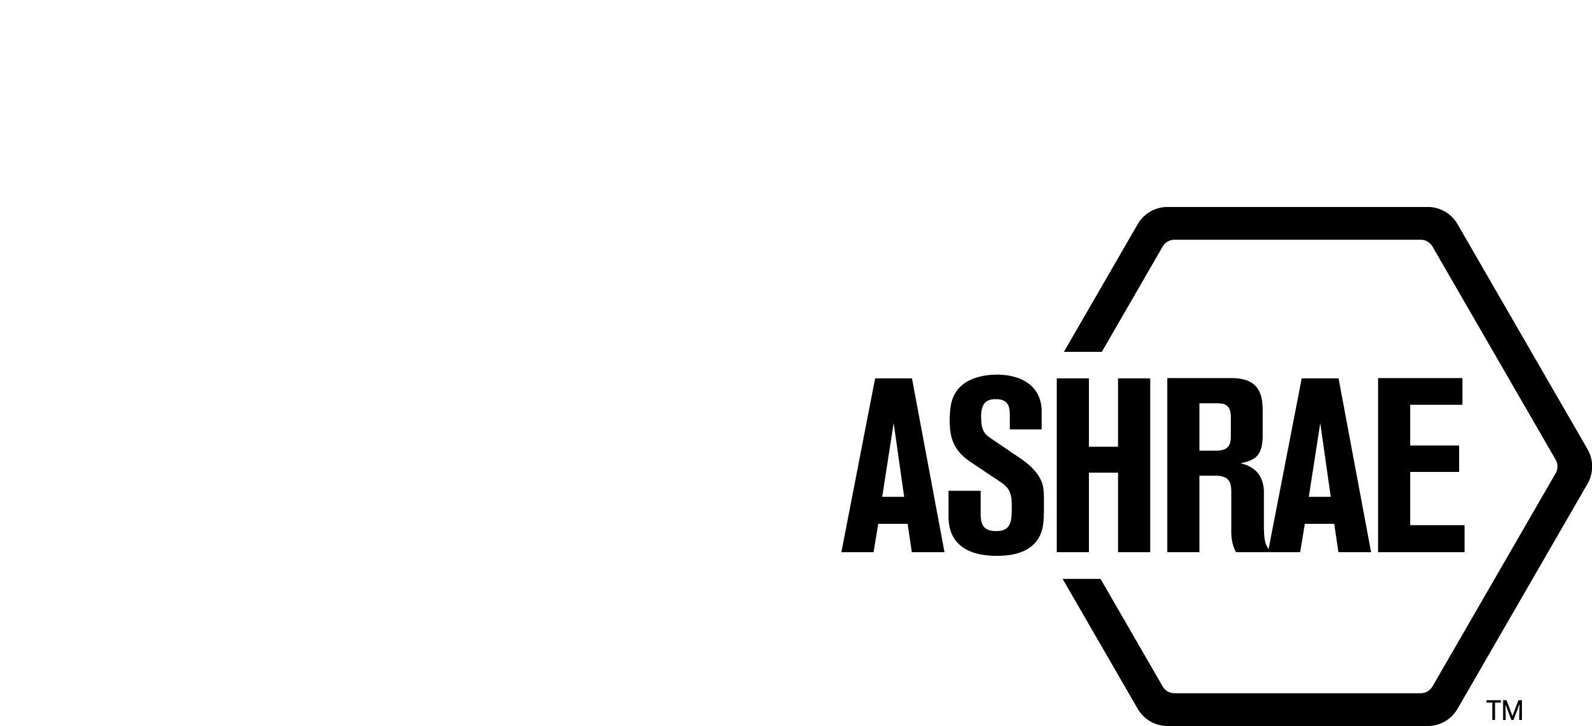

PLANNING, POLICY, AND INTERPRETATIONS SUBCOMMITTEE (PPIS)

MINUTES

Spring Meeting
April 10, 2025

NOTE: These draft minutes have not been approved and are the unofficial record by PPIS.

TABLE OF CONTENTS
1. Call to Order/Introductions and Review of Agenda 3
2. Chairman’s Report 3
3. Staff Report 3
4. Approval of Minutes 3
5. Review of Action Items/Unfinished Business 3
6. Planning – New Projects 3
7. Policy – Procedural Changes 3
8. Interpretations 4
9. Old Business 4
10. Adjournment 4

ACTION ITEMS ASSIGNED SPRING 2025
1 | PPIS has requested staff to provide a list of pros and cons of cosponsorship. | STAFF | OPEN
2 | PPIS will be developing criteria to evaluate the need for committees to be on continuous maintenance. | PPIS | OPEN
3 | PPIS discussed the idea of developing a definition of safety standards. Karl has contacted ASTM, AHRI, and NEMA and none have a definition of safety standards. Karl suggests surveying the PC Chairs (SSPC 15, 34, SPC 243 and 400) to ask them why their standard is safety related. Karl and Julie will work on contacting committees. | KARL | OPEN

1. Call to Order/Introductions and Review of Agenda

Call to Order/Chairman’s Report

The Planning, Policy, and Interpretations Subcommittee (PPIS) meeting was called to order on April 10, 2025, at 11:00 a.m. via conference call.

Introductions

Chair Bill Walter greeted members.

PPIS Members  Bill Walter, Chair  Drake Erbe  Julie Majurin  Karl Peterman  Christopher Seeton | PPIS Members Absent  Kelley Cramm  Guests | Staff  Tanisha Meyers-Lisle, AMOS

2. Chairman’s Report
Chair greeted guests and read the ASHRAE Value Statement and highlighted the ASHRAE Code of Ethics, Anti-Trust Guidelines, and the prohibition of recording meetings.

3. Staff Report
Staff updated the committee about the 2025 ANSI audit. A call will be held on April 16, 2025 with Staff and ANSI auditors to review findings and recommendations.

4. Approval of Minutes
Winter meeting minutes were approved via OSR.

5. Review of Action Items/Unfinished Business
5A. Action Items
A list of action items was presented to members for review. An update of the action items is presented on page 2. PPIS members will continue to review their assigned action item(s). NO ACTION ITEMS PRESENTED.

6. Planning – New Projects
None.

7. Policy – Procedural Changes
It was moved by Drake Erbe and seconded by Julie Majurin that:

- That the Procedures for ASHRAE Standards Action (PASA) Definitions, be approved as shown below:

User: A member who represents the interest of those that purchase or use materials, products, systems, or services other than for household use covered in the project scope.

BACKGROUND: This recommendation clarifies the definition of User.

MOTION PASSED: 4-0-1
Chair abstains.

8. Interpretations
None.

9. Old Business
1. A request was received from SSPC 169 for IBPSA to cosponsor ANSI/ASHRAE Standard 169-2021, Climatic Data for Building Design Standards. PPIS questions the value of this cosponsorship to ASHRAE. It appears this request may be better aligned with ANSI/ASHRAE Standard 209-2018, Energy Simulation Aided Design for Buildings Except Low-Rise Residential Buildings. Staff contacted the Chair of Standard 169 and asked for additional background/rationale information to support their request. A response was received but PPIS has requested staff to provide a list of pros and cons of cosponsorship.

2. PPIS discussed the idea of developing a definition of safety standards. Should safety and/or risk management be included in the definition? ANSI defines a Safety Standard as “If a SDO has “Safety” in the title and/or scope it is considered by the ExSC as a safety or safety related standard. Otherwise, we let the SDO decide on that.” An action item was assigned to Karl Peterman to review other Standards Development Organizations (SDO) rules/definitions as it relates to their safety standards. Karl has contacted ASTM, AHRI, and NEMA and none have a definition of safety standards. Karl suggests surveying the PC Chairs (SSPC 15, 34, SPC 243 and 400) to ask them why their standard is safety related. Karl and Julie will work on contacting committees.

3. PPIS reviewed a request to set criteria for continuous maintenance (CM) standards. It appears some committees believe being on CM is a sign of prestige. The issue occurs for staff when addendums is submitted, it is a full revision of the standard. Addenda should not be utilized to revise the entire standard. PPIS will be developing criteria to evaluate the need for committees to be on continuous maintenance.

10. Adjournment
PPIS adjourned at 12:00 pm.

