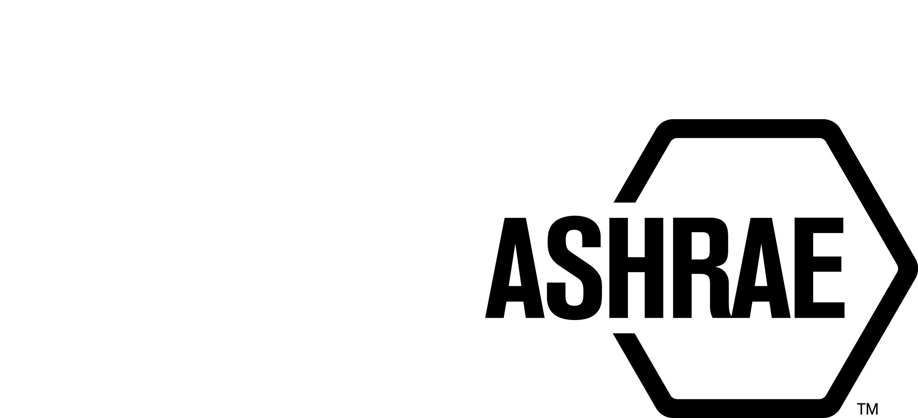

PLANNING, POLICY AND INTERPRETATIONS SUBCOMMITTEE (PPIS)

MINUTES

Winter Meeting
Conference Call
Meeting of January 8, 2021

NOTE: These draft minutes have not been approved and are the unofficial record by PPIS.

TABLE OF CONTENTS
1. Call to Order/Introductions and Review of Agenda 3
2. Chairman’s Report 3
3. Staff Report 3
4. Approval of Minutes 3
5. Review of Action Items/Unfinished Business 4
6. Planning – New Projects 4
7. Policy – Procedural Changes 4
8. Interpretations 5
9. New Business 5
10. Recess 5

ACTION ITEMS ASSIGNED WINTER MEETING 2020
AI# | Action | Assigned To | Status
1 | Action item proposed by StdC (Walter Grondzik) to look at the implications of Globalization in PASA and relevant documents. | PPIS as lead in conjunction with CIS/ILS/ISAS | OPEN –  ASHRAE standards should be considered for globalization at the time of reaffirmation, revision, withdrawal, and including newly proposed standards, guidelines or portions thereof. Workplans for all standards and guidelines should also consider globalization. Because of the magnitude of this effort, we will review ASHRAE documents and report an update at the next conference in Austin, TX.  Assignments:  PASA – Steve Sill  PC Guide to PASA – Srinivas Katipamula  StdC Mop – Bob Burkhead  StdC RM – Will assign to 2 members  ROB Vol 1-4 – Rick Heiden  Update 10/19/2020: Bob will follow up with Rick Heiden. Srinivas needs help with condensing his comments in the report. Srinivas to connect with Bob for assistance. Els needs additional time but should be able to complete by year end.  Update 1/8/2021: Bob will assign Els Baert assignment to new members. We will continue to work on these items as ILS transitions from reporting to Standards Committee to TAC. (motion has not yet been approved by StdC/Board) See Attachment A for additional guidance.
ACTION ITEMS FALL MEETING 2020
AI# | Action | Assigned To | Status
2 | An email was received from Karl Peterman addressing a possible topic of discussion for PPIS. How to handle letter ballots when you are meeting virtually as our procedures seem to be silent on the matter. PPIS discussed and determined that while this may need to be addressed, it may be out of PPIS’ scope of work. This will be a huge endeavor and it was suggested that instead of overhauling all of our documents, that PPIS review our current rules and procedures to make sure we are in alignment with our current practice. | PPIS | COMPLETED -  Update 12/17/2020 – Staff has reviewed our current procedures and determined that we are in alignment with our current practice.

1. Call to Order/Introductions and Review of Agenda

Call to Order/Chairman’s Report

The Planning, Policy and Interpretations Subcommittee (PPIS) meeting was called to order on Friday, January 8, 2021, at 9:00 a.m. via teleconference.

Introductions

Chairman Bob Burkhead greeted members and guests. .

PPIS Members  Bob Burkhead, Chair  Robert Burkhead  Srinivas Katipamula  Cesar Lim  Dave Robin  Steve Sill  Theresa Watson | PPIS Members Absent  Guests  Henry Greist  Rick Heiden  Linda Lee  Stephen Martin  Kathleen Owen | Staff  Susan LeBlanc, SA  Tanisha Meyers-Lisle, Procedures Administrator

2. Chairman’s Report
Chairman greeted guests and discussed the ASHRAE Code of Ethics, Anti-Trust Guidelines and Recording of meetings prohibition. Chairman discussed a proposal coming forward from ILS (International Liaison Subcommittee), it relates to our action item regarding Globalization. (see action item, p.2)

3. Staff Report
Staff noted the resignation of Els Baert, effective November 24, 2020. The Board will be reviewing candidates to fulfill her seat at their next meeting. No updates for the Summer conference.

4. Approval of Minutes
The PPIS Minutes from the Fall Meeting 2020 was presented to members for approval.

It was moved by Dennis Knight and seconded by Theresa Watson:

- That the PPIS Minutes from the Fall Meeting 2020 be approved as
written.

MOTION 1 PASSED: 6-0-0, CNV

5. Review of Action Items/Unfinished Business
5A. Action Items
A list of action items was presented to members for review. An update of the action items is presented on page 2. PPIS members will continue to review their assigned action item(s).

6. Planning – New Projects
It was moved by Dennis Knight and seconded by Steve Sill that Title, Purpose and Scope be approved as shown below:

TITLE: Method of Testing of Performance In-Room Devices/Systems for Microorganism
and/or Virus Removal or Inactivation in a Chamber

PURPOSE:
The standard establishes a method of test for evaluating in-room Devices/Systems for microorganism and/or virus removal or inactivation in a chamber.

SCOPE:
2.1 This standard describes a method of laboratory testing to measure the performance of in-room Devices/Systems for microorganism and/or virus removal or inactivation in a chamber.

2.2 The method of test measures the performance of in-room Devices/Systems for microorganism and/or virus removal or inactivation in a chamber. The method recommends selected indicator microorganisms/viruses in the chamber. The standard defines procedures for generating the bioaerosols required for conducting the test. It also provides a method for counting the airborne bioaerosols in the chamber in order to calculate inactivation efficiency for each microorganism.

2.3 This standard also establishes minimum performance specifications for the equipment required to conduct the tests, defines methods of calculating and reporting results obtained from the test data, and establishes a reporting system to be applied to in-room Devices/Systems covered herein.

BACKGROUND: This TPS will also have to be approved by the Board. This TPS was submitted by Stephen Martin for consideration at the Winter PPIS meeting. PPIS assigned TC 2.9, Ultraviolet Air and Surface Treatment as the cognizant committee. Dr. Linda Lee was recommended as the Chair of the proposed new project committee. There are at least five members willing to volunteer.

VOTE: 6-0-0, CNV

7. Policy – Procedural Changes
None.

8. Interpretations
None.

9. New Business
None.

10. Recess
PPIS adjourned at 10:35 am.
ATTACHMENT A:
DOCUMENT REVIEW OBJECTIVES:

Subject - PPIS prime objective of “Globalization” of Policy and Procedures documents.

Tanisha reminded me that we have provided no real guidance in reviewing the guiding policy documents for the subject objective. Below is my take or how these documents should be reviewed – I do consider this a draft and would be open for modifications if so inclined.

The major documents under review should be screened for references that are solely domestic in nature and have clear need to coordinate with international organizations. Examples

- Standards
- Guidelines
- Code interaction
- Recommended practices

Specifically, any reference to these bodies and organizational structures should be considered as a potential area for us to broaden the scope to include the global of objectives.

It is clear that we may not have clear understanding of those objectives – an issue that I hope to talk through at each level as we progress through the goals.

Bob Burkhead
8 January 2021

