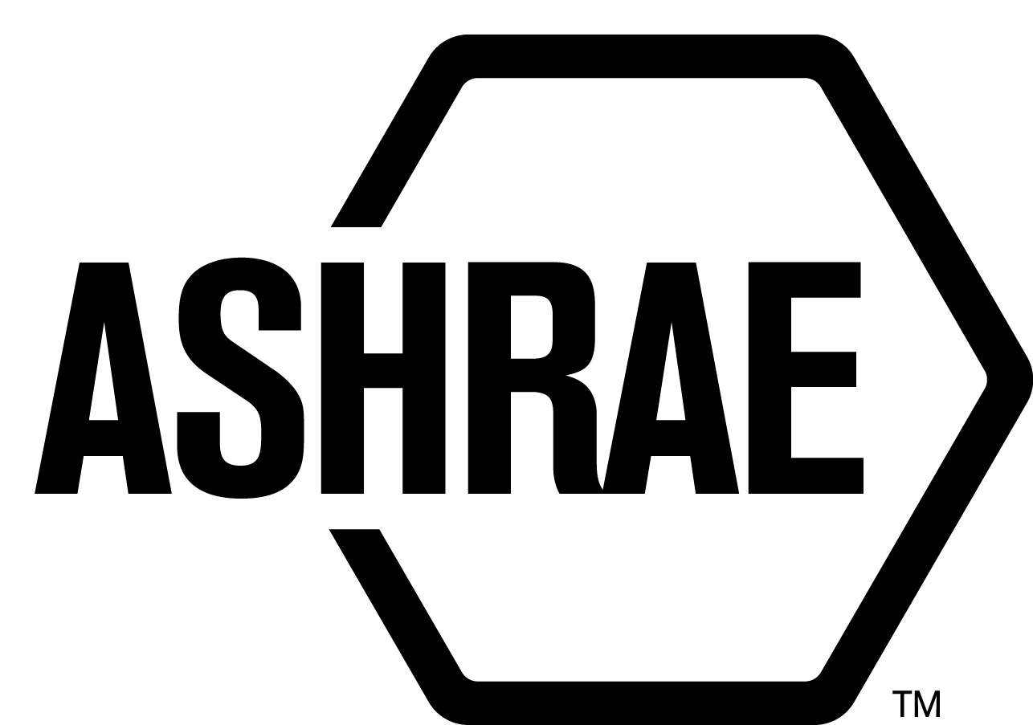

PLANNING, POLICY AND INTERPRETATIONS SUBCOMMITTEE (PPIS)

MINUTES

Hilton Hotel
Atlanta, GA
Meeting of June 26, 2015

NOTE: These draft minutes have not been approved and are the unofficial record by PPIS.

TABLE OF CONTENTS
1. Call to Order/Introductions and Review of Agenda 3
2. Chairman’s Report 3
3. Staff Report 3
4. Approval of Minutes 3
5. Review of Action Items/Unfinished Business 3
6. Planning – New Projects 4
7. Policy – Procedural Changes 5
8. Interpretations 6
9. New Business 6
10. Recess 6

ACTION ITEMS ASSIGNED WINTER MEETING IN ATLANTA, GA
AI# | Action | Assigned To | Status
 | None.

1. Call to Order/Introductions and Review of Agenda

Call to Order/Chairman’s Report

The Planning, Policy and Interpretations Subcommittee (PPIS) meeting was called to order on Friday, June 26, 2015, at 2:00 p.m., in 306 (3).

Introductions

Chairman Rita Harrold greeted members and guests. Introductions were made.

PPIS Members  Rita Harrold, Chair  Joseph Anderson  David Conover  Dennis Knight  Cyrus Nasseri | PPIS Members Absent  Rick Larson  Guests  Jim Aswegan  Rick Hall  Dennis Stanke | Staff  Tanisha Meyers-Lisle, Procedures Administrator  Stephanie Reiniche, Sr. Manager of Standards  Katrina Shingles, Secretary/Admin. Asst.

2. Chairman’s Report
None.

3. Staff Report
None.

4. Approval of Minutes
The PPIS Minutes from the Chicago, IL Winter Meeting 2015 was presented to members for approval.

It was moved by Dave Conover and seconded by Joseph Anderson:

- That the PPIS Minutes from the Chicago, IL Winter Meeting 2015 be approved as written.

MOTION 1 PASSED: 4-0-0, CNV

5. Review of Action Items/Unfinished Business
5A. Action Items
A list of action items was presented to members for review. An update of the action items is presented on page 2.

6. Planning – New Projects
It was moved by Dave Conover and seconded by Dennis Knight, that the Title, Purpose and Scope be approved as shown below:

2 TITLE: Method of Testing the Ability of Liquid Line Filter Driers or Adsorbents to Remove Organic and Inorganic Acid

1. PURPOSE:
This standard establishes a suitable laboratory apparatus and test method for determining the ability of various adsorbents and refrigerant liquid line filter driers to remove specific organic and inorganic acids from refrigerant-lubricant mixtures.

2. SCOPE:
This standard applies to the measurement of the mass of a specific organic acid or inorganic acid removed from a refrigerant-lubricant mixture by a liquid line filter drier containing an adsorbent desiccant material or through a specific adsorbent material which can remove acid by adsorption and/or chemical reaction. The standard applies to methods associated with the extraction of both short and long chain carboxylic acids.

BACKGROUND: This TPS will also have to be approved by the Board. This TPS was submitted by John Senediak for consideration at the Atlanta PPIS meeting. PPIS assigned TC 3.3, Refrigerant Contaminant Control. John Senediak was recommended as the Chair of the proposed new project committee. There are at least five members willing to volunteer.

MOTION 2 PASSED: 4-0-0, CNV

It was moved by Dennis Knight and seconded by Dave Conover, that the Title, Purpose and Scope be approved as shown below:

3 TITLE: Standard Methods for Uncertainty Analysis

1.PURPOSE:
This standard prescribes methods for analyzing data and reporting the uncertainty in measurements to a confidence level of 95%.
2. SCOPE:
This standard applies to direct and derived measurements from instruments and to assigned values, where used to determine test results.

BACKGROUND: This TPS will also have to be approved by the Board. This TPS was submitted by Patrick Collins for consideration at the Atlanta PPIS meeting. PPIS assigned TC 1.2, Instruments and Measurements as the cognizant TC. Patrick Collins was recommended as the Chair of the proposed new project committee. There are at least five members willing to volunteer. The intent is to convert ASHRAE Guideline 2: Engineering Analysis of Experimental Data” to a mandatory language standard and reissue it as Standard 41.12 (formerly 41.5, last issued in 1975).

MOTION 3 PASSED AS AMENDED: 4-0-0, CNV

7. Policy – Procedural Changes
It was moved by Dennis Knight and seconded by Dave Conover,

4 That the Rules of the Board 1.201.004.5 be approved as shown in Attachment A.

BACKGROUND: Standards Committee has been working towards enforcing the mandatory language requirement for new standards and existing standards. This requirement has created an increase in work load in the volunteers and staff. Standards Committee is developing a priority list for the requirement that would allow Standards to more properly address this issue. In order to do this it is being requested that a waiver be included in the rules of the board.

MOTION 4 PASSED: 4-0-0, CNV
(Secretary’s Note: At the June 27, 2015 Standards Committee meeting, Stdc amended the approved change as shown in Attachment A. “Definitive mandatory language, unless a waiver has been granted by Standards Committee.”)

It was moved by Dave Conover and seconded by Dennis Knight,

5 That the StdC Reference Manual, Section 12, Code Interaction Subcommittee, be approved as shown in Attachment B.

BACKGROUND: CIS is in favor of ASHRAE being able to submit proposals if there’s no published standard (i.e. to ensure the code permits proper use of ASHRAE Handbooks) which is currently not permitted by procedure. These proposed revisions allow ASHRAE to submit proposals to model code groups from non-standards committee documents (i.e. from the Handbook).

MOTION 5 PASSED: 4-0-0, CNV

It was moved by Dave Conover and seconded by Dennis Knight,

6 That the PC MOP be discontinued and the information be transferred to forms and training materials.

BACKGROUND: Findings from our ANSI audit suggested we streamline our procedures. When PASA was approved in June 2014 (incorporating ANSI findings), it was noted that we would discontinue the use of the PC MOP and incorporate PC MOP information into forms and training materials. Staff has completed this task and the ASHRAE website has a PC Chairs Toolkit that is very useful to the project committee members. https://www.ashrae.org/standards-research--technology/standards--guidelines/pc-chairs-toolkit.

MOTION 6 PASSED: 4-0-0, CNV
(Secretary’s Note: At the June 27, 2015 Standards Committee meeting, StdC issued an action item for Staff to work with Adam Hinge and Wayne Stoppelmoor to develop a guide similar to the PC MOP that will be easy to reference and locate items in PASA. An action item was issued to SPLS to revise and approve reference materials.)

8. Interpretations
PPIS approved the formation of an Interpretation Committee for SPC 185.1-2015, Method of Testing UVC Lights for Use in Air Handling Units or Air Ducts to Inactivate Airborne Microorganisms.

9. New Business
None.

10. Recess
PPIS adjourned at 3:00pm.
ATTACHMENT A
ATTACHMENT B

