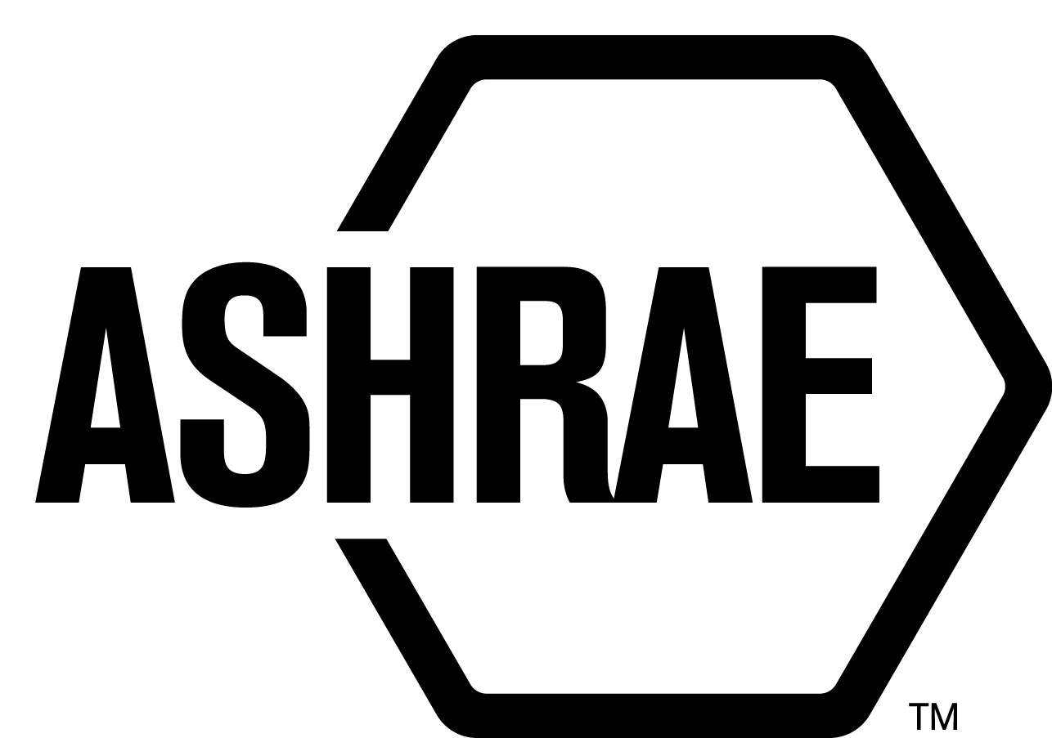

PLANNING, POLICY AND INTERPRETATIONS SUBCOMMITTEE (PPIS)

MINUTES

Kansas City Marriott Downtown
Meeting of June 21, 2019
and June 25, 2019

NOTE: These draft minutes have not been approved and are the unofficial record by PPIS.

TABLE OF CONTENTS
1. Call to Order/Introductions and Review of Agenda 3
2. Chairman’s Report 3
3. Staff Report 3
4. Approval of Minutes 3
5. Review of Action Items/Unfinished Business 3
6. Planning – New Projects 4
7. Policy – Procedural Changes 4
8. Interpretations 5
9. New/Ongoing Business 5
10. Recess 5
11. Call to Order/Introductions and Review of Agenda 5
12. Chairman’s Report 6
13. Staff Report 6
14. Unfinished Business 6
15. Planning – New Projects 6
16. Policy – Procedural Changes 6
17. Interpretations 6
18. New Business 6
19. Next Meeting 6
20. Adjournment 6

ACTION ITEMS ASSIGNED ANNUAL MEETING IN KANSAS CITY, KS
AI# | Action | Assigned To | Status
1 | Send rejected comments to Chair of newly formed SPC TPS 227 and 228. | Staff | Open -sent to 228. Need to send to SPC 227 Chair.

1. Call to Order/Introductions and Review of Agenda

Call to Order/Chairman’s Report

The Planning, Policy and Interpretations Subcommittee (PPIS) meeting was called to order on Friday, June 21, 2019 at 2:00 p.m., in Marriott West, Big Joe Turner A.

Introductions

Chairman Jonathan Humble greeted members and guests. Introductions were made.

PPIS Members  Jonathan Humble, Chair  Niels Bidstrup  Robert Burkhead  Rick Heiden  Dennis Stanke  Mike Woodford | PPIS Members Absent  Els Baert  Roger Hedrick  Guests  Walter Grondzik  Karl Peterman  Steven Sill | Staff  Stephanie Reiniche, Director  Steve Ferguson, MOS  Tanisha Meyers-Lisle, Procedures Administrator

2. Chairman’s Report
The Chair acknowledged the ASHRAE Code of Ethics Commitment.

3. Staff Report
None.

4. Approval of Minutes
The PPIS Minutes from Spring Meeting May 29, 2019 was presented to members for approval.

It was moved by Rick Heiden and seconded by Dennis Stanke:

- That the PPIS Minutes from the Spring Meeting May 29, 2019 be approved as written.

MOTION 1 PASSED: 6-0-0, CV

5. Review of Action Items/Unfinished Business
5A. Action Items
A list of action items was presented to members for review. An update of the action items is presented on page 2.

6. Planning – New Projects
Secretary’s Notes: There were two TPS’s presented to PPIS, Evaluating Ruleset Implementation in Building Energy Modeling Software (Supriya Goel) and Guideline for Testing Performance of Cool Storage Systems (Ken Fulk). The first TPS was discussed and PPIS determined that revisions were necessary in order to proceed with approval. It was placed on PPIS’s next agenda. The second TPS was discussed and PPIS chose not to act on that request. PPIS instructed to the submitter to request to ASHRAE the formation of a revision committee in order that Standard 150 be restarted such that the submitter and his colleagues’ proposals can be heard for consideration into Standard 150. No further action is required by PPIS.

7. Policy – Procedural Changes
2 It was moved by Rick Heiden and seconded by Dennis Stanke that Standards Manual of Procedures, Sections 1.6.1, Voting Rules for Meetings; 1.6.2, Voting Rules for Letter Ballots; Standards Committee Reference Manual Sections 1.3.1, Voting Rules for Meetings and 1.3.2, Voting Rules for Letter Ballots be approved as shown below:

Standards Committee Manual of Procedures

    - Voting Rules for Meetings
1.6.1 Voting Rules for Meetings
Unless otherwise specified, aActions of the StdC and Subcommittees require approval by a majority of those voting at a meeting, excluding abstentions. Standards actions and official interpretations require:

- affirmative votes by the majority of the voting membership and
- affirmative votes from at least two-thirds of those voting at a meeting (yes + no), excluding abstentions.

1.6.2 Voting Rules for Letter Ballots
The Chair of the StdC or its subcommittees may authorize a letter ballot to be issued on any matter. Unless otherwise specified, aActions of the StdC and Subcommittees conducted by letter ballot require approval by a majority of the voting membership of the committee, excluding abstentions or unreturned letter ballots. If a vote passes with one or more negative votes with a reason, the results shall be recirculated to the committee to provide voting members with an opportunity to vote, reaffirm their vote, or change their vote. Standards action and issuance of an official interpretations require:

- affirmative votes of the majority of the voting membership and
- affirmative votes from at least two-thirds of those voting (yes + no), excluding abstentions.

Standards Committee Reference Manual

1.3.1 Voting Rules for Meetings
Unless otherwise specified, actions of the StdC and Subcommittees require approval by a majority of those voting at a meeting, excluding abstentions.

Votes taken by SRS for standards action require:
- Affirmative recorded votes by the majority of the voting membership of the
approving body and
- Affirmative votes from at least two-thirds of those voting, excluding abstentions.

1.3.2 Voting Rules for Letter Ballots (email)
Unless otherwise specified, actions of the StdC and Subcommittees conducted by letter ballot require approval by a majority of the voting membership of the committee, excluding abstentions and unreturned letter ballots.

Votes taken by SRS for standards action require:
- affirmative votes of the majority of the voting membership and;
- affirmative votes from at least two-thirds of those voting (yes+no), excluding abstentions.
- Negative votes with reason shall be ‘recirculated’ to all voting members with time
limit in case anyone wants to change vote. Results are final upon expiration of time limit.

Official Interpretation votes taken by PPIS require:
- affirmative votes by the majority of the voting membership, and
- affirmative votes from at least two-thirds of those voting, excluding abstentions

BACKGROUND: The proposed StdC MOP and StdC Reference Manual changes are to align with current practice and to match Section 7 of the StdC MOP.

MOTION 2 PASSED: 6-0-0, CV

8. Interpretations
None.

9. New/Ongoing Business
PPIS addressed the comments received to Title, Purpose and Scope 227P. Their findings can be found in Attachment A.

10. Recess
PPIS adjourned at 6:00pm.

11. Call to Order/Introductions and Review of Agenda
The Planning, Policy and Interpretations Subcommittee (PPIS) meeting was called to order on Tuesday, June 25, 2019 at 11:00 a.m., Marriott West, Lester Young A.

Introductions
Chairman Jonathan Humble greeted members and guests.

PPIS Members  Jonathan Humble, Chair  Niels Bidstrup  Robert Burkhead  Rick Heiden  Dennis Stanke  Michael Woodford | PPIS Members Absent  Els Baert  Roger Hedrick  Guests  Ken Fulk  Supriya Goel  Yaap Hogeling  Michael Rosenberg  Craig Wray | Staff  Susan LeBlanc, Standards Administrator  Tanisha Meyers-Lisle, Procedures Administrator

12. Chairman’s Report
PPIS would like to recognize those who have received Distinguished Service Rewards; Niels Bidstrup, Bob Burkhead, Yaap Hogeling and Jonathan Humble. Thank you for your service. Effective July 1, 2019, Rick Heiden will assume the PPIS Chair role.

13. Staff Report
None.

14. Unfinished Business
None.

15. Planning – New Projects
Secretary’s Notes: PPIS reviewed the revisions made to the TPS submitted by Supriya Goel, Evaluating Ruleset Implementation in Building Energy Modeling Software and determined that additional revisions were necessary in order to proceed with approval. This TPS will be discussed on PPIS’s next agenda (Fall Meeting 2019).

16. Policy – Procedural Changes
None.

17. Interpretations
None.

18. New Business
None.

19. Next Meeting
Fall Meeting
September 12, 2019
11:00 – 1:00am Eastern Time

20. Adjournment
PPIS adjourned at 2:00pm.

Attachments:

