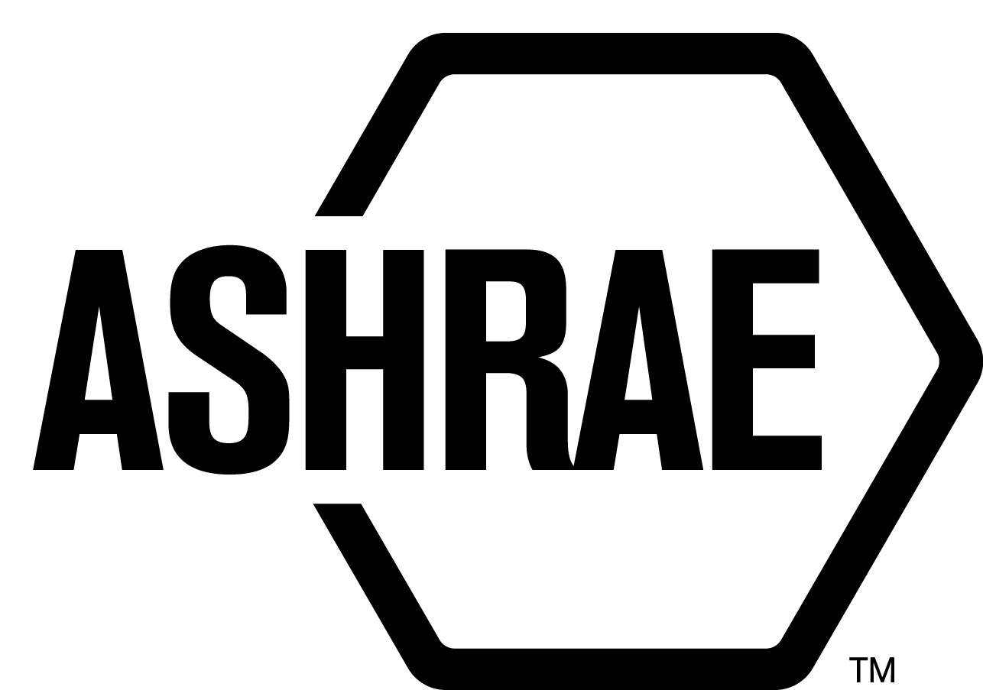

PLANNING, POLICY AND INTERPRETATIONS SUBCOMMITTEE (PPIS)

MINUTES

Sheraton Hotel
Seattle, WA
Meeting of June 27, 2014
and July 1, 2014

NOTE: These draft minutes have not been approved and are the unofficial record by PPIS.

TABLE OF CONTENTS
1. Call to Order/Introductions and Review of Agenda 3
2. Chairman’s Report 3
3. Staff Report 3
4. Approval of Minutes 3
5. Review of Action Items/Unfinished Business 3
6. Planning – New Projects 3
7. Policy – Procedural Changes 4
8. Interpretations 5
9. New Business 5
10. Recess 5
11. Call to Order/Introductions and Review of Agenda 5
12. Chairman’s Report 6
13. Staff Report 6
14. Unfinished Business 6
15. Planning – New Projects 6
16. Policy – Procedural Changes 6
17. Interpretations 6
18. New Business 6
19. Next Meeting 7
20. Adjournment 7

ACTION ITEMS ASSIGNED WINTER MEETING IN NEW YORK, NY
AI# | Action | Assigned To | Status
1 | None An action item was assigned to PPIS and StdC ExCom to determine next steps and actions resulting from the Ad-Hoc Standards Coordination Committee Report. | PPIS/StdC Excom | Closed

1. Call to Order/Introductions and Review of Agenda

Call to Order/Chairman’s Report

The Planning, Policy and Interpretations Subcommittee (PPIS) meeting was called to order on Friday, June 27, 2014, at 2:00 p.m., in Columbia (4 Union Tower).

Introductions

Chairman Doug Reindl greeted members and guests. Introductions were made.

PPIS Members  Doug Reindl, Chair  Joseph Anderson  Dennis Knight  Rick Larson  Cyrus Nasseri | PPIS Members Absent  David Conover  Guests  Dean Saputa  Stephanie Reiniche, MOS | Staff  Tanisha Meyers-Lisle, Procedures Administrator

2. Chairman’s Report
None.

3. Staff Report
None.

4. Approval of Minutes
The PPIS Minutes from the January 17, 2014 Winter Meeting was presented to members for approval.

It was moved by Cyrus Nasseri and seconded by Joseph Anderson:

- That the PPIS Minutes from the Winter Meeting be approved as written.

MOTION 1 PASSED: 5-0-0, CV

5. Review of Action Items/Unfinished Business
5A. Action Items
A list of action items was presented to members for review. An update of the action items is presented on page 2.

6. Planning – New Projects
It was moved by Cyrus Nasseri and seconded by Rick Larson,

2 That the following Title, Purpose and Scope (TPS) be approved as shown,

TITLE: Guidelines for the Application of Upper-Air (Upper Room) Ultraviolet Germicidal (UV-C) Devices to Control the Transmission of Airborne Pathogens

1. PURPOSE:
The purpose of this guideline is to provide information and recommendations for dosing, placement and safe usage of Upper-Air UV-C devices.
2. SCOPE:
2.1 The guideline applies to passive and fan-assisted Upper-Air UV-C devices.
2.2 The guideline applies for proper installation, operating and maintenance procedures for the safe use of these devices.

BACKGROUND: This TPS will also have to be approved by the Board. This TPS was submitted by Dean Saputa for consideration at the Seattle PPIS meeting. PPIS assigned TC 2.9, Ultraviolet Air and Surface Treatment as the cognizant TC. Richard Vincent was recommended as the Chair of the proposed new project committee. There are at least five members willing to volunteer.

MOTION 2 PASSED: 5-0-0, CV

7. Policy – Procedural Changes
It was moved by Dennis Knight and seconded by Cyrus Nasseri,

3 It is recommended that PASA, be approved as shown in Attachment A.

BACKGROUND: ASHRAE completed its ANSI audit in November 2013. As part of the audit, ASHRAE is required to make some modifications to its ANSI approved procedures. These changes reflect those from the ANSI audit. This moved some of the procedures previously in the Project Committee Manual of Procedures into PASA, correcting an error in the Appeals section, adding the Standards Reaffirmation Subcommittee, and a few others that were suggestions from the auditors. The other change includes changing how publication approval is done specifically, only the items with unresolved objectors and/or those where legal action has been threatened will come forward for approval by the Board of Directors. All other publications will be approved by lower bodies and reported to the Board of Director as information items. The ANSI auditors indicated there was too much oversight and approvals for publications. This will also speed up the publication process as well as even out workload on ASHRAE staff. This effort will discontinue the use of the PC MOP once PASA is reaccredited (which is at minimum a 6 month process).

MOTION 6 PASSED: 5-0-0, CV

It was moved by Rick Larson and seconded by Joseph Anderson,

4 That the revisions to PC MOP 6.1.1 PC Shall Develop Working Draft, be approved as shown:

6.1.1 PC Shall Develop Working Draft
The PC shall develop a draft of the proposed or revised standard, guideline or addendum using the approved structure and style for ASHRAE Standards given in the Guide for Writing Standards in Mandatory Language for the normative portions of the standard. For Code-Intended Standards, the normative portions of the draft shall also be written in accordance with the Guide for Writing Code-Intended Standards. The draft should be as complete as possible without unnecessary reference to other SCDs. All guidelines should shall be written in informative language.

BACKGROUND: The proposed changes clarify the requirements for PCs developing working drafts.

MOTION 5 PASSED: 5-0-0, CV

8. Interpretations
None.

9. New Business
None.

10. Recess
PPIS recessed at 11:00 am until Tuesday, July 1, 2014.

11. Call to Order/Introductions and Review of Agenda
The Planning, Policy and Interpretations Subcommittee (PPIS) meeting was called to order on Tuesday, July 1, 2014, at 11:00 a.m., in Alki Boardroom (4 Pike Tower).

Introductions

Chairman Doug Reindl greeted members and guests.

PPIS Members  Doug Reindl, Chair  Joseph Anderson  Dennis Knight  Rick Larson  Cyrus Nasseri | PPIS Members Absent  David Conover  Guests  Eric Berg  Brad Boggess  Rita Harrold  Susan LeBlanc, Standards Administrator  Chris Seeton  Rusty Tharp | Staff  Tanisha Meyers-Lisle, Procedures Administrator

12. Chairman’s Report
None.

13. Staff Report
None.

14. Unfinished Business
None.

15. Planning – New Projects
It was moved by Dennis Knight and seconded by Joseph Anderson,

5

TITLE: Method of Test for Lubricant and Refrigerant Miscibility Determination

1. PURPOSE:
To establish a test procedure to determine the critical solution locus of miscibile properties of a lubricant and refrigerant mixture.

2. SCOPE:
This standard applies to:
2.1. pure component refrigerants and lubricants, and
2.2. multi-component refrigerant and lubricant mixtures.

BACKGROUND: This TPS will also have to be approved by the Board. This TPS was submitted by William “Brad” Boggess for consideration at the Seattle PPIS meeting. PPIS assigned TC 3.4, Lubrication as the cognizant TC. Brad Boggess was recommended as the Chair of the proposed new project committee. There are at least five members willing to volunteer.

MOTION 3 PASSED: 5-0-0, CV

Secretary’s Note: A TPS was submitted by Rusty Tharp but after review, PPIS elected to return it with comments as the changes proposed were substantive and PPIS wanted to ensure the cognizant TC would be ok with the changes. PPIS also suggested adding interest categories and the committee should check with SSPC 15 and bring the TPS into alignment.

16. Policy – Procedural Changes
None.

17. Interpretations
None.

18. New Business
Per the action item, PPIS responded to the recommendation from the Ad-Hoc Standards Coordination Committee Report. See Attachment B.

19. Next Meeting
Tech Weekend
Date TBD

20. Adjournment
PPIS adjourned at 1:00pm.
ATTACHMENT A

ATTACHMENT B

