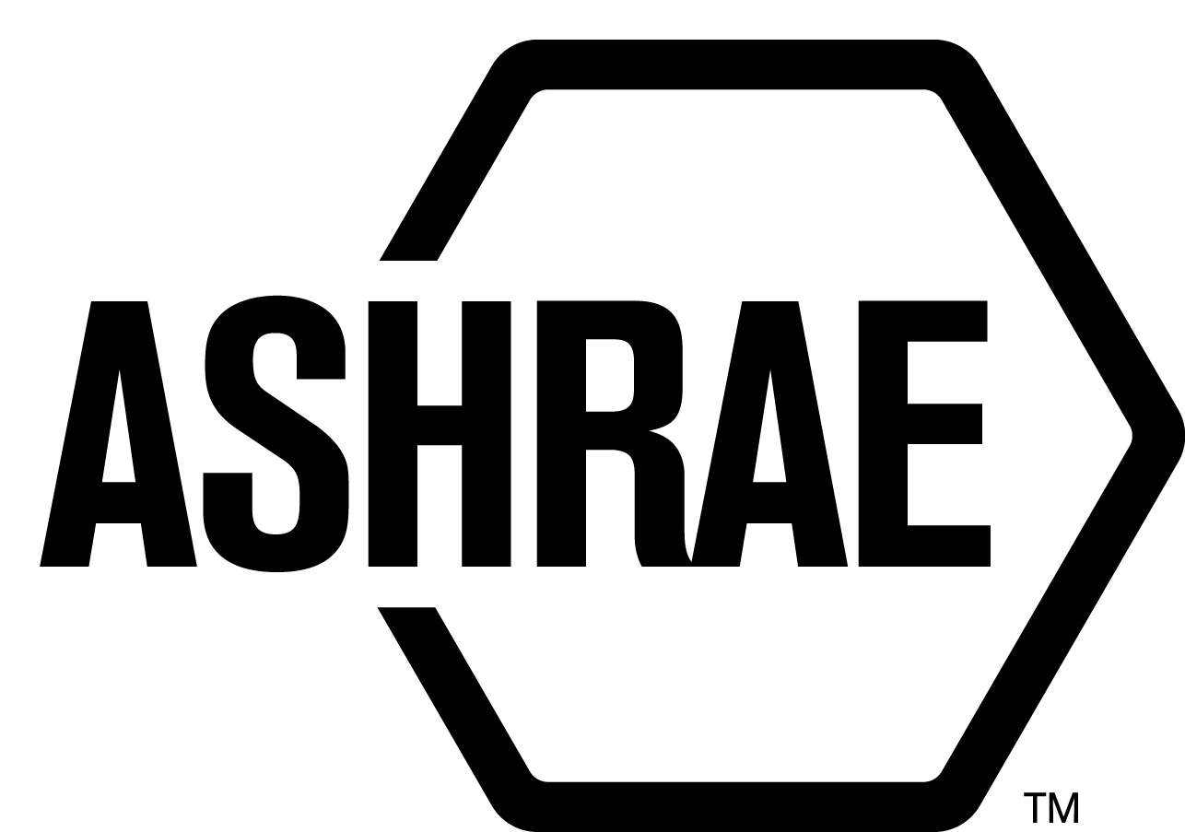

PLANNING, POLICY AND INTERPRETATIONS SUBCOMMITTEE (PPIS)

MINUTES

Fall Meeting 2019
Conference Call
Meeting of September 12, 2019

NOTE: These draft minutes have not been approved and are the unofficial record by PPIS.

TABLE OF CONTENTS
1. Call to Order/Introductions and Review of Agenda 4
2. Chairman’s Report 4
3. Staff Report 4
4. Approval of Minutes 4
5. Review of Action Items/Unfinished Business 4
6. Planning – New Projects 5
7. Policy – Procedural Changes 6
8. Interpretations 10
9. New Business 10
10. Recess 10

ACTION ITEMS ASSIGNED KANSAS CITY, KS 2019
AI# | Action | Assigned To | Status
1 | ASHRAE Policy – Non-voting members and access to work in progress and access to free standards  A question submitted by Craig Wray, asked if the access policy for materially affected guests to have access to work in progress. Currently must contact Ferguson (MOS) for each and every subject under review. In addition, would StdC consider making all published standards free to members by compensating through additional membership fees to cover cost.  Update: Per MOS; Anyone on the roster should have access to any committee working draft. Materially affected parties need to wait for public review. If they want to be involved in drafting, they should apply to be on the committee. Standards committee previously made a request to make all published standards free, or free online. This was deferred to a BOD Ad Hoc that is trying to determine free standards as a membership benefit in January 2018. I have an action item with ILS/ISAS to find out the status, but can report to PPIS. | Staff | CLOSED
2 | Interpretations – Do we need to take action to define if/when interpretations can be submitted during addendum development?  Update: Per MOS: No. Interpretations are to published documents, so there shouldn’t be interpretations to anything in development. | Staff | CLOSED
3 | How to harmonize successive addenda - PPIS member Stanke asked if PPIS could look into having ASHRAE system modified such that a public commenter could be able to view previous addendum (e.g. 1st draft, 2nd draft, etc.) when commenting on a later draft addendum. Also asked that the addendum on the ASHRAE web page could include single line description of the contents of the addendum out for public review (Currently they do not).  Update: Per MOS: The ASHRAE system allows for viewing previous addenda. It does require staff to remember to link documents. If a previous PR draft isn’t linked, this can easily be solved by emailing staff to link the draft. The descriptors cannot be added to the online comment database at this time. We discussed it, and decided to NOT do this because it would make osr.ashrae.org a 30 page long website. The descriptors can be found in Standards Action. It’s also too late because the contractor is not adding functions at this time. If we were to add something, we’d have to wait until the next update (whenever that occurs). | Staff | CLOSED

1. Call to Order/Introductions and Review of Agenda

Call to Order/Chairman’s Report

The Planning, Policy and Interpretations Subcommittee (PPIS) meeting was called to order on Thursday, September 12, 2019, at 11:00 a.m. via teleconference.

Introductions

Chairman Rick Heiden greeted members and guests. Introductions were made.

PPIS Members  Rick Heiden, Chair  Niels Bidstrup  Srinivas Katipamula  Cesar Lim  Steven Sill | PPIS Members Absent  Els Baert  Robert Burkhead  Guests  Supriya Goel  Michael Rosenberg  Michael Sheerin | Staff  Steve Ferguson, S-MOS  Susan LeBlanc, SA  Tanisha Meyers-Lisle, Procedures Administrator

2. Chairman’s Report
Chairman greeted guests and discussed the ASHRAE Code of Ethics.

3. Staff Report
None.

4. Approval of Minutes
The PPIS Minutes from the Annual Meeting 2019 was presented to members for approval.

It was moved by Steven Sill and seconded by Niels Bidstrup:

- That the PPIS Minutes from the Kansas City Annual Meeting 2019 be approved as
written.

MOTION 1 PASSED: 5-0-0, CV

5. Review of Action Items/Unfinished Business
5A. Action Items
A list of action items was presented to members for review. An update of the action items is presented on page 2.

6. Planning – New Projects
It was moved by Steven Sill and seconded by Srinivas Katipamula:

2 That the following Title, Purpose and Scope (TPS) be approved and that SSPC 170 be responsible for developing the Guideline:

TITLE: Operations Guideline for Ventilation of Health Care Facilities
- PURPOSE: The purpose of this guideline is to provide information and guidance for the operation of ventilation systems that provide environmental control in new and existing health care facilities.

- SCOPE:
2.1 This guideline is intended for use by facility operators and those involved in the design, construction, installation, commissioning, management, operation, maintenance, accreditation, inspection, and service of health care facilities. This guideline applies to patient care areas, resident care areas, and related support areas within health care facilities.
2.2 This guideline considers chemical, physical, and biological contaminants that can affect the delivery of medical care to patients and residents, the convalescence of patients and residents, and the safety of patients, residents, health care workers, and visitors.
2.3 This guideline provides guidance for temperature and humidity.
2.4 This guideline provides guidance for odor control and asepsis.
2.5 This guideline provides guidance for ventilation rates including, but not limited to outdoor air, to serve health care facilities.
2.6 This guideline provides guidance for thermal comfort.
BACKGROUND: This TPS will also have to be approved by the Board. This TPS was submitted by Michael Sheerin for consideration at the Fall PPIS meeting. PPIS assigned 9.6, Healthcare as the cognizant committee. SSPC 170 will be responsible for developing the Guideline. Ron Westbrook was recommended as the Chair of the proposed new project committee. There are at least five members willing to volunteer.

MOTION 2 PASSED: 5-0-0, CV

It was moved by Steven Sill and seconded by Srinivas Katipamula:

3 That the following Title, Purpose and Scope (TPS) be approved and that a new Standard Project Committee be formed:

TITLE: Protocols for Evaluating Ruleset Implementation in Building Performance
Modeling Software

- PURPOSE: This standard establishes tests and acceptance criteria for
implementation of rulesets and reporting in building performance modeling
software.

2. SCOPE:
2.1 This standard applies to building performance modeling software that
implements rulesets.

  - This standard applies to rulesets associated with new and existing buildings
and their systems, system controls, their sites, and other aspects of buildings
described by the ruleset implementation being evaluated.

2.3 The standard applies throughout a building’s lifecycle.

BACKGROUND: This TPS will also have to be approved by the Board. This TPS was submitted by Supriya Goel for reconsideration at the Fall PPIS meeting. PPIS assigned TC 4.7, Energy Calculations as the cognizant committee. Supriya Goel was recommended as the Chair of the proposed new project committee. There are at least five members willing to volunteer.

MOTION 3 PASSED: 5-0-0, CV

7. Policy – Procedural Changes
It was moved by Steven Sill and seconded by Srinivas Katipamula:

- That the PC Guide to PASA, Meeting Requests (p.14) be approved as shown below:

- Expediting Funds/Interim Meeting Request – Project Committees can always hold interim meetings between Society Conference meetings. These meetings can be via conference call, web meeting, or face to face meetings. Conference call requests need to be submitted to the MOS at least 14 days in advance of the call and face to face meeting requests need be submitted at least 30 days in advance.

For face to face or interim conference call/web meetings that exceed $500, a form must be submitted to request approval of the meeting. The meetings over $500 need to have additional approvals but Staff approval is generally quick. As indicated on the forms meetings over $500 need justification for the meeting (i.e. accelerated schedule) and need to have additional approvals but Staff approval is generally quick. PC Chairs should submit these forms well in advance to provide staff time to get approval for funding and announce the meetings to interested parties. Face to face meetings are normally held at ASHRAE headquarters unless the cost at a different location is less than or equal to the cost of meetings in Atlanta. Requests for conference call/web meetings under $500 may be submitted via email to the MOS. Conference call requests need to be submitted to the MOS at least 14 days in advance of the call and face to face meeting requests need be submitted at least 30 days in advance. This provides staff time to announce the meetings to interested parties. Face to face meetings are normally held at ASHRAE headquarters unless the cost at a different location is less than or equal to the cost of meetings in Atlanta.

BACKGROUND: The proposed changes to this section offer clarity and offers guidance to members about interim meetings.

MOTION 4 PASSED: 5-0-0, CV

It was moved by Cesar Kim and seconded by Srinivas Katipamula:

- That the PC Guide to PASA, Duplication and Harmonization (p.23) be approved as shown below:

Duplication and Harmonization (PASA 7.6)
SPLS or Standards committee may not approve a SCD for public review or publication if the requirements in Section 5.4 of the ANSI Essential Requirements or Section 7.6 of PASA are not met. When allegations related to duplication and harmonization are made during the development of the SCD, it is recommended that PC Chairs reach out to their SPLS liaison and Staff.
Section 5.4e) of the Essential Requirements states “a declaration that other national standards have been examined with regard to harmonization and duplication of content, and if duplication exists, there is compelling need for the standard”.
Section 7.6e) of PASA states “other known national standards were examined with regard to harmonization and duplication of content, and if duplication exists, there is a compelling need for the standard”
Committees should justify there is a compelling need to duplicate standards, and in particular if there is a lack of harmonization between ASHRAE Standards, and not providing that justification may result in disapproval of the SCD.
Further, if allegations of duplication/lack of harmonization of standards are raised during the development process, Standards Committee will report those objections and the provided compelling need to the ASHRAE Board of Directors if Standards Committee recommends the SCD for publication.

Duplication and Harmonization (PASA 7.6)
SPLS or Standards committee may not approve a standard or guideline document for public review or publication if the requirements of Section 5.4, Requirements of the ANSI Essential Requirements or Section 7.6, Criteria for Approval of PASA, specifically, items 7.6d, (conflict) and 7.6e (duplication), are not met. As part of the development process, PCs should avoid conflict with other ASHRAE or American National Standards.

Refer to PASA Annex A1, Definitions for the formal definition of a conflict between standards, but in general a conflict exists when a practitioner cannot comply with both standards.
- For example, if the maximum flow specified in one standard is less than the
minimum flow specified in the related standard, there is a conflict.
- In another example, the maximum flow specified in one standard is higher than the maximum flow specified in the related standard; while this is inconsistent a by specifying a flow at the lesser of the two maximum flows.

To address policy requirements pertaining to harmonization and duplication during the standards development process, PC’s are expected to:
- examine other known standards for conflicts and keep records of evaluations (PASA 7.6e, ANSI ER 5.4e)
- pursue findings and/or allegations of duplication or lack of harmonization
- notify the SPLS liaison and Staff if allegations related to duplication and harmonization are made,
- exercise and document good faith efforts to resolve allegations and findings (e.g. ad hoc committees, working groups, meetings with objectors, etc.) (ANSI ER 2.4)
- where duplication is deemed necessary, formally document the compelling need for the standard (PASA 7.6)
- provide above documentation to SPLS and Standards Committee along with requests for standards or guideline approvals

Again, PC’s should strive to avoid conflicts in the development of standards and guidelines. However, if the PC chooses to make a case for duplication or lack of harmonization, SPLS and Standards Committee will base recommendations for approval on the PC’s good faith attempts to resolve conflicts and the PCs case for compelling need. If Standards Committee recommends the standard or guideline for publication, Standards Committee will also report objections and the provided compelling need to the ASHRAE Board of Directors for their consideration as well.

BACKGROUND: The proposed section has been updated to offer more clarity between conflict, duplication and harmonization and to set expectations for PCs consideration of such matters.

MOTION 5 PASSED: 5-0-0, CV

It was moved by Cesar Kim and seconded by Srinivas Katipamula:

- That new sections be added to the PC Guide to PASA, Role of Subcommittees (PASA 4.3.4) and PC Guide to PASA, Role of Ad Hoc Working Groups, and PC Guide to PASA, Balance (p.11), PC Guide to PASA, Meetings (p.14) and PC Guide to PASA, Voting (p.17) be approved as shown below:

Role of Subcommittees (PASA 4.3.4)
If used, Subcommittees are formed by the PC Chair. The Subcommittee is typically responsible for tasks agreed upon by the Project Committee. This can include managing addenda, appendices and comment responses related to the development of the standard or guideline. Or in cases where an SSPC manages multiple documents, a Subcommittee may be responsible for a complete standard or guideline. All Subcommittee actions related to the standard or guideline need to be submitted as recommendations for action by the Project Committee. The PC chair appoints the subcommittee members from the PC membership and the Subcommittee Chair and members must be approved by SPLS.

Role of Ad Hoc Working Groups
If used, ad hoc Working Groups are formed by the PC Chair. A Working Group is typically tasked with relatively short duration assignments. For example, Working Groups could be asked to study how a specific technology or regulatory trend may influence the standard or guideline, or may be asked to attempt to work with a few individuals to develop a consensus proposal to a committee. In another example, the Working Group may be tasked with researching a given public review comment. The Working Group reports its findings back to the PC chair. The PC Chair invites volunteers from the PC membership to form the Working Group and typically appoints an individual to coordinate the Working Group activity. It’s recommended that the PC Chair or his/her designee maintain a list of tasks assigned to Working Groups and publish that information on their meeting agenda.

PC Guide to PASA, Balance (Seee PASA 7.4.3) (p11)
ASHRAE’s requirements for balance on SPCs and SSPCs flow from ANSI’s “due process criteria.” The ANSI Essential Requirements: Due process requirements for American National Standards states, “The standards development process should have a balance of interests. Participants from diverse interest categories shall be sought with the objective of achieving balance.” The criteria for balance are that a) no single interest category constitutes more than one-third of the membership of a consensus body dealing with safety, and b) no single interest category constitutes a majority of the membership of a consensus body dealing with all other standards. Although not required to, Subcommittees are encouraged to maintain balance. Motions made to the PC by unbalanced Subcommittees may result in more deliberation.

PC Guide to PASA, MEETINGS (See PASA 7.4.1) (p14)
All meetings in ASHRAE are open, on a space-available basis, to observation by directly and materially interested parties. PCs normally meet a minimum of twice each year at the Society meetings. This also includes subcommittee and working group meetings. ASHRAE staff is responsible for publicly announcing meetings at the request of the PC Chair. PC Chairs are also encouraged to announce meetings to the entire PC membership. Participation in the meeting is by permission of the Chair. While all meetings are open, the Chair may limit discussions to members of the PC, may limit the length of presentations, etc. It is advisable to allow materially affected and interested parties attending the meetings to participate but there may be instances where this is not possible. Participation by materially affected and interested parties can be met by submitting a public comment.

PC Guide to PASA, VOTING (See PASA 7.2.4, 7.5, 7.2.5, and 7.2.6) (p17)
In order to take any type of vote the PC Chair needs to determine if quorum has been met. Quorum is met when more than 50% of the PCVMs are at the meeting. PASA voting requirements depend on the motion types. Standards has prepared the PC Chairs Training Getting Started- An Overview of Standards Writing to assist PC Chairs in determining the types of motions. The motion types include the following;

- Standards Actions – this includes votes for publication public review and publication with knowledge of unresolved objectors (commenters/negative PC voters). Standards Action votes can only occur in meetings that have been properly announced. can only occur at meetings that have been announced. Standards Actions require that all voting members, present or absent, be given the opportunity to vote, and the opportunity to change their vote in the event of a recirculation letter ballot. A written response to negative voters on a letter ballot needs to be provided, advising them of the disposition of the objection and the reason(s) why. (See Appendix 5 for guidance on this topic) Chairs need to return a ballot indicating whether or not their vote is a yes, no or abstention vote or the ballot will be recorded as not returned. Chair not voting is not an option for standards actions motions. Approval of these motions requires:

  - A majority of the voting membership, excluding abstentions, voting in the affirmative, and
  - Two-thirds of those voting, excluding abstentions, voting in the affirmative.

See the Voting Calculation Tool for Standards Actions for guidance on tallying votes.

- Non- Standards Actions votes – this includes TPS changes not part of a public review draft, approval of work plans, straw-man votes on draft language, user manual requests, responses to continuous maintenance proposals, responses to reviewer comments etc. These do not require that all voting members be given the opportunity to vote. For these matters, approval requires affirmative votes by a simple majority of PCVMs present.

Generally, a Chair does not vote (abstains) unless voting changes the outcome of the ballot. If the Chair does not submit a ballot in letter ballots the vote will be recorded as unreturned. The Voting Calculation Tools for Standards Actions, referenced above, is a valuable resource in determining numerically if the motion is approved.

BACKGROUND: Currently there is a limited amount of guidance on the formation and management of working groups and subcommittees. This leaves concern for allegations of non-compliance with PASA and in general, lack of direction for how those groups should operate and manage themselves. This proposed revision is intended to provide some guidance to address those concerns.

As further background, previously ANSI issued a formal interpretation on this issue which should be used to guide a limited amount of changes to the PC guide. No changes are planned to PASA. The intent is to provide expanded guidance for what subcommittees and working groups can do and what they can’t do without crossing the line noted in the interpretation. Edits address; Membership, Balance, Openness and Voting Actions

MOTION 6 PASSED: 5-0-0, CV

8. Interpretations
None.

9. New Business
The Chair and Staff will recommend a new section to the PC Guide to PASA – Periodic Maintenance. A letter ballot will be issued at a later date for approval.

10. Recess
PPIS adjourned at 12:58 pm.

