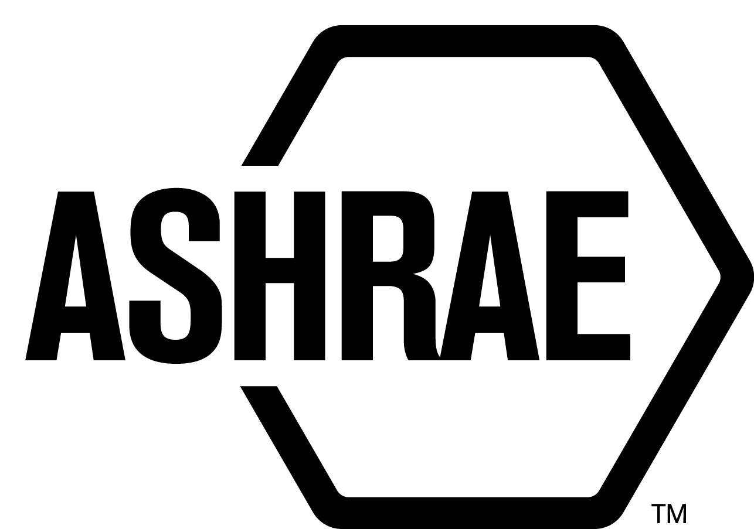

PLANNING, POLICY AND INTERPRETATIONS SUBCOMMITTEE (PPIS)

MINUTES

Conference Call
Meeting of November 28, 2018

NOTE: These draft minutes have not been approved and are the unofficial record by PPIS.

TABLE OF CONTENTS
1. Call to Order/Introductions and Review of Agenda 3
2. Chairman’s Report 3
3. Staff Report 3
4. Approval of Minutes 3
5. Review of Action Items/Unfinished Business 3
6. Planning – New Projects 4
7. Policy – Procedural Changes 4
8. New Business 6
9. Recess 6

ACTION ITEMS ASSIGNED HOUSTON 2018
AI# | Action | Assigned To | Status
1 | New from Standards Committee 6/23/18:  Review letter ballot procedures in regards to 62.1 addendum c. Improve language in the PC Chairs Guide.  An action item to PPIS and Staff to provide language to PC Guide regarding mandatory language waivers. | PPIS and Staff | Ongoing – Submit draft by December 20, 2018
ACTION ITEMS ASSIGNED NOVEMBER 28, 2018 CONFERENCE CALL
AI# | Action | Assigned To | Status
2 | Staff to provide PASA changes as a result of preliminary ANSI audit findings prior to December 20, 2018. | Staff | Open
3 | Dennis Stanke and Steve Ferguson to provide recommendations on ISC’s for CM documents by December 20, 2018. | Steve Ferguson and Dennis Stanke | Open
4 | Mr. Grondzik to review the comments provided by PPIS and re-submit a revised TPS for the passive house proposal. Revised proposal due on or prior to December 27, 2018. | Walter Grondzik | Open

1. Call to Order/Introductions and Review of Agenda

Call to Order/Chairman’s Report

The Planning, Policy and Interpretations Subcommittee (PPIS) meeting was called to order on Wednesday, November 28, 2018, at 11:00 a.m. via teleconference.

Introductions

Chairman Jonathan Humble greeted members and guests. Introductions were made.

PPIS Members  Jonathan Humble, Chair  Els Baert  Niels Bidstrup  Robert Burkhead  Rick Heiden  Dennis Stanke | PPIS Members Absent  Roger Hedrick  Guests  Walter Grondzik | Staff  Steve Ferguson, S-MOS

2. Chairman’s Report
Chairman reminded members of the ASHRAE Code of Ethics Commitment and the Sherman Anti-Trust Act.

3. Staff Report
Steve Ferguson will provide PASA changes as a result of preliminary ANSI Audit Findings prior to December 20, 2018. There is no urgency to respond to all ANSI findings in January.

4. Approval of Minutes
The PPIS Minutes from the Annual Meeting 2018 was presented to members for approval.

It was moved by Niels Bidstrup and seconded by Rick Heiden:

- That the PPIS Minutes from the Tech Weekend 2018 be approved as amended.

MOTION 1 PASSED: 4-0-2-1, CV
Secretary’s Notes: Roger Hedrick was not present for this vote. Dennis Stanke and Els Baert abstained as they were not present on the call.

5. Review of Action Items/Unfinished Business
5A. Action Items
A list of action items was presented to members for review. An update of the action items is presented on page 2.

6. Planning – New Projects
TITLE: Passive Building Design Standard

PURPOSE: This standard provides requirements for the design of buildings that will achieve low energy consumption in accordance with climate-specific building performance targets. The requirements in this standard are expected to result in buildings with low values for peak and annual heating load, peak and annual cooling load, annual source energy consumption, and infiltration.

SCOPE:
2.1 This standard applies to all buildings intended for human occupancy including
dwelling units; including new and existing buildings.

2.2 This standard does not apply to:
equipment or building systems that are inherent to industrial or manufacturing
processes.

2.3 This standard provides requirements for the design and construction of the:
building envelope, heating and cooling equipment and systems, ventilation
systems, service hot water systems, interior and exterior lighting systems, and
plug, appliance, and other process loads.

2.4 This standard does not provide requirements for the operation, maintenance,
and use of buildings.

2.5 This standard shall not be used to circumvent any safety, health, or
environmental requirements.

BACKGROUND/DISCUSSION: This TPS will also have to be approved by the Board. This TPS was submitted by Walter Grondzik for consideration at the PPIS November 28, 2018 conference call. Mr. Grondzik is seeking opportunities for collaboration/coordination between ASHRAE and PHIUS. He believes there is a substantial gap in the outcomes between 90.1 and 90.1. He doesn’t believe there is much scope overlap. This standard would be used as another tool in the residential market. It would give ASHRAE a tool that may be closer to carbon neutral buildings. PPIS members have a concern for overlap and would like the TPS to be specific and clear. An action item was assigned to Walter to provide a revised TPS on or prior to December 27, 2018.

7. Policy – Procedural Changes
It is recommended that the PC Guide to PASA (p.12), Removal for Cause be approved as shown below:

Removal for Cause (See PASA 4.3.8 and PASA 4.3.9)
A sample letter for removal for cause can be found here: Sample Letter of Intent to Recommend Removal for Cause.

When a project committee member has not been participating in meetings or responding to letter ballots a PC Chair may recommend (with justification) that the member be removed from the PC roster. (See PASA 4.3.8) While understanding that things come up, members should inform the chair of conflicts or other difficulties. SPLS may also recommend removal for cause of members as well. (See PASA 4.3.9)

- Examples of Justification for Chairs:
  - Member hasn’t attended 50% of scheduled PC meetings in 12 months
  - Member hasn’t responded to 60% of the letter ballots in 12 months.
- Examples of Justifications for SPLS:
  - Same as those listed in A above;
  - Failure to disclose conflicts of interest; or
  - Violating ASHRAE’s Code of Ethics

A PC Chair may recommend removal of a PC member from the roster for due cause based on a member’s failure to actively participate in PC proceedings or meet PC responsibilities.

Prior to submitting a recommendation for removal to the SPLS Liaison and MOS, the PC Chair must notify the PC member in writing of his/her intent to recommend removal for cause and the reasons why (see example letter of intent below). An offer to the member to resign from the PC rather than be removed for cause is highly recommended.

The recommendation for removal is submitted to the SPLS Liaison and MOS via the PC Chair’s Membership Recommendation Form. The PC Chair shall complete the Removal of Member section of the PC Chair’s Membership Recommendation Form, and include documentation of the PC Chair’s communication to the member, his/her response, and written justification for the recommendation (e.g., copy of meeting minutes noting absences, letter ballot vote counts noting unreturned ballots, etc.). The recommendation will be acted on by SPLS.

BACKGROUND: There’s no requirement in the procedure that places the responsibility on the chair to provide/procure justification for removing PC members for cause. PC Chairs Guide to PASA simply refers to a sample letter, and a chair may recommend removal. Currently, some PC Chairs are expecting ASRHAE membership staff to procure the justification. The lead in information in the sample letter states “the PC Chair must notify the PC member in writing of his/her intent to recommend removal for cause and the reasons why”, then outlines the removal process. It has good guidance information for the PC Guide to PASA, but requirements/guidance/recommendations are buried in a sample letter (not in procedure). This proposed change moves the requirement in the sample letter to the procedures.

Steve Ferguson to modify the proposal to account for Proposed PASA changes by December 20, 2018.

8. New Business
ISCs for Standards on CM. Do we want to eliminate ISCs for CM documents? If there’s a string of PPR’s with ISC’s should the previous changes be available?

Action Item assigned to Dennis and Steve, report on finings and provide recommendations on ISCs for CM documents by December 20, 2018.

9. Recess
PPIS adjourned at 1:00 pm.
Next meeting will be in Atlanta, Omni Hotel at CNN Center.
January 11, 2019 2:00pm-6:00pm (North Tower, Willow Room)
January 15, 2019 11:00am-2:00pm (North Tower, Magnolia Room)

