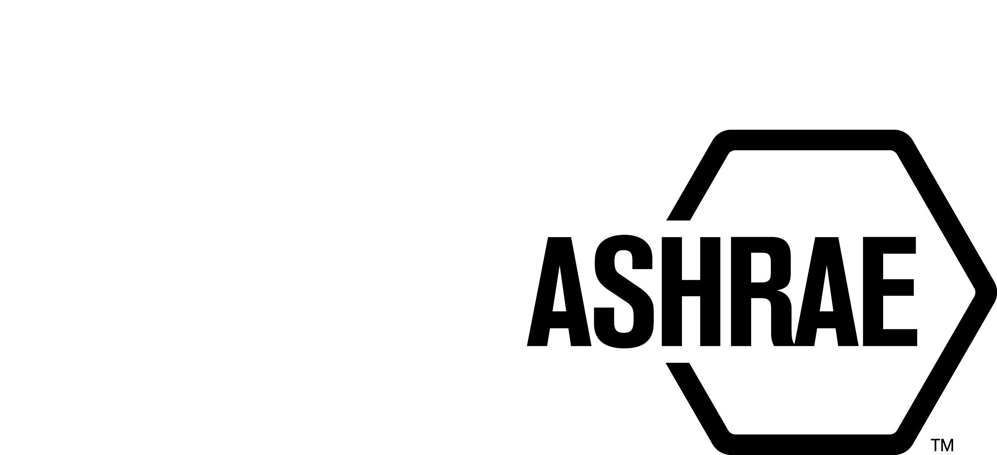

PLANNING, POLICY AND INTERPRETATIONS SUBCOMMITTEE (PPIS)

MINUTES

Conference Call
Meeting of April 19, 2016

NOTE: These draft minutes have not been approved and are the unofficial record by PPIS.

TABLE OF CONTENTS
1. Call to Order/Introductions and Review of Agenda 3
2. Chairman’s Report 3
3. Staff Report 3
4. Approval of Minutes 3
5. Review of Action Items/Unfinished Business 3
6. Planning – New Projects 4
7. Policy – Procedural Changes 4
8. Interpretations 4
9. New Business 5
10. Adjournment 5

ACTION ITEMS ASSIGNED
AI# | Action | Assigned To | Status
None

1. Call to Order/Introductions and Review of Agenda

Call to Order/Chairman’s Report

The Planning, Policy and Interpretations Subcommittee (PPIS) meeting was called to order on Tuesday, April 19, 2016, at 11:00 a.m.

Introductions

Chairman Steven Emmerich greeted members and guests. Introductions were made.

PPIS Members  Steven Emmerich, Chair  James Aswegan  Walter Grondzik  Rick Larson  Dennis Stanke | PPIS Members Absent  Guests  Susan Leblanc, Standards Administrator  Stephanie Reiniche, Sr. MOS  Mark Weber, Manager of Standards - American | Staff  Tanisha Meyers-Lisle, Procedures Administrator

2. Chairman’s Report
None.

3. Staff Report
None.

4. Approval of Minutes
The PPIS Minutes from the Orlando Winter Meeting 2016 was presented to members for approval.

It was moved by Dennis Stanke and seconded by Walter Grondzik:

- That the PPIS Minutes from the Orlando Winter Meeting 2016 be approved as written.

MOTION 1 PASSED: 4-0-0 CNV

5. Review of Action Items/Unfinished Business
5A. Action Items
A list of action items was presented to members for review. An update of the action items is presented on page 2.

6. Planning – New Projects
It was moved by Walter Grondzik and seconded by Dennis Stanke that the following Title, Purpose and Scope (TPS) be approved and that SSPC 62.1 be the cognizant PC.

2 TITLE: Indoor Air Quality in Commercial and Institutional Buildings

1. PURPOSE:
The purpose of this guideline is to recommend measures that exceed minimum requirements for improving indoor air quality in commercial and institutional buildings. These measures are intended to provide enhanced indoor air quality that is acceptable to human occupants and that minimizes adverse health effects.

2. SCOPE:
2.1 This guideline applies to spaces intended for human occupancy within commercial and institutional buildings except those within dwelling units in residential occupancies in which occupants are non-transient.

2.2 This guideline provides recommendations related to certain sources, and for ventilation and air-cleaning-system design, installation, commissioning, and operation and maintenance.

BACKGROUND: This TPS will also have to be approved by the Board. This TPS was submitted by Hoy Bohannon for consideration on the Spring PPIS conference call. PPIS assigned TC 4.3, Ventilation Requirements and Infiltration. Jennifer Isenbeck was recommended as the Chair of the proposed new project committee. There are at least five members willing to volunteer. SSPC 62.1 is supportive of this guideline.

PPIS discussed possibly revising the existing IAQ Guide (developed by Special Projects) in lieu of developing a new guideline. After speaking with Lilas Pratt (Special Projects Manager) she was not in favor of this and suggested we continue with forming a new guideline. The IAQ guide is lengthy (500 pages) and serves as a valuable educational resource.

MOTION 2 PASSED: 4-0-0, CNV

7. Policy – Procedural Changes
- PPIS has offered feedback to the PC Guide developed by Staff. The next steps will be to receive feedback from SPLS. PPIS hopes to have a completed draft for Standards Committee to review, in time for the annual meeting in St. Louis.

8. Interpretations

9. New Business
None.

10. Adjournment
PPIS adjourned at 12:00 pm.

The Planning, Policy and Interpretations Subcommittee (PPIS) meeting was called to order on Tuesday, January 26, 2016 at 11:00 a.m., in Lake Louise B (L).

Introductions

Chairman Rita Harrold greeted members and guests.

PPIS Members  Steven Emmerich, Chair  James Aswegan  Rick Larson  Dennis Stanke | PPIS Members Absent  Walter Grondzik  Guests  Brian Bogdan  Paul Doppel | Staff  Tanisha Meyers-Lisle, Procedures Administrator

