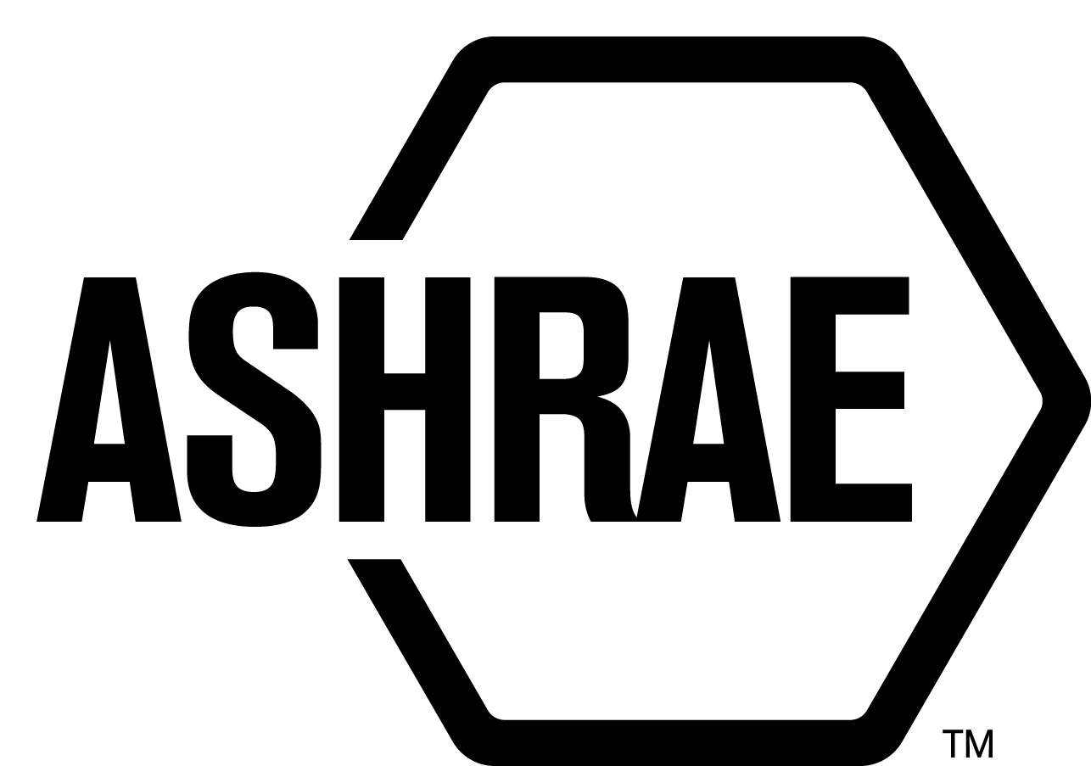

PLANNING, POLICY AND INTERPRETATIONS SUBCOMMITTEE (PPIS)

MINUTES

Conference Call
Meeting of March 14, 2019

NOTE: These draft minutes have not been approved and are the unofficial record by PPIS.

TABLE OF CONTENTS
1. Call to Order/Introductions and Review of Agenda 3
2. Chairman’s Report 3
3. Staff Report 3
4. Approval of Minutes 3
5. Review of Action Items/Unfinished Business 3
6. Planning – New Projects 4
7. Policy – Procedural Changes 4
8. Interpretations 5
9. New Business 5
10. Adjournment 5

ACTION ITEMS ASSIGNED SPRING CONFERENCE CALL 2019
AI# | Action | Assigned To | Status
1 | Review the use of the term SCD. Is the definition correct in the Rules of the Board? | Steve Ferguson | Open
2 | StdC MOP section 1.6.1, should we lessen the requirements; make it affirmative votes by the membership if by letter ballot, or affirmative votes of voting membership at a meeting with a quorum? | Steve Ferguson and Jonathan Humble | Open

1. Call to Order/Introductions and Review of Agenda

Call to Order/Chairman’s Report

The Planning, Policy and Interpretations Subcommittee (PPIS) meeting was called to order on Thursday, March 14, 2019, at 12:00 p.m.

Introductions

Chairman Jonathan Humble greeted members and guests. Introductions were made.

PPIS Members  Jonathan Humble, Chair  Els Baert  Niels Bidstrup  Bob Burkhead  Roger Hedrick  Michael Woodford | PPIS Members Absent  Rick Heiden  Dennis Stanke  Guests  Larry Smith | Staff  Steve Ferguson, Sr. MOS  Tanisha Meyers-Lisle, Procedures Administrator

2. Chairman’s Report
None.

3. Staff Report
None.

4. Approval of Minutes
The PPIS Minutes from the Atlanta Winter Meeting 2019 was presented to members for approval.

It was moved by Roger Hedrick and seconded by Niels Bidstrup:

- That the PPIS Minutes from the Atlanta Winter Meeting 2019 be approved as written.

MOTION 1 PASSED: 3-0-2, CNV
Secretary’s Note: Niels Bidstrup and Els Baert abstained as they were not at the meeting.

5. Review of Action Items/Unfinished Business
5A. Action Items
A list of action items was presented to members for review. An update of the action items is presented on page 2.

6. Planning – New Projects
A new Guideline proposal was submitted from Mr. Larry Smith for PPIS review and it was determined that additional work is needed. Mr. Smith will work with the PPIS Chair to edit the proposal and bring it forward at the next PPIS meeting.

7. Policy – Procedural Changes
2 It was moved by Roger Hedrick and seconded by Niels Bidstrup:

That Procedures for ASHRAE Standards Actions (PASA) Section 4, Approval of Proposed Standards, Section 7, Criteria for Approval, Withdrawal and Discontinuance of ASHRAE Standards, A1 Definitions, Annex B: Appeals of Board of Directors; Standards Actions or Inactions and Annex E: Procedures – Emergency Interim Standards Action, be approved as shown in Attachment A.

BACKGROUND: The problem identified for this proposal is that PASA’s current language is not clear how Guide Project Committees (GPC’s) and Standing Guide Project Committees (SGPC’s) should operate. The purpose of this submission proposes to update the ANSI/PASA by including language in appropriate locations in the PASA that allows the users to more readily identify and comply with the necessary procedures for GPC’s and SGPC’s. In addition, grammatical modifications were made to be consistent with terminology and grammatical tense within the section.

VOTE: 5-0-0, CNV
(Secretary’s note: Rick Heiden and Dennis Stanke were absent.)

3 It was moved by Els Baert and seconded by Mike Woodford:

That Procedures for ASHRAE Standards Action (PASA) 7.2.7, Negative Votes on Letter Ballots of PCs and Project Subcommittees, and PC Guide to PASA (p.18), Recirculation Ballot, be approved as shown in Attachment B.

BACKGROUND: This proposed change to both the ANSI/PASA and the PC-Guide to PASA is designed to take commentary from the PASA and install it into the PC-Guide to PASA. The subject is Section 7.2.7 Negative Votes on Letter Ballots of PCs and Project Subcommittees time frames to reaffirm their votes or change their votes or to the vote during a reconsideration period. The PC Guide to PASA change is contingent on final approval of the PASA Change by ANSI.

VOTE: 5-0-0, CNV
(Secretary’s note: Rick Heiden and Dennis Stanke were absent.)

4 It was moved by Mike Woodford and seconded by Bob Burkhead:

That Procedures for ASHRAE Standards Action (PASA) 4.2.2.6 Standards Reaffirmation Subcommittee (SRS), PASA 7.2.4.2, Numerical Requirements for Standards Action Votes, PASA 7.4.3, Balance and Interest Categories, PASA, Definitions be approved as shown in Attachment C.

BACKGROUND: PPIS was assigned the task to review the term “consensus body” in PASA. PPIS found the term “consensus body” and “project committee” is used interchangeably; the term is not used consistently, and neither “consensus body” or “project committee” are defined in PASA. The proposed changes provide a resolution to the issue.

The PC Guide to PASA change is contingent on final approval of the PASA Change by ANSI.

VOTE: 5-0-0, CNV
(Secretary’s note: Rick Heiden and Dennis Stanke were absent.)

5 It was moved by Roger Hedrick and seconded by Niels Bidstrup:

That Procedures for ASHRAE Standards Action (PASA) 4.2.2.6, Standards Reaffirmation Subcommittee (SRS), and Standards Committee Manual of Procedures, 6.2.6.1, Standards Reaffirmation Subcommittee Membership, and Standards Committee Reference Manual 13, Standards Reaffirmation Subcommittee, be approved as shown in Attachment D.

BACKGROUND: Current practice for SRS membership approval stops at the Standards Committee Chair. The proposed changes would reconcile this change across all Standards Committee documents.

The Standards Committee MOP and Standards Committee Reference Manual change is contingent on final approval of the PASA Change by ANSI.

VOTE: 5-0-0, CNV
(Secretary’s note: Rick Heiden and Dennis Stanke were absent.)

8. Interpretations
None.

9. New Business
None.

10. Adjournment
PPIS adjourned at 2:00 pm.

ATTACHMENT A

ATTACHMENT B

ATTACHMENT C

ATTACHMENT D

