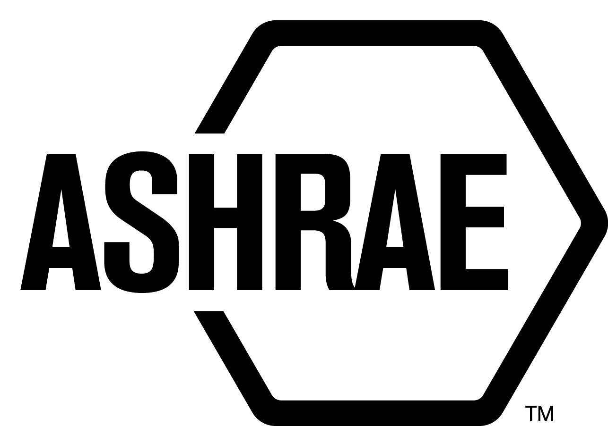

PLANNING, POLICY AND INTERPRETATIONS SUBCOMMITTEE (PPIS)

MINUTES

Conference Call
Meeting of May 29, 2019

NOTE: These draft minutes have not been approved and are the unofficial record by PPIS.

TABLE OF CONTENTS
1. Call to Order/Introductions and Review of Agenda 3
2. Chairman’s Report 3
3. Staff Report 3
4. Approval of Minutes 3
5. Review of Action Items/Unfinished Business 3
6. Planning – New Projects 4
7. Policy – Procedural Changes 4
8. Interpretations 4
9. New Business 4
10. Adjournment 6

ACTION ITEMS ASSIGNED MAY 29, 2019 CONFERENCE CALL
AI# | Action | Assigned To | Status
1 | StdC MOP section 1.6.1, should we lessen the requirements; make it affirmative votes by the membership if by letter ballot, or affirmative votes of voting membership at a meeting with a quorum?  5.29.19 – Susan has concerns with “unless otherwise stated…” this statement appears to be broad and does not address the voting requirements for Standards Actions by SRS nor official interpretations by PPIS. | Steve Ferguson, Jonathan Humble and Susan LeBlanc | Open
2 | Send rejected comments to Chair of newly formed SPC TPS 228. | Staff | Open

1. Call to Order/Introductions and Review of Agenda

Call to Order/Chairman’s Report

The Planning, Policy and Interpretations Subcommittee (PPIS) meeting was called to order on Wednesday, May 29, 2019, at 11:00 a.m.

Introductions

Chairman Jonathan Humble greeted members and guests. Introductions were made.

PPIS Members  Jonathan Humble, Chair  Niels Bidstrup  Bob Burkhead  Roger Hedrick  Rick Heiden  Michael Woodford | PPIS Members Absent  Els Baert  Guests | Staff  Susan LeBlanc, Standards Administrator  Tanisha Meyers-Lisle, Procedures Administrator

2. Chairman’s Report
Mr. Humble has been reassigned as chair of the Code Interaction Subcommittee which will be effective July 1, 2019.

3. Staff Report
Mr. Rick Heiden will be assuming the role of the Planned, Policy, Interpretations Subcommittee Chair effective July 1, 2019.

4. Approval of Minutes
The PPIS Minutes from the March 14, 2019 conference call was presented to members for approval.

It was moved by Dennis Stanke and seconded by Rick Heiden:

- That the PPIS Minutes from the March 14, 2019 conference call be approved as written.

MOTION 1 PASSED: 5-0-0, CV
Secretary’s Note: Els Baert and Mike Woodford were not on the call at the time the vote was taken.

5. Review of Action Items/Unfinished Business
5A. Action Items
A list of action items was presented to members for review. An update of the action items is presented on page 2.

6. Planning – New Projects
The previous Guideline proposal submitted by Mr. Larry Smith for PPIS review was withdrawn based on an email dated 5/30/3019.

7. Policy – Procedural Changes
2 It was moved by Roger Hedrick and seconded by Dennis Stanke:

That Procedures for ASHRAE Standards Actions (PASA) and the PC Guide to PASA, be approved as shown in Attachment A.

BACKGROUND: This term “standards document” and “SD” is used in such a way as to be in some cased confusing. The ASHRAE Board of Directors created a rule that states:
“Rule 1.201.004.4 There are four types of Standards Committee documents:
A. Standards
B. Guidelines
C. User Manuals
D. Code Change Proposals”
In view of the differences between the use of the term and acronym PPIS recommends the following modifications for clarity in PASA and the PC Guide to PASA.

VOTE: 5-0-0, CNV
(Secretary’s note: Els Baert was absent.)

8. Interpretations
None.

9. New Business
PPIS has received comments to TPS 227 and TPS 228. TPS deferred review of comments for TPS 227 until the Kansas 2019 Annual Meeting. PPIS reviewed the public comments to TPS 228.

- It was moved by Dennis Stanke and seconded by Bob Burkhead:

That PPIS accept with minor changes Comment #1 (add “net”); add hyphen between “net-zero”.

MOTION 3 VOTE: 6-0-0, CV

- It was moved by Rick Heiden and seconded by Dennis Stanke:

That PPIS reject Comment #2.

Reason: Rejected. Thank you for taking the time to provide your comments. We do not agree that the language should be removed in order that the SPC is permitted to provide requirements for those conditions. While we are sensitive to possible "gaming" we do not believe that this can be enforced at the scoping level, but rather will trust the SPC appointed members will address this subject when developing the technical requirements of this new standard.

MOTION 4 VOTE: 6-0-0, CV

- It was moved by Rick Heiden and seconded by Niels Bidstrup:

That PPIS accept Comment 3 with minor changes. Strike “or methodologies”, and ignore “net” as that was covered by comment 001.

MOTION 5 VOTE: 6-0-0, CV

- It was moved by Rick Heiden and seconded by Dennis Stanke:

That PPIS reject Comment #4.

Reason: Rejected. Thank you for taking the time to provide your comments. This is a technical issue and not a scoping issue. Also, the laundry list of examples is not all inclusive and therefore will be problematic for SPC and users of the document. Preference is to retain the current language as the broad terms can be all inclusive.

MOTION 6 VOTE: 6-0-0, CV

- It was moved by Rick Heiden and seconded by Dennis Stanke:

That PPIS reject Comment #5.

Reason: Rejected. Thank you for taking the time to provide your comments. This is a comment that is technical in nature and not a scoping comment. Preference is to send this comment to the new SPC to determine how the technical language can be addressed in the new standard.

MOTION 7 VOTE: 5-0-0, CV

- It was moved by Rick Heiden and seconded by Dennis Stanke:

That PPIS reject Comment #6.

Reason: Rejected. Thank you for taking the time to provide your comments. This is a comment that is technical in nature and not a scoping comment. Preference is to send this comment to the new SPC to determine how the technical language can be addressed in the new standard.

MOTION 8 VOTE: 5-0-0, CV

- It was moved by Dennis Stanke and seconded by Michael Woodford:

That PPIS reject Comment #7.

Reason: Rejected. Thank you for taking the time to provide your comments. This is a comment that is technical in nature and not a scoping comment. Preference is to send this comment to the new SPC to determine how the technical language can be addressed in the new standard.

MOTION 9 VOTE: 5-0-0, CV

All rejected comments shall be sent to the newly formed SPC to address Mr. Rosenstock’s concerns.

10. Adjournment
PPIS adjourned at 12:50 pm.

ATTACHMENT A

