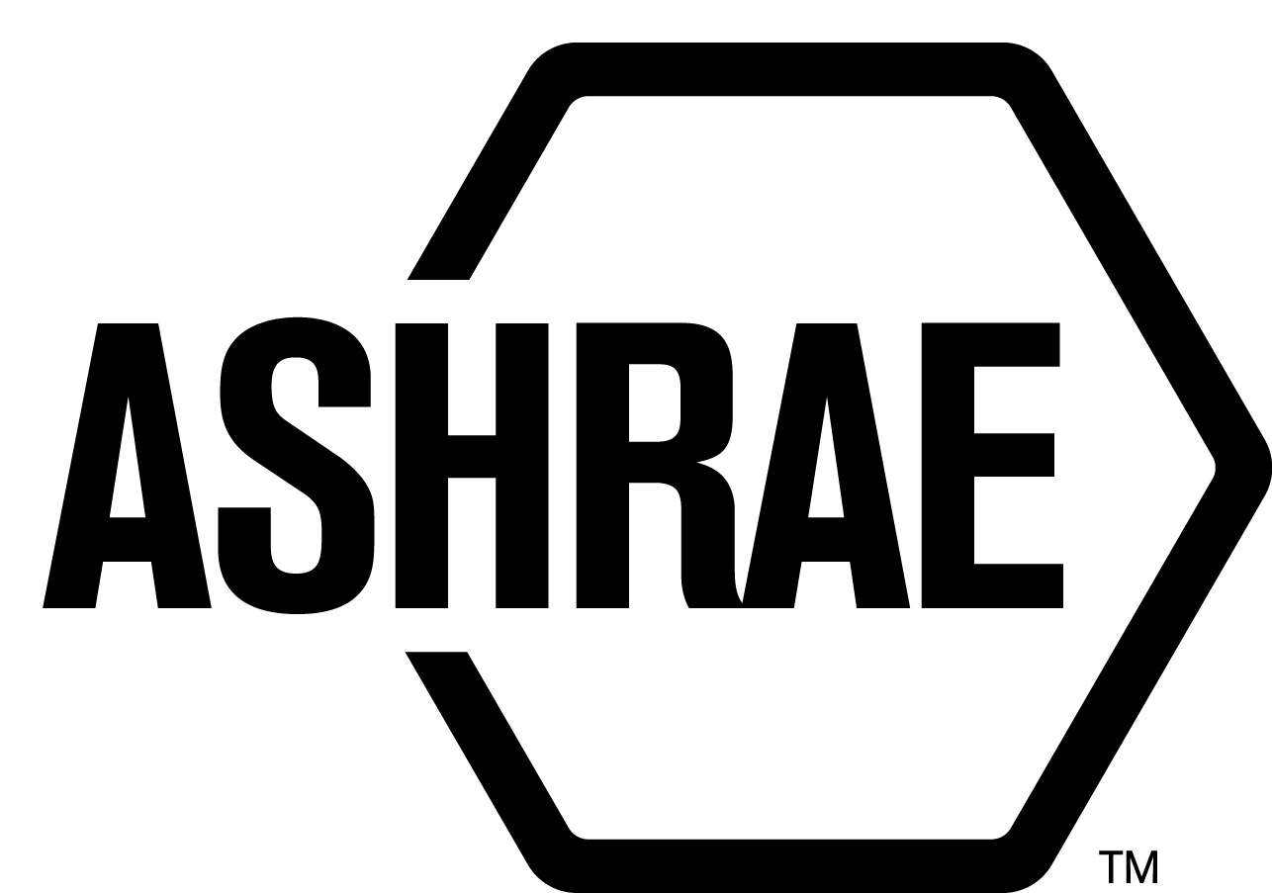

PLANNING, POLICY AND INTERPRETATIONS SUBCOMMITTEE (PPIS)

MINUTES

Technology Weekend 2016
Conference Call
Meeting of August 18, 2016

NOTE: These draft minutes have not been approved and are the unofficial record by PPIS.

TABLE OF CONTENTS
1. Call to Order/Introductions and Review of Agenda 3
2. Chairman’s Report 3
3. Staff Report 3
4. Approval of Minutes 3
5. Review of Action Items/Unfinished Business 3
6. Planning – New Projects 4
7. Policy – Procedural Changes 4
8. Interpretations 4
9. New Business 4
10. Recess 4

ACTION ITEMS ASSIGNED TECHNOLOGY WEEKEND 2016
AI# | Action | Assigned To | Status
1 | None. | Staff | Open

1. Call to Order/Introductions and Review of Agenda

Call to Order/Chairman’s Report

The Planning, Policy and Interpretations Subcommittee (PPIS) meeting was called to order on Wednesday, August 17, 2016, at 9:00 a.m. via teleconference.

Introductions

Chairman Steven Emmerich greeted members and guests. Introductions were made.

PPIS Members  Don Brundage, Chair  James Aswegan  Niels Bidstrup  Rick Heiden  Dennis Stanke | PPIS Members Absent  Guests  Armin Hauer | Staff  Tanisha Meyers-Lisle, Procedures Administrator

2. Chairman’s Report
None.

3. Staff Report
None.

4. Approval of Minutes
The PPIS Minutes from the Annual Meeting 2016 was presented to members for approval.

It was moved by Don Brundage and seconded by Jim Aswegan:

- That the PPIS Minutes from the St. Louis Annual Meeting 2016 be approved as written.

MOTION 1 PASSED: 3-0-0, CNV
Secretary’s Notes: Rick Heiden was not present for this vote.

5. Review of Action Items/Unfinished Business
5A. Action Items
A list of action items was presented to members for review. An update of the action items is presented on page 2.

6. Planning – New Projects
It was moved by Dennis Stanke and seconded by James Aswegan that the following Title, Purpose and Scope (TPS) be approved and that a new Standard Project Committee be formed:

TITLE: Standard Method of Test for Electrical Power Drive Systems

1. PURPOSE: To determine the performance of power drive systems for rating the energy efficiency and electrical compatibility with the power grid and with motor insulation.

2. SCOPE: Adjustable speed electric AC power drive systems, which combine semiconductor power converters including means for their control, protection, monitoring, and measurement, with connected electric motors. The standard is intended for HVACR applications that operate from low voltage (≤ 600 V). Power converters may be completely integrated in motor casings and remote power converters may be tested with default motors. All electric motor types are included.

BACKGROUND: This TPS will also have to be approved by the Board. This TPS was submitted by Kezhen Shen for consideration at the Technology Weekend PPIS meeting. PPIS assigned TC 1.11, Electric Motors and Motor Control as the cognizant committee. Armin Hauer was recommended as the Chair of the proposed new project committee. There are at least five members willing to volunteer.

MOTION 2 PASSED: 4-0-0, CNV

7. Policy – Procedural Changes
PPIS distributed the PC Guide to PASA to SPLS and will review their feedback in the coming months ahead with hopes to finalize the document in time for the Winter Meeting in Vegas 2017.
.

8. Interpretations
None.

9. New Business
None.

10. Recess
PPIS adjourned at 9:37 am.

