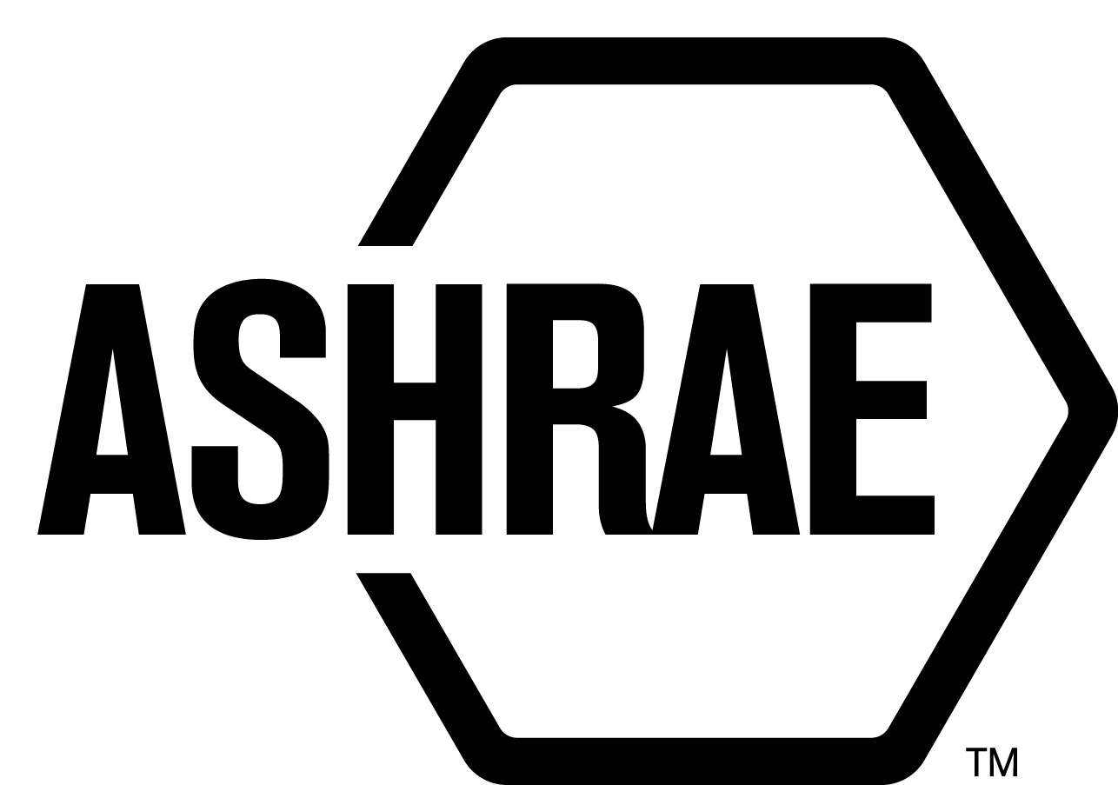

PLANNING, POLICY AND INTERPRETATIONS SUBCOMMITTEE (PPIS)

MINUTES

Palmer House Hotel
Chicago, IL
Meeting of January 23, 2015
and January 27, 2015

NOTE: These draft minutes have not been approved and are the unofficial record by PPIS.

TABLE OF CONTENTS
1. Call to Order/Introductions and Review of Agenda 3
2. Chairman’s Report 3
3. Staff Report 3
4. Approval of Minutes 3
5. Review of Action Items/Unfinished Business 3
6. Planning – New Projects 3
7. Policy – Procedural Changes 4
8. Interpretations 6
9. New Business 6
10. Recess 6
11. Call to Order/Introductions and Review of Agenda 6
12. Chairman’s Report 7
13. Staff Report 7
14. Unfinished Business 7
15. Planning – New Projects 7
16. Policy – Procedural Changes 8
17. Interpretations 8
18. New Business 8
19. Next Meeting 8
20. Adjournment 8

ACTION ITEMS ASSIGNED WINTER MEETING IN CHICAGO, IL
AI# | Action | Assigned To | Status
 | None.

1. Call to Order/Introductions and Review of Agenda

Call to Order/Chairman’s Report

The Planning, Policy and Interpretations Subcommittee (PPIS) meeting was called to order on Friday, January 23, 2015, at 2:00 p.m., in Marshfield (3).

Introductions

Chairman Rita Harrold greeted members and guests. Introductions were made.

PPIS Members  Rita Harrold, Chair  Joseph Anderson  David Conover  Dennis Knight  Rick Larson  Cyrus Nasseri | PPIS Members Absent  Guests  Neil Leslie  Doug Reindl  Stephanie Reiniche, MOS | Staff  Tanisha Meyers-Lisle, Procedures Administrator

2. Chairman’s Report
None.

3. Staff Report
None.

4. Approval of Minutes
The PPIS Minutes from the August 26, 2015 Technology Weekend Meeting was presented to members for approval.

It was moved by Dave Conover and seconded by Dennis Knight:

- That the PPIS Minutes from the Technology Weekend Meeting be approved as written.

MOTION 1 PASSED: 4-0-0, CNV

5. Review of Action Items/Unfinished Business
5A. Action Items
A list of action items was presented to members for review. An update of the action items is presented on page 2.

6. Planning – New Projects
None.

7. Policy – Procedural Changes
It was moved by Dennis Knight and seconded by Cyrus Nasseri,

2 That PASA 4.2.2.6, Standards Reaffirmation Subcommittee (SRS) be approved as shown below:

4.2.2.6 Standards Reaffirmation Subcommittee (SRS)
SRS serves as the project committee (consensus body) for reaffirmation, withdrawal or revision (when updating references will not make a substantive change to the standard or guideline) of existing ASHRAE standards.

SRS is a balanced project committee of at least five (5) members, including at least three members of the StdC and applicants responding to a call for members posted in ASHRAE Standards Actions. SRS acts, in limited circumstances, as a project committee for existing standards and is subject to the rules of project committees for reaffirmations, withdrawals, and revisions only to update references, that are not themselves reaffirmations and do not cause a substantive change to the standard. SRS must comply with all ANSI requirements for openness, balance and due process. SRS may act in lieu of a PC, with the advice of the cognizant TC/TG/TRG, to recommend, reaffirm, withdraw or revise an existing standard based on updated references (that do not cause a substantive change to the standards) or add a second system of units to an existing standard, thereby making the existing standard useable in either SI or IP units. (See Standards Action Annex A.)

BACKGROUND: As part of our ANSI audit, the ANSI ExSC’s Subcommittee on Accreditation made a recommendation to include the above statement in our next PASA revision.

MOTION 2 PASSED AS AMENDED:
VOTE: 5-0-0, CNV

It was moved by Dennis Knight and seconded by Joseph Anderson,

3 That the revisions to PASA 7.11, Interpretation Requests of Standards be approved as shown below:

7.11 Interpretation Requests of Standards
Interpretation requests for a standard must be submitted to the MOS in writing. The Assistant Manager of Research & Technical Services or the Chair of the current or past cognizant PC or the Chairs designee may respond in writing to written requests for unofficial personal interpretations. Cognizant SSPCs, if they exist, and SPCs that have not yet been disbanded will be asked to respond to requests for official interpretations in writing. If no PC exists, StdC will form an Interpretations Committee (IC) to respond. Procedures for interpretations of published SCDs are provided in StdC MOP Reference Manual Section 10. An issuance or revision of an official interpretation requires affirmative votes for the majority of the memberships of each approving and of at least two-thirds of those voting, excluding abstentions.

BACKGROUND: Currently, only the Assistant Manager of Research & Technical Services or the Chair can respond to unofficial interpretation requests. Staff suggests adding this statement so the Chairs designee can also respond to unofficial requests. This will improve the speed in which interpretation requests are distributed. The Gloria Rule (a change in a higher level document can automatically change the lower level document) will be applied to update section 10.3.2 of the Standards Committee Reference Manual.

MOTION 3 PASSED: 5-0-0, CNV

It was moved by Dave Conover and seconded by Joseph Anderson,

4 That the revisions to PASA 11, Antitrust Policy be approved as shown below:

11 ANTITRUST POLICY
ASHRAE agrees to comply with the Antitrust Policy as stated in ANSI Essential Requirements.

BACKGROUND: ANSI revised their Essential Requirements and this change brings PASA in line with ANSI’s new requirements.

MOTION 4 PASSED: 5-0-0, CNV

It was moved by Dennis Knight and seconded by Joseph Anderson

5 That the revisions to PASA Annex A: Definitions be approved as shown below:

Informative notes: explanatory information, appearing in a standard, that does not contain requirements or any information considered indispensable for the use of the standard. Informative notes are to begin with the word “(iInformative Note(s))” and be placed at after the end of the clause or sub clause, or after the paragraph, to which they refer section of the standard to which the note applies. If the “informative note” is more than two sentences, then the information shall be placed in an informative annex and referred to by the informative note. Where there is more than one informative note, the notes must be numbered sequentially.

BACKGROUND: Rick Hall and Dave Conover suggested these proposed changes to further clarify the informative notes definition.

MOTION 5 PASSED: 5-0-0, CNV

It was moved by Dave Conover and seconded by Dennis Knight

6 That PASA Annex B, Appeals of Board of Directors’ Standards Actions or Inactions be approved as shown below:

ANNEX B: APPEALS OF BOARD OF DIRECTORS’ STANDARDS ACTIONS OR INACTIONS

B4 SCOPE OF APPEAL AND BURDEN OF PROOF
An appeal of a BOD standards action or inaction mayshall be solely based upon procedural and/or substantive technical grounds. When an appeal is based on substantive technical grounds, it shall be the burden of the appellant to establish the grounds and basis of the appeal. When the basis of an appeal is procedural appeals are filed, the appellant shall demonstrate that proper ASHRAE Standards development procedures were not followed. Appeals arguments that are based on actions that took place in previous revision cycles will not be considered.

BACKGROUND: The proposed change includes removing the option of technical appeals from ASHRAE procedures. ANSI has suggested several times during our audits that technical appeals are not required and thus we should remove this option out of our procedures. We are receiving appeals that are based on technical issues but there is a concern that our panel does not have enough technical expertise to make a decision in regard to these matters. While currently, there isn’t a balance requirement for the ASHRAE Appeals Panel, it seems as if there should be if decisions are being issued on technical appeals. ASHRAE has a fair process which allows members to express their concerns during the development process of the standards/addenda. Everyone is given an opportunity to vote, ballots are recirculated when there is a negative vote with comment, lengthy discussions on the matter are often held, there is a public review process in which the unresolved commenter or negative voter can comment and have the PC address their issue. ASHRAE gives everyone a fair opportunity to share their concerns and if a vote is taken to publish after this process is completed, it should stand. The amount of staff and volunteer time far exceeds the cost of what we receive in appeal fees ($600). In addition, the PC Chair and their guests have to travel on their own expense since it’s not reimbursable.

MOTION 6 PASSED AS AMENDED:
VOTE: 5-0-0, CNV

8. Interpretations
None.

9. New Business
None.

10. Recess
PPIS recessed at 11:00 am until January 27, 2015.

11. Call to Order/Introductions and Review of Agenda
The Planning, Policy and Interpretations Subcommittee (PPIS) meeting was called to order on Tuesday, January 27, 2015 at 11:00 a.m., in Burnham (1).

Introductions

Chairman Rita Harrold greeted members and guests.

PPIS Members  Rita Harrold, Chair  Joseph Anderson  David Conover  Dennis Knight  Rick Larson  Cyrus Nasseri | PPIS Members Absent  Guests  Randy Hoseman  Susan LeBlanc, Standards Administrator  Rusty Tharp | Staff  Tanisha Meyers-Lisle, Procedures Administrator

12. Chairman’s Report
None.

13. Staff Report
None.

14. Unfinished Business
None.

15. Planning – New Projects
It was moved by Dave Conover and seconded by Dennis Knight,

7 That the following Title, Purpose and Scope (TPS) be approved and that a new Standard Project Committee be formed and be developed by SSPC 15, Safety Standard for Refrigeration Systems:

TITLE: Safety Standard for Air-conditioning and Heat Pump Systems in Residential Applications

1. PURPOSE:
This standard specifies safe design, installation, operation and maintenance of air-conditioning systems in residential applications.

2. SCOPE:
This standard establishes safeguards for life, limb, health and property and prescribes safety requirements.
This standard applies to the design, installation, operation and maintenance of mechanical air-conditioning and heat pump systems installed in stationary applications that include:
- one and two-family dwellings (single family detached, duplexes and townhomes), or
- multi-family structures with individual dwelling units, where each dwelling unit has its own heating and air-conditioning system, or
outbuildings and pool houses located on the same private property as a one and two family dwelling.

BACKGROUND: This TPS will also have to be approved by the Board. This TPS was submitted by Rusty Tharp for consideration at the Seattle PPIS meeting. PPIS assigned TC 8.11, Unitary and Room Air Conditioners and Heat Pumps as the cognizant TC. Rusty Tharp was recommended as the Chair of the proposed new project committee. There are at least five members willing to volunteer. There has been plenty of discussion since its submission between PPIS, Rusty Tharp and SSPC 15. Mr. Tharp has revised the TPS to offer greater clarity in the Scope. Doug Reindl took an action item to garner endorsement from SSPC 15. SSPC 15 fully endorses the proposed TPS which establishes a subcommittee to develop a residential standard.

MOTION 7 PASSED: 5-0-0, CV

16. Policy – Procedural Changes
None.

17. Interpretations
None.

18. New Business
None.

19. Next Meeting
Spring Meeting
TBD

20. Adjournment
PPIS adjourned at 1:00pm.

