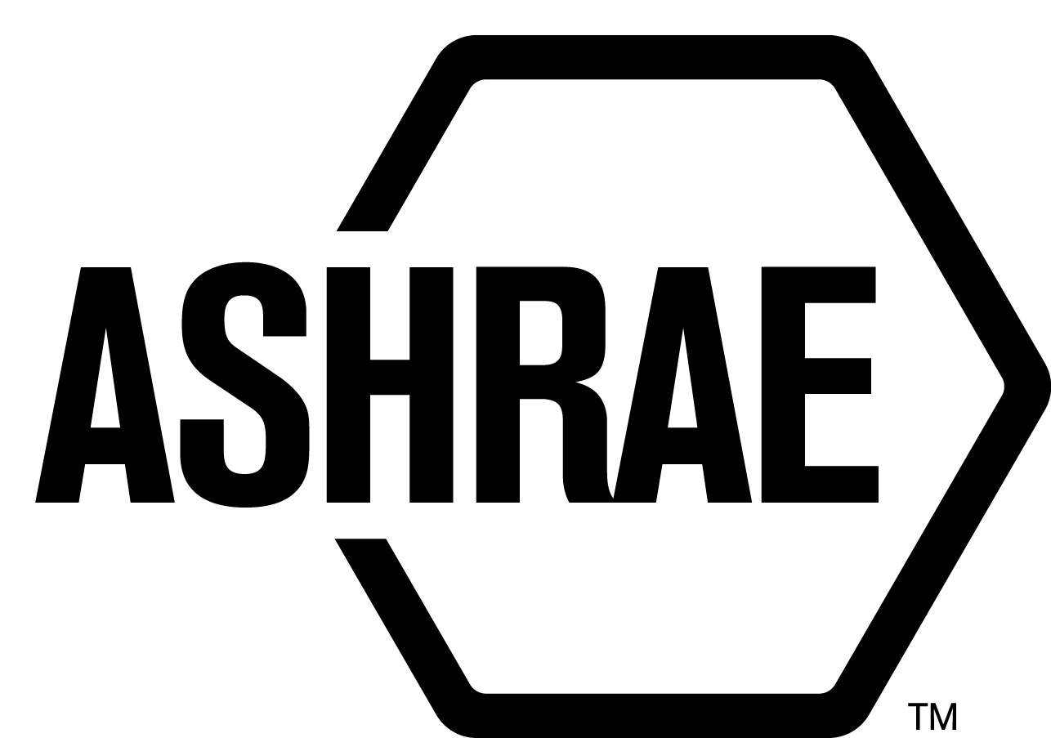

PLANNING, POLICY AND INTERPRETATIONS SUBCOMMITTEE (PPIS)

MINUTES

The Palmer House Hilton
Meeting of January 19, 2018
and January 23, 2018

NOTE: These draft minutes have not been approved and are the unofficial record by PPIS.

TABLE OF CONTENTS
1. Call to Order/Introductions and Review of Agenda 3
2. Chairman’s Report 3
3. Staff Report 3
4. Approval of Minutes 3
5. Review of Action Items/Unfinished Business 3
6. Planning – New Projects 3
7. Policy – Procedural Changes 4
8. Interpretations 6
9. New/Ongoing Business 6
10. Recess 6
11. Call to Order/Introductions and Review of Agenda 6
12. Chairman’s Report 7
13. Staff Report 7
14. Unfinished Business 7
15. Planning – New Projects 7
16. Policy – Procedural Changes 7
17. Interpretations 7
18. New Business 8
19. Next Meeting 8
20. Adjournment 8

ACTION ITEMS ASSIGNED WINTER MEETING IN CHICAGO, IL
AI# | Action | Assigned To | Status
1 | Develop disclosure policy procedures for guests at meetings. Jonathan Humble would like procedures for guests who want to work with the committee and review documents. Also need a definition for designated reviewer in the PC Guide to PASA. | Staff/Jonathan Humble | Jonathan Humble to develop a draft for committee review.
2 | Review the Standards Template and provide comments. The template provides guidance on how to format a standard or a guideline. | PPIS | Dennis Stanke, Steve Ferguson and Susan LeBlanc are in editing mode.
3 | Staff to provide guidance in the PC Guide to PASA on new submittals when there is an overarching cognizant committee. Ex: SSPC 300, SSPC 41 | PPIS | Define term overarching? Is there a problem?
4 | Update PC Guide to PASA on use of new Online Comment Database | PPIS | Should have a draft between now and Houston.

1. Call to Order/Introductions and Review of Agenda

Call to Order/Chairman’s Report

The Planning, Policy and Interpretations Subcommittee (PPIS) meeting was called to order on Friday, January 19, 2018 at 2:00 p.m., in Burnham 3.

Introductions

Chairman Wayne Stoppelmoor greeted members and guests. Introductions were made.

PPIS Members  Wayne Stoppelmoor, Chair  Niels Bidstrup  Rick Heiden  Jonathan Humble  Dennis Stanke | PPIS Members Absent  Guests  Steven Emmerich | Staff  Steve Ferguson, MOS  Tanisha Meyers-Lisle, Procedures Administrator

2. Chairman’s Report
The Chair acknowledged the ASHRAE Code of Ethics Commitment.

3. Staff Report
None.

4. Approval of Minutes
The PPIS Minutes from Technology Weekend Meeting 2017 was presented to members for approval.

It was moved by Jonathan Humble and seconded by Dennis Stanke:

- That the PPIS Minutes from the Technology Weekend Meeting 2017 be approved as written.

MOTION 1 PASSED: 4-0-0, CNV

5. Review of Action Items/Unfinished Business
5A. Action Items
A list of action items was presented to members for review. An update of the action items is presented on page 2.

6. Planning – New Projects
None.

7. Policy – Procedural Changes
2 It was moved by Jonathan Humble and seconded by Rick Heiden:

That PASA 4.2.2.6, Standards Reaffirmation Subcommittee (SRS) be approved as shown in Attachment A.

BACKGROUND: Since SRS is a consensus body and must comply with ANSI Requirements, it makes sense that PASA should include the appointment of members to SRS. Currently the requirements reside only in the Standards Committee Reference Manual. If not in PASA, it could be interpreted that SRS membership must meet all of the membership approvals as any other consensus body. This proposes to bring in the membership approval requirements from the Reference Manual for SRS into PASA. If this occurs, it is recommended that the Reference Manual be revised to point to 4.2.2.6 of PASA for SRS membership appointment.

MOTION 2 PASSED: 4-0-0, CNV

3 It was moved by Rick Heiden and seconded by Niels Bidstrup:

That PASA 7.2.4, Voting Requirements for Standards Actions and new sections 7.2.4.1 Voting on Standards Actions at Meetings, 7.2.4.2 Numerical Requirements for Standards Action Votes, 7.2.4.3 Treatment of Negative Voters on Standards Actions, 7.2.4.4 Responses to Negative Votes with Reason, 7.2.4.5 Consideration of Unresolved Objections, 7.2.4.6 Approval of Standards Actions by Approval Bodies, and 7.2.5 Voting Rules for Meetings be approved as shown in Attachment B.

BACKGROUND: In 2016, PPIS issued an interpretation on what “held in abeyance means”. The current requirements are not clear and this attempts to revise the procedures to make them clear and to match a previously issued interpretation. While looking at the sections, it was determined that there was additional ambiguity. This is an attempt to clarify precisely what is required for Standards Actions, what is required for letter ballots (for anything including Standards Actions), and what to do with negative votes on a letter ballot (for anything including Standards Actions). The modifications to 7.2.4 also address a PPIS interpretation related to the intent of “held in abeyance”.

MOTION 3 PASSED: 4-0-0, CNV

4 It was moved by Dennis Stanke and seconded by Niels Bidstrup:

That PASA 7.4.6, Consideration of Public Review Comments Received be approved as shown
in Attachment C.

BACKGROUND: It has been long standing practice (and used to be in the PC MOP) that if there’s a full subsequent public review, then the PC is not required to respond to all comments on the previous public review. When the PC MOP was removed, language related to this was not added to PASA. PPIS issued an interpretation on the matter, and this adds that language into PASA to match the interpretation.

MOTION 4 PASSED: 3-0-0, CNV
Secretary’s Note: Jonathan Humble left the room.

5 It was moved by Rick Heiden and seconded by Dennis Stanke:

That PASA 7.8.1, Project Discontinuation Due to Lack of Membership be approved as shown in
Attachment D.

BACKGROUND: This proposal was brought forward by SPLS and the MOS. This
proposal clarifies the project committee discontinuation process as well as adds
circumstances not previously covered in PASA.

MOTION 5 PASSED: 3-0-0, CNV
Secretary’s Note: Jonathan Humble left the room.

6 It was moved by Jonathan Humble and seconded by Dennis Stanke:

That PASA Annex C: Complaints of Actions or Inactions by the StdC, Its Subcommittees or PCs
be approved as shown in Attachment E.

BACKGROUND: The number of complaints have increased over the past few years, and it’s become evident that there is:
- Ambiguity/lack of clarity in the rules, and
- Too many steps in the process that include many of the same people.
The intent of these revisions are to work with the existing procedures and develop a streamlined and clear path for complaints. Previously there were three levels of complaints embedded in one procedure. This splits it apart. There are complaints against StdC Subcommittees (aka SRS), and PCs, which are only adjudicated once by Standards Committee ExCom. Then there are complaints against Standards Committee/Standards ExCom which are adjudicated once by Technology Council.

It also proposes a fee be submitted with a complaint. It’s been confirmed with ANSI that this is permitted.

MOTION 6 PASSED: 4-0-0, CNV

7 It was moved by Rick Heiden and seconded by Dennis Stanke:

That Standards Committee Reference Manual of Procedures 1.7, Complaints of Actions or
Inactions by the StdC, its Subcommittees or PCs be approved as shown in Attachment F.

BACKGROUND: These changes are in line with PASA changes shown in Attachment E.

MOTION 7 PASSED: 4-0-0, CNV

8 It was moved by Rick Heiden and seconded by Niels Bidstrup:

That PASA Annex A: Definitions, Abbreviations and Acronyms, and Classifications be approved
as shown in Attachment G.

BACKGROUND: We define and use “substantive change” in PASA many times. We define, but never use “non-substantive change”. There’s actually changes that neither meet the definition of substantive or non-substantive which cannot be (a change must either be substantive or non-substantive). Standards action was also modified to clarify the difference between Standards Action (ANSI related) and a standards action vote.

MOTION 8 PASSED: 4-0-0, CNV

9 It was moved by Dennis Stanke and seconded by Jonathan Humble:

That Standards Committee Reference Manual 11.1 Responsibilities be approved as shown in
Attachment H.

BACKGROUND: This revision is now in line with PASA 4.3.1 Project Committees – Recommended members and non-policy level PC Chairs are approved by a majority vote of a designated subcommittee of Standards Committee, normally SPLS. Standards committee must concur by majority vote for all policy level PC Chairs.

MOTION 9 PASSED: 4-0-0, CNV
Note: This recommendation was deferred at the Standards Committee meeting on January 20, 2018 to January 22, 2018, where it was approved.

8. Interpretations
None.

9. New/Ongoing Business
PPIS to look at PASA 7.4.6 in the future to address late comments.
7.4.6 states “The PC may consider any public review comments received after the close of the public review period, or shall consider them as a new proposal.” Should this say “may” and should the option also be to “consider them as a new proposal”? Staff states that even though this is written in PASA, it has never happened. Staff to review this as a possible future change for PASA.

10. Recess
PPIS adjourned at 6:00pm.

11. Call to Order/Introductions and Review of Agenda
The Planning, Policy and Interpretations Subcommittee (PPIS) meeting was called to order on Tuesday, January 23, 2018 at 11:00 a.m., in Wilson.

Introductions

Chairman Wayne Stoppelmoor greeted members and guests.

PPIS Members  Wayne Stoppelmoor, Chair  Niels Bidstrup  Rick Heiden  Jonathan Humble  Dennis Stanke | PPIS Members Absent  Guests  Jeff Inks | Staff  Steve Ferguson, MOS  Susan LeBlanc, Standards Administrator  Tanisha Meyers-Lisle, Procedures Administrator

12. Chairman’s Report
None.

13. Staff Report
None.

14. Unfinished Business
None.

15. Planning – New Projects
None.

16. Policy – Procedural Changes
10 It was moved by Jonathan Humble and seconded by Rick Heiden:

That PASA Annex B: Appeals of Board of Directors’ Standards Actions or Inactions be approved
as shown in Attachment I.

BACKGROUND: There are currently some unclear provisions in the appeals procedures. These revisions clarify what should happen when.

MOTION 10 PASSED: 4-0-0, CNV
Note: This (B5 item i) was amended at the Standards Committee meeting on January 23, 2018.

11 It was moved by Dennis Stanke and seconded by Jonathan Humble:

That Standards Committee Reference Manual 11.1 item c, SPLS Responsibilities be approved
as shown in Attachment J.

BACKGROUND: This revision is now in line with PASA 4.3.1 Project Committees – Recommended members and non-policy level PC Chairs are approved by a majority vote of a designated subcommittee of Standards Committee, normally SPLS. Standards committee must concur by majority vote for all policy level PC Chairs.

MOTION 11 PASSED: 4-0-0, CNV

17. Interpretations
None.

18. New Business
12 That PPIS recommends to Standards Committee to recommend to Tech Council to
recommend to the Board that ASHRAE cosponsor Standard for Restoration of Buildings Impacted by Combustion Particles, with Restoration Industry Association (RIA) and the Indoor Air Quality Association(IAQA) with ASHRAE as the lead organization.

BACKGROUND: When IAQA became an affiliate association of ASHRAE all of the PINS for the development of standards by Indoor Environmental Standards Organization (IESO) were moved under ASHRAE at ANSI. IESO is no longer an ANSI standards developer. RIA is not an ANSI standards developer organization. The issue of cosponsoring standards was not addressed when IAQA became an affiliate association of ASHRAE. RIA has significantly completed most of the work on the project so the ASHRAE resources needed to do this will be minimal.

This standard will provide a basis to determine how to perform restoration services of properties and contents, and how to determine services have been successful. The standard will address safety and environmental issues related to fire restoration and the re-occupancy of properties. The standard will be produced by a committee of representatives of the IESO SDC, the Restoration Industry Association, and other stakeholders as appropriate. The standard will be adopted and specified within the fire restoration industry, the insurance industry, and related parties.

MOTION 12 PASSED: 4-0-0, CNV

19. Next Meeting
Annual Meeting
Houston 2018

20. Adjournment
PPIS recessed at 2:00pm.

ATTACHMENT A
ATTACHMENT B
ATTACHMENT C
ATTACHMENT D
ATTACHMENT E
ATTACHMENT F
ATTACHMENT G
ATTACHMENT H
ATTACHMENT I
ATTACHMENT J

