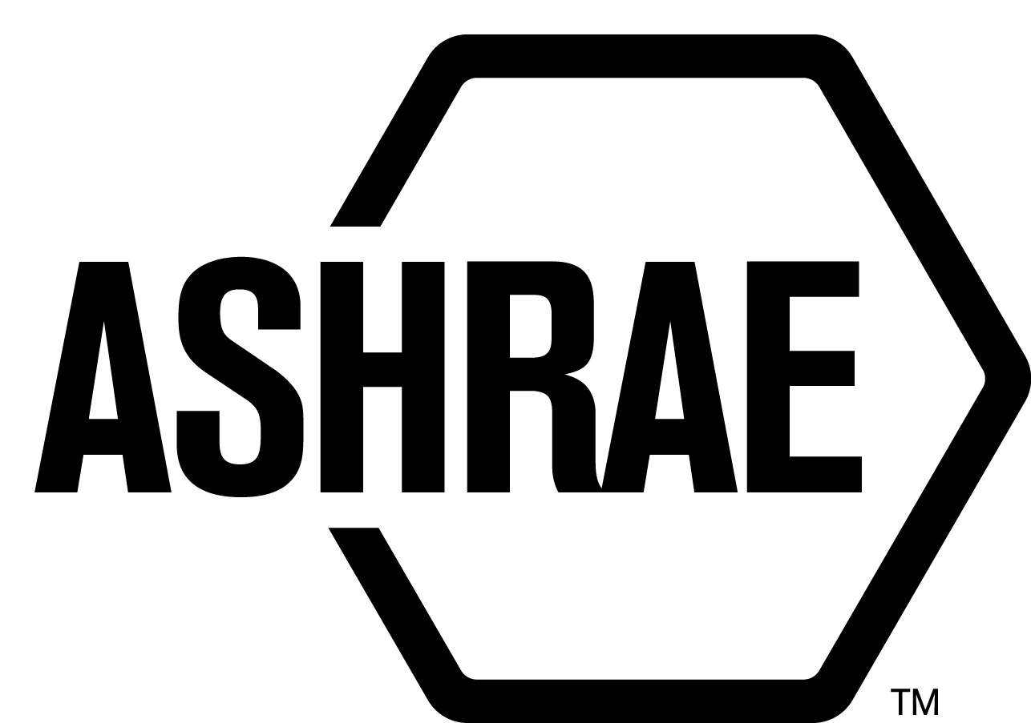

PLANNING, POLICY AND INTERPRETATIONS SUBCOMMITTEE (PPIS)

MINUTES

Caesar’s Palace
Meeting of January 27, 2017
and January 31, 2017

NOTE: These draft minutes have not been approved and are the unofficial record by PPIS.

TABLE OF CONTENTS
1. Call to Order/Introductions and Review of Agenda 3
2. Chairman’s Report 3
3. Staff Report 3
4. Approval of Minutes 3
5. Review of Action Items/Unfinished Business 3
6. Planning – New Projects 4
7. Policy – Procedural Changes 4
8. Interpretations 4
9. New Business 5
10. Recess 5
11. Call to Order/Introductions and Review of Agenda 5
12. Chairman’s Report 5
13. Staff Report 5
14. Unfinished Business 5
15. Planning – New Projects 5
16. Policy – Procedural Changes 6
17. Interpretations 6
18. New Business 6
19. Next Meeting 6
20. Adjournment 6

ACTION ITEMS ASSIGNED WINTER MEETING IN LAS VEGAS, NV
AI# | Action | Assigned To | Status
 | None.

1. Call to Order/Introductions and Review of Agenda

Call to Order/Chairman’s Report

The Planning, Policy and Interpretations Subcommittee (PPIS) meeting was called to order on Friday, January 27, 2017 at 2:00 p.m., in Campania.

Introductions

Chairman Donald Brundage greeted members and guests. Introductions were made.

PPIS Members  Donald Brundage, Chair  James Aswegan  Niels Bidstrup  Rick Heiden  Dennis Stanke | PPIS Members Absent  Guests  Nicholas Lea | Staff  Tanisha Meyers-Lisle, Procedures Administrator  Stephanie Reiniche, Sr. Manager of Standards

2. Chairman’s Report
None.

3. Staff Report
None.

4. Approval of Minutes
The PPIS Minutes from Technology Weekend 2016 was presented to members for approval.

It was moved by Jim Aswegan and seconded by Niels Bidstrup:

- That the PPIS Minutes from the Technology Weekend Meeting 2016 be approved as written.

MOTION 1 PASSED: 4-0-0, CV
Secretary’s Notes: Dennis Stanke was not present.

5. Review of Action Items/Unfinished Business
5A. Action Items
A list of action items was presented to members for review. An update of the action items is presented on page 2.

6. Planning – New Projects
2 It was moved by Jim Aswegan and seconded by Niels Bidstrup that the following Title, Purpose and Scope (TPS) be approved and that a new Standard Project Committee be formed:

TITLE: Method of Test for Commercial and Industrial Adiabatic Humidifiers

1. PURPOSE: This standard method of test establishes a uniform method of laboratory testing for rating commercial and industrial adiabatic humidifiers.

2. SCOPE:

2.1 The scope of the standard covers a method of test for the humidification rate and efficiency of commercial and industrial adiabatic humidifiers.

2.2 This method of test describes the test apparatus, conduct of the test, and information to be recorded.

2.3 Information resulting from the application of this method of test is intended for use by manufacturers, specifiers, installers, and users of commercial and industrial humidifiers.

BACKGROUND: This TPS will also have to be approved by the Board. This TPS was
submitted by Nicholas Lea for consideration at the Las Vegas PPIS meeting. PPIS
assigned TC 5.11, Humidifiers. Nicholas Lea was recommended as the Chair of the
proposed new project committee. There are at least five members willing to volunteer.

MOTION 2 PASSED: 4-0-0, CNV
Secretary’s note: Membership is not balanced. A call for members will be issued by ASHRAE
Staff.

7. Policy – Procedural Changes
3 It was moved by Dennis Stanke and seconded by James Aswegan that the PC MOP be replaced with the PC Guide to PASA.

MOTION 3 PASSED: 4-0-0, CNV

BACKGROUND: The PC MOP has been replaced with the PC Guide to PASA. PPIS
voted 3-0-0, CV to approve the PC Guide to PASA on December 20, 2016. Standards
Committee voted to 20-0-1, CNV to approve the PC Guide to PASA on January 12,
2017.

8. Interpretations
None.

9. New Business
None.

10. Recess
PPIS adjourned at 2:00pm.

11. Call to Order/Introductions and Review of Agenda
The Planning, Policy and Interpretations Subcommittee (PPIS) meeting was called to order on Tuesday, January 31, 2017 at 11:00 a.m., in Calabria.

Introductions

Chairman Donald Brundage greeted members and guests.

PPIS Members  Donald Brundage, Chair  James Aswegan  Niels Bidstrup  Rick Heiden  Dennis Stanke | PPIS Members Absent  Guests  Steve Bushby  David Robin | Staff  Stephanie Reiniche, Sr. Manager of Standards

12. Chairman’s Report
None.

13. Staff Report
None.

14. Unfinished Business
None.

15. Planning – New Projects
It was moved by James Aswegan and seconded by Rick Heiden,

4 That the following Title, Purpose and Scope (TPS) be approved and that a new Standard Project Committee be formed and be developed by SSPC 135, BACnet - A Data Communication Protocol for Building Automation and Control Networks:

TITLE: Designation and Classification of Semantic Tags for Building Data

1. PURPOSE:
The purpose of this standard is to provide a dictionary of uniform semantic tags. These
tags enable interoperable use of descriptive information on building data.
2. SCOPE:
This standard provides a dictionary of semantic tags for descriptive tagging of building data including building automation and control data along with associated systems.

BACKGROUND: This TPS will also have to be approved by the Board. This TPS was submitted by SSPC 135. This document will be developed by SSPC 135. The committee intends to develop this and also submit this for consideration as an international standard.

MOTION 4 PASSED: 4-0-0, CNV

16. Policy – Procedural Changes
1. PPIS approved a motion to recommend that the Society Rules Committee revise Rule of the Board 1.201.034, International Policy for Standards, that would remove footnote two that states “See the definition of adoption in Appendix R of the Standards Committee Manual of Procedures. The Presidential ad hoc committee on ASHRAE's Role in the Globalization of Standards had been reviewing a broad range of issues related to this topic, including ROB 1.201.034. The ad hoc committee had found that this ROB is consistent with recommendations that will be made to the BOD and is not in need of significant changes. However, there is an issue that came up in the context of an appeal to Standard 90.1 that needs to be addressed. Footnote 2 references a section in the Standards Committee Reference Manual that no longer exists. Interpreting this footnote was a source of confusion during the appeal. The normal English meaning of "adoption" is sufficient for a complete understanding of this policy. For these reasons it was recommended that the footnote and the reference to it be removed. This was sent to the Society Rules Committee for consideration as a minor editorial clarification and SRC asked for feedback from Standards Committee. SRC removed the footnote from the Rule of the Board.

Secretary’s Note: Listed as an information item in report to Standards Committee.

17. Interpretations
None.

18. New Business
None.

19. Next Meeting
Spring Meeting
TBD

20. Adjournment
PPIS adjourned at 12:30pm.

