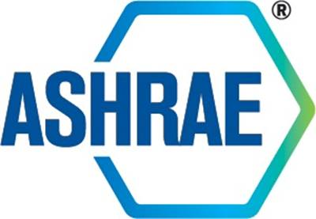

Standards Project Liaison Subcommittee
(SPLS)

MINUTES

Virtual Meeting
November 20th, 2025

These are not the official minutes until approved by SPLS

Table of Contents

1. Introductions and Review of Agenda 3
2. Minutes 3
3. Old Business 3
4. Public Review Drafts 3
5. Other Business 3
6. Adjournment 4

Standards Project Liaison Subcommittee
Virtual Meeting, November 20, 2025
MINUTES

These are not the official minutes until approved by SPLS.

- Introductions and Review of Agenda

The SPLS meeting was called to order on November 20, 2025, at 11:00 AM ET. Chair Hoy Bohanon welcomed members and guests and reviewed the ASHRAE Value Statement and ASHRAE Code of Ethics. The following members, guests and staff were in attendance:

Members Present  Hoy Bohanon, Chair  Charles Barnaby  Abdel Darwich  Phillip Johnson  Paul Lindahl Jr  Kenneth Monroe  Kathleen Owen  Rusty Tharp  Douglas Tucker  Thomas Watson | Members Not Present  Omar Abdelazi  Drake Erbe  William Healy  Phillip Naughton  David Yuill  Staff  Thomas Loxley, AMOS-C  Tanisha Meyers-Lisle, AMOS-A  Klaudette Spencer- SAS  Guests  Adrienne Thomle

Minutes

SPLS October meetings were approved via OSR Ballot. (11,0,3,1) Ballot closed 11/18/2025

Old Business

None.

Public Review Drafts

It was moved by Kenneth Monroe and seconded by Kathleen Owen:

1 That BSR/ASHRAE Addendum a to ANSI/ASHRAE Standard 62.2-2025, Ventilation and Acceptable Indoor Air Quality in Residential Buildings, be approved for publication public review.

MOTION PASSED. 9-0-1

Other Business
- Harmonization Process – Phillip Johnson – Phillip Johnson gave a reminder that a mass email was sent with a deadline for feedback on 12/15. At the previous meeting, Johnson gave guidance to SPLS liaisons to touch base with PCs by mid-November. Johnson created a file to start compiling the feedback. The file can be found on OneHub, titled PC Feedback Harmonization Plan. See Attachment A.

Adjournment

The next SPLS meeting will be held Thursday, December 18, 2025, 11:00 AM to 12:00 PM ET.
The meeting was adjourned at 11:21 AM ET.

ATTACHMENT A

Hoy Bohanon abstains as SPLS Chair.

