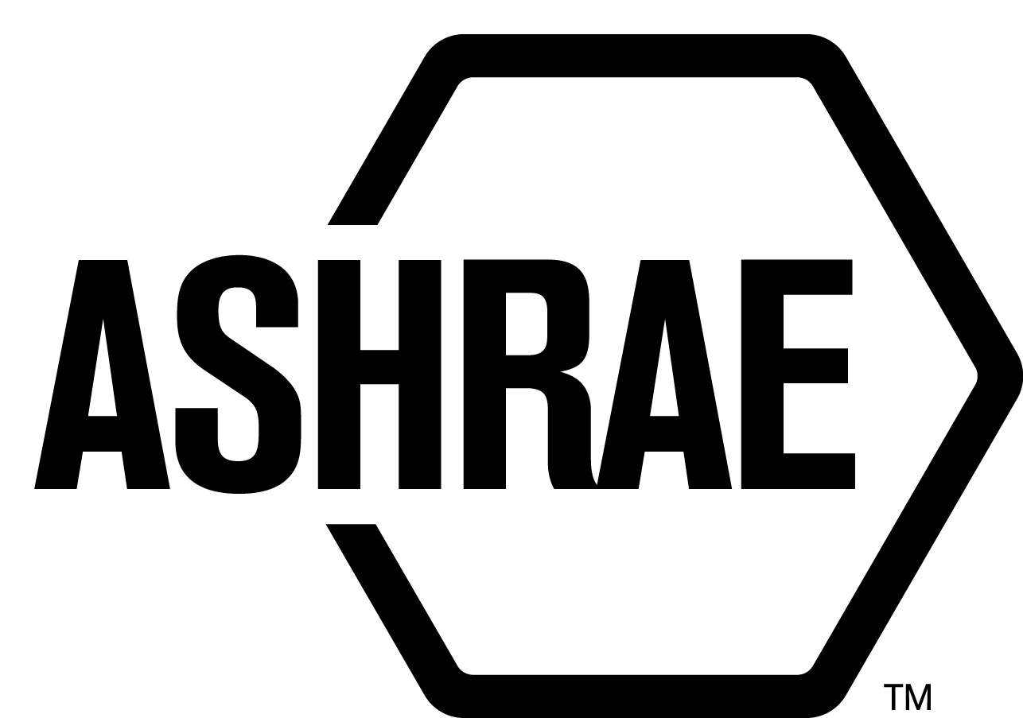

STANDARDS REAFFIRMATION SUBCOMMITTEE (SRS)

MINUTES

St. Louis Marriott Grand Hotel
St. Louis, MO
Meeting of June 28, 2016

NOTE: These draft minutes have not been approved and are not the official, approved record until approved by SRS.

TABLE OF CONTENTS
1. Call to Order/Introductions and Review of Agenda 4
2. Chairman’s Report 4
3. Staff Report 4
4. Approval of Minutes 4
5. Review of Action Items/ Unfinished Business 4
6. Drafts for Reaffirmation Publication Public Review 4
7. Drafts for Revision Publication Public Review 4
9. Drafts for Withdrawal 5
10. New Business 5
11. Next Meeting 5
12. Adjournment 5

MAJOR MOTIONS PASSED
MOTION # | PAGE | MOTION

ACTION ITEMS ASSIGNED ORLANDO, FL
AI# | Action | Assigned to | Status
 | None

1. Call to Order/Introductions and Review of Agenda

Call to Order

The Standards Reaffirmation Subcommittee (SRS) meeting was called to order on Tuesday, June 28, 2016, in Benton (M).

Introductions

Chairman Rita Harrold greeted members and guests.

SRS Members  Rita Harrold, Chair  James Aswegan  Niel Bidstrup  Rick Larson  Cyrus Nasseri | SRS Members Absent  Dennis Knight  Arsen Melikov  Guests  Steve Emmerich | Staff  Tanisha Meyers-Lisle, Procedures Administrator

2. Chairman’s Report
There have been discussions to combine both PPIS and SRS since their duties are fairly similar in nature. Thoughts can be shared with the incoming SRS Chair, Standards Committee Chair and Vice Chair.

3. Staff Report
None.

4. Approval of Minutes
The SRS Minutes from the 2016 Spring Meeting were presented to members for approval.

It was moved by James Aswegan and seconded by Niels Bidstrup:

1 That the SRS Minutes from the 2016 Spring Meeting be approved as written.

MOTION 1 PASSED: 4-0-0, CNV
Secretary’s Note: Dennis Knight and Arsen Melikov were not present.

5. Review of Action Items/ Unfinished Business
A list of Action Items was presented to SRS members for review and is updated on page iii.

6. Drafts for Reaffirmation Publication Public Review
None.

7. Drafts for Revision Publication Public Review

None.

9. Drafts for Withdrawal
None.

10. New Business
None.

11. Next Meeting
Tech Weekend – TBA
Doodle poll will be sent by Staff in July.

12. Adjournment
The SRS meeting adjourned at 5:10 p.m.

