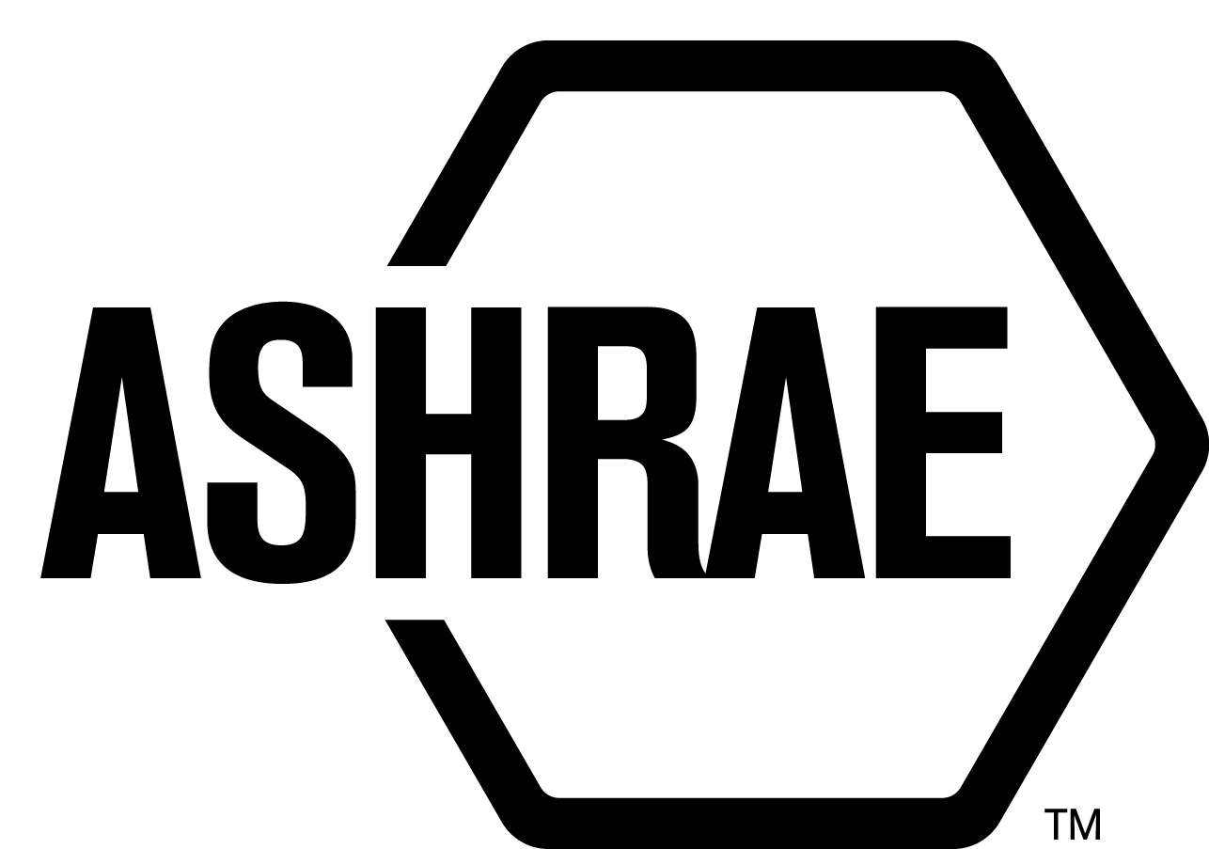

STANDARDS REAFFIRMATION SUBCOMMITTEE (SRS)

MINUTES

Spring Meeting Conference Call
Meeting of April 14, 2016

NOTE: These draft minutes have not been approved and are not the official, approved record until approved by SRS.

TABLE OF CONTENTS
1. Call to Order/Introductions and Review of Agenda 4
2. Chairman’s Report 4
3. Staff Report 4
4. Approval of Minutes 4
5. Review of Action Items/ Unfinished Business 4
6. Drafts for Reaffirmation Publication Public Review 4
7. Drafts for Revision 5
8. Drafts for Revision Publication Review 5
9. Drafts for Withdrawal 5
10. New Business 5
11. Next Meeting 6
12. Adjournment 6

MAJOR MOTIONS PASSED
MOTION # | PAGE | MOTION
2 | 4 | It is recommended that SRS committee agenda item 6A be approved for reaffirmation publication public review.
3 | 5 | It is recommended that SRS Committee agenda item 7A-C be approved for revision.

ACTION ITEMS ASSIGNED ORLANDO, FL
AI# | Action | Assigned to | Status
 | None

1. Call to Order/Introductions and Review of Agenda

Call to Order

The Standards Reaffirmation Subcommittee (SRS) meeting was called to order on Thursday, April 14, 2016 via conference call.

Introductions

Chairman Rita Harrold greeted members and guests.

SRS Members  Rita Harrold, Chair  James Aswegan  Niel Bidstrup  Rick Larson  Dennis Knight  Arsen Melikov | SRS Members Absent  Rick Larson  Cyrus Nasseri  Guests | Staff  Tanisha Meyers-Lisle, Procedures Administrator

2. Chairman’s Report
None.

3. Staff Report
None.

4. Approval of Minutes
The SRS Minutes from the 2016 Orlando Winter Meeting were presented to members for approval.

It was moved by Niels Bidstrup and seconded by Jim Aswegan:

1 That the SRS Minutes from the 2016 Orlando Winter Meeting be approved as written.

MOTION 1 PASSED: 5-0-0, CNV

5. Review of Action Items/ Unfinished Business
A list of Action Items was presented to SRS members for review and is updated on page iii.

6. Drafts for Reaffirmation Publication Public Review
It was moved by Dennis Stanke and seconded by Arsen Melikov,

2 That the item 6A be approved for reaffirmation publication public review.

6A ANSI/ASHRAE Standard 137-2013, Methods of Testing for Efficiency of Space-Conditioning/Water Heating Appliances that Include a Desuperheater Water Heater

MOTION 2 PASSED: 6-0-0, CNV
*Secretary’s Note: A letter ballot was sent to Rick Larson and Cyrus Nasseri, both voted in the affirmative for all motions.

7. Drafts for Revision
It was moved by Dennis Stanke and seconded by Jim Aswegan:

3 That items 7A-7E be approved as consent agenda for revision publication public review.

7A ANSI/ASHRAE Standard 41.1-2013, Standard Method for Temperature Measurement, be approved for revision and a revision project committee be formed. SSPC 41 voted to approve the revision of ANSI/ASHRAE Standard 41.1-2013. SSPC 41 also recommended Erik Anderson to chair the revision project committee. There are at least five members willing to volunteer for the revision project committee.

7B ANSI/ASHRAE Standard 41.10-2013, Standard Methods for Refrigerant Mass Flow Measurement Using Flowmeters, be approved for revision and a revision project committee be formed. SSPC voted to approve the revision of ANSI/ASHRAE Standard 41.10-2013. SSPC 41 also recommended John Neel as Chair. There are at least five members willing to volunteer for the revision project committee.

7C ANSI/ASHRAE Standard 195-2013, Method of Test for Rating Air Terminal Unit Controls, be approved for revision with the existing committee. TC 1.4, Control Theory and Application, voted to approve the revision of ANSI/ASHRAE Standard 195-2013. TC 1.4 also recommended Jim Coogan as Chair. There are at least five members willing to volunteer for the revision project committee.

MOTION 3 PASSED: 6-0-0, CNV
*Secretary’s Note: A letter ballot was sent to Rick Larson and Cyrus Nasseri, both voted in the affirmative for all motions.

8. Drafts for Revision Publication Review
None.

9. Drafts for Withdrawal
None.

10. New Business
SRS discussed the TC Member Survey on standard needs and has requested the TC Chairs add the feedback as a discussion item on their agendas.

11. Next Meeting
Annual Meeting

12. Adjournment
The SRS meeting adjourned at 10:00 a.m.

