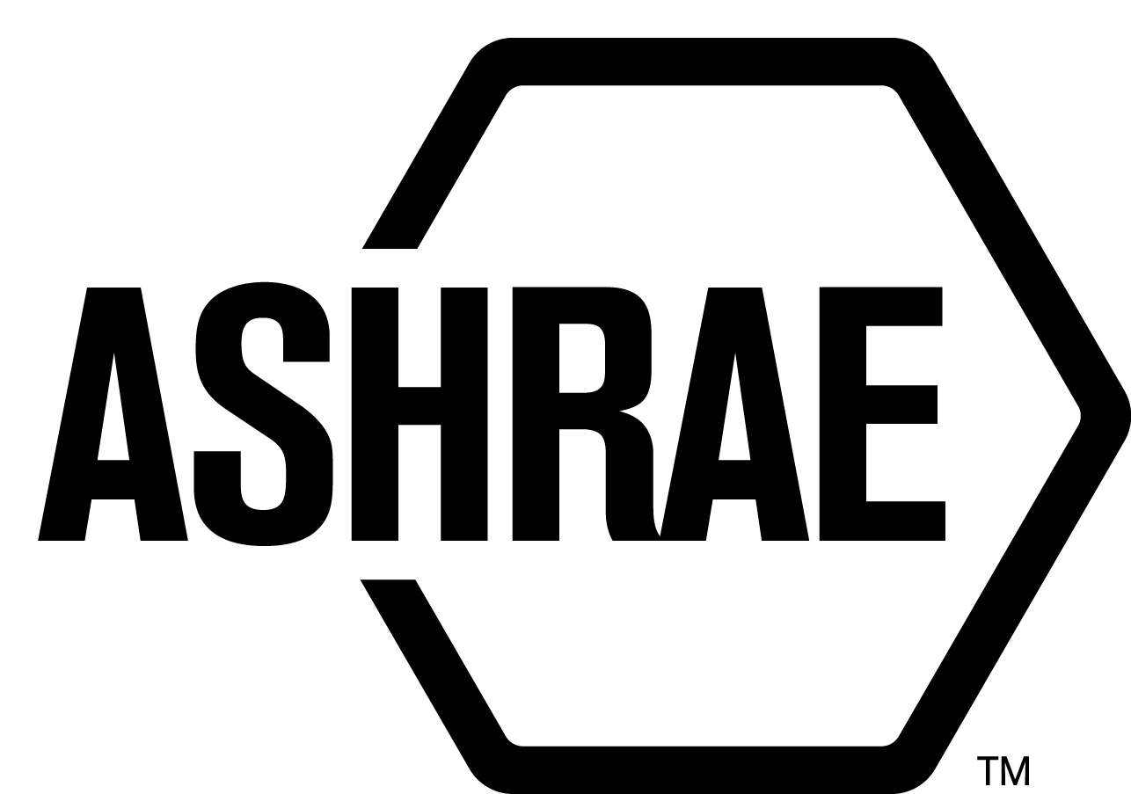

STANDARDS REAFFIRMATION SUBCOMMITTEE (SRS)

MINUTES

Conference Call
Meeting of March 28, 2014

NOTE: These draft minutes have not been approved and are not the official, approved record until approved by SRS.

TABLE OF CONTENTS
1. Call to Order/Introductions and Review of Agenda 4
2. Chairman’s Report 4
3. Staff Report 4
4. Approval of Minutes 4
5. Review of Action Items/ Unfinished Business 4
6. Drafts for Reaffirmation Publication Public Review 4
7. Drafts for Revision 5
8. Drafts for Publication 5
9. Drafts for Withdrawal 5
10. New Business 5
11. Next Meeting 5
12. Adjournment 5

MAJOR MOTIONS PASSED
MOTION # | PAGE | MOTION
2 | 4 | It is recommended that SRS Committee agenda item 6A, be approved for reaffirmation publication public review.
3 | 5 | It is recommended that SRS Committee agenda items 7A and 7B, be approved for revision public review.

ACTION ITEMS ASSIGNED
AI# | Action | Assigned to | Status
 | None

1. Call to Order/Introductions and Review of Agenda

Call to Order

The Standards Reaffirmation Subcommittee (SRS) meeting was called to order on Friday, March 28, 2014.

Introductions

Chairman Rick Hall greeted members.

SRS Members  Rick Hall, Chair  James Aswegan  Malcolm D. Knight  Rick Larson | SRS Members Absent  Cyrus Nasseri  Guests | Staff  Tanisha Meyers-Lisle, Procedures Administrator

2. Chairman’s Report
None.

3. Staff Report
None.

4. Approval of Minutes
The SRS Minutes from the 2014 Winter meeting were presented to members for approval.

It was moved by Jim Aswegan and seconded by Dennis Knight:

1 That the SRS Minutes from the January 21, 2014 Annual meeting be approved as written.

MOTION 1 PASSED: 4¹-0-0, CNV
¹Secretary’s Note: Cyrus Nasseri was absent.

5. Review of Action Items/ Unfinished Business
A list of Action Items was presented to SRS members for review and is updated on page iii.

6. Drafts for Reaffirmation Publication Public Review
It was moved by Rick Hall and seconded by Jim Aswegan:

2 That item 6A be approved for reaffirmation publication public review.

6A ANSI/ASHRAE/ACCA Standard 183-2007 RA 2009, Peak Cooling and Heating
Load Calculations in Buildings Except Low-Rise Residential Buildings

MOTION 2 PASSED: 5-0-0, CV
Secretary’s Note: Letter Ballot issued on 3/28/2014 to Cyrus Nasseri since he was not present on the call.

7. Drafts for Revision
It was moved by Rick Hall and seconded by Rick Larson:

3 That items 7A and 7B be approved by consent agenda for revision public review

7A ANSI/ASHRAE Standard 32.2-2003 (RA 2011), Methods of Testing for Rating
Pre-Mix and Post-Mix Beverage Dispensing Unit

7B ANSI/ASHRAE Standard 70-2006 (RA 2011), Method of Testing the Performance of Air Outlets and Air Inlets

MOTION 3 PASSED: 4-0-0, CV
Secretary’s Note: Cyrus Nasseri did not need to vote on these items since they are not standards actions.

8. Drafts for Publication
No action taken.

9. Drafts for Withdrawal
No action taken.

10. New Business
None.

11. Next Meeting
Annual Meeting
Seattle, WA
June 28, 2014 – July 2, 2014

12. Adjournment
The SRS meeting adjourned at 10:15am.

