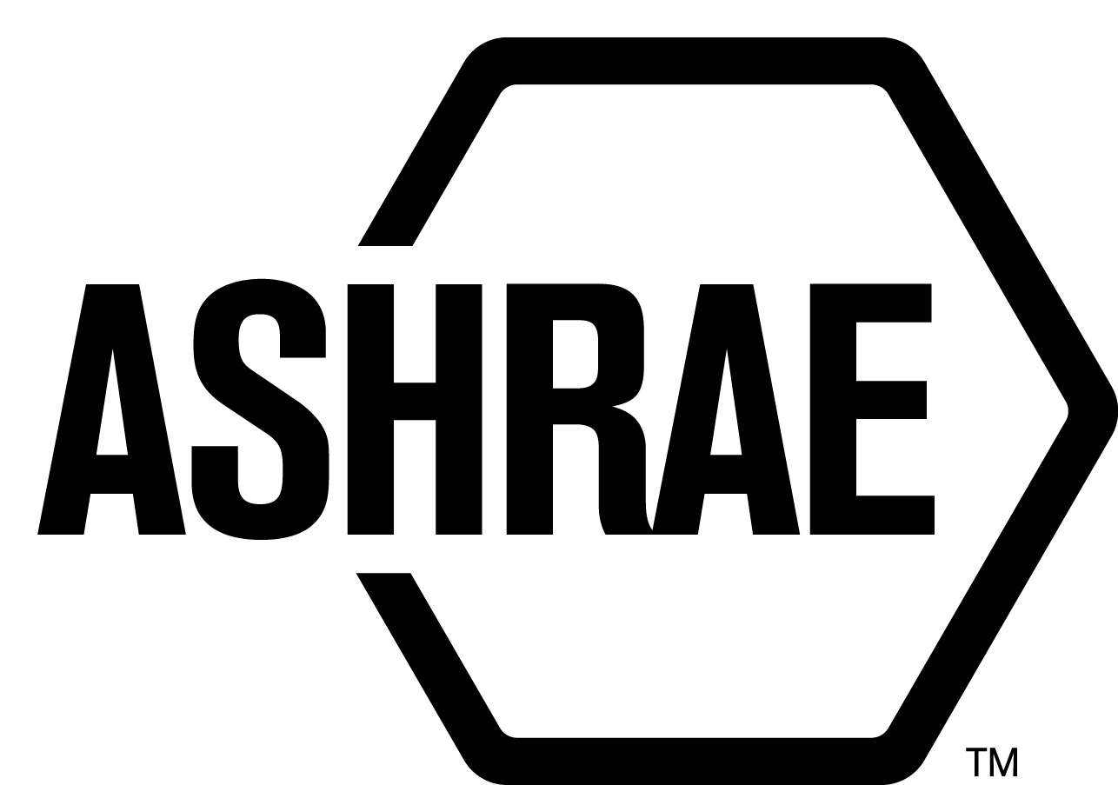

STANDARDS REAFFIRMATION SUBCOMMITTEE (SRS)

MINUTES

Caesars Palace
Las Vegas, NV
Meeting of January 31, 2017

NOTE: These draft minutes have not been approved and are not the official, approved record until approved by SRS.

TABLE OF CONTENTS
1. Call to Order/Introductions and Review of Agenda 4
2. Chairman’s Report 4
3. Staff Report 4
4. Approval of Minutes 4
5. Review of Action Items/ Unfinished Business 4
6. Drafts for Reaffirmation Publication Public Review 4
7. Drafts for Revision Publication Public Review 4
9. Drafts for Withdrawal 5
10. New Business 5
11. Next Meeting 5
12. Adjournment 5

ACTION ITEMS ASSIGNED LAS VEGAS 2017
AI# | Action | Assigned to | Status
 | None

1. Call to Order/Introductions and Review of Agenda

Call to Order

The Standards Reaffirmation Subcommittee (SRS) meeting was called to order on Tuesday, January 31, 2017 in Calabria.

Introductions

Chairman Steven Emmerich was not at the meeting but he voted on all motions via letter ballot. Rick Heiden was elected to serve as interim chair for the SRS meeting in Las Vegas.

SRS Members  Rick Heiden, Interim Chair  James Aswegan  Niel Bidstrup  Rick Larson  Arsen Melikov  Cyrus Nasseri | SRS Members Absent  Steven Emmerich, Chair  Guests | Staff  Stephanie Reiniche, Sr. Manager of Standards

2. Chairman’s Report
None.

3. Staff Report
None.

4. Approval of Minutes
The SRS Minutes from the 2016 Annual Meeting were presented to members for approval.

It was moved by James Aswegan and seconded by Niels Bidstrup:

1 That the SRS Minutes from the 2016 Annual Meeting be approved as written.

MOTION 1 PASSED: 5-0-0, CNV
Secretary’s Note: Steve Emmerich was not present.

5. Review of Action Items/ Unfinished Business
A list of Action Items was presented to SRS members for review and is updated on page iii.

6. Drafts for Reaffirmation Publication Public Review
It was moved by Jim Aswegan and seconded by Cyrus Nasseri,

2 That the following items be approved as consent agenda for reaffirmation publication public review:

- ANSI/ASHRAE Standard 78-1985 (RA 2007), Method of Testing Flow Capacity of Suction Line Filter-Driers

- ANSI/ASHRAE Standard 97-2007, Sealed Glass Tube Method to Test the Chemical Stability of Materials for Use Within Refrigerant Systems

- ANSI/ASHRAE Standard 206-2013, Method of Testing for Rating of Multi-Purpose Heat Pumps for Residential Space Conditioning and Water Heating

MOTION 2 PASSED: 6-0-0, CV

7. Drafts for Revision Public Review
It was moved by Jim Aswegan and seconded by Cyrus Nasseri:

3 That the following be approved for revision and a revision project committee be formed:

ANSI/ASHRAE Standard 190-2013, Method of Testing for Rating Indoor Pool Dehumidifiers, be approved for revision and that a revision project committee be formed. TC 8.10, Mechanical Dehumidification Equipment and Heat Pipes, voted to approve the revision of ANSI/ASHRAE Standard 190-2013. TC 8.10 also recommended Titu Doctor to chair the revision project committee. There are at least five members willing to volunteer for the revision project committee

MOTION 3 PASSED: 6-0-0, CV

It was moved by Jim Aswegan and seconded by Cyrus Nasseri:

4 That the following be approved for revision and a revision project committee be formed:

ANSI/ASHRAE Standard 198-2013, Method of Testing for Rating DX-Dedicated Outdoor Air Systems for Moisture Removal Capacity and Moisture Removal Efficiency, be approved for revision and that a revision project committee be formed. TC 8.10, Mechanical Dehumidification Equipment and Heat Pipes, voted to approve the revision of ANSI/ASHRAE Standard 198-2013. TC 8.10 also recommended Craig Burg to chair the revision project committee. There are at least five members willing to volunteer for the revision project committee.

MOTION 4 PASSED: 6-0-0, CV

9. Drafts for Withdrawal
None.

10. New Business
None.

11. Next Meeting
Spring Meeting 2017.
TBA

12. Adjournment
The SRS meeting adjourned at 5:20 p.m.

