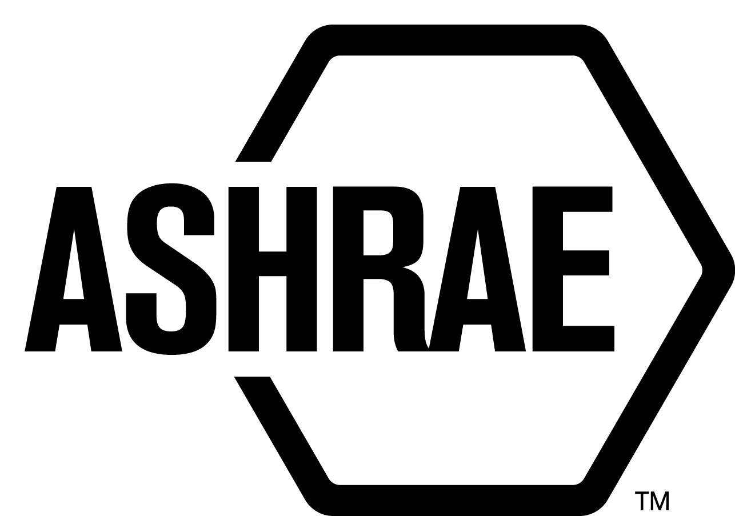

STANDARDS REAFFIRMATION SUBCOMMITTEE (SRS)

MINUTES

Palmer House Hilton
Chicago, IL
Meeting of January 23, 2018

NOTE: These draft minutes have not been approved and are not the official, approved record until approved by SRS.

TABLE OF CONTENTS
1. Call to Order/Introductions and Review of Agenda 3
2. Chairman’s Report 3
3. Staff Report 3
4. Approval of Minutes 3
5. Review of Action Items/ Unfinished Business 3
6. Drafts for Reaffirmation Publication Public Review 3
7. Drafts for Revision Public Review 3
9. Drafts for Withdrawal 3
10. New Business 4
11. Next Meeting 4
12. Adjournment 4

ACTION ITEMS ASSIGNED CHICAGO 2018
AI# | Action | Assigned to | Status
 | None

1. Call to Order/Introductions and Review of Agenda

Call to Order

The Standards Reaffirmation Subcommittee (SRS) meeting was called to order on Tuesday, January 23, 2017 in Wilson.

Introductions

Chairman Donald Brundage greeted guests and members.

SRS Members  Donald Brundage, Chair  Niels Bidstrup  Rick Heiden  Kwang Woo Kim  Doug Tucker  Mike Gallagher | SRS Members Absent  Arsen Melikov  Guests  Danny Halel | Staff  Tanisha Meyers-Lisle, Procedures Administrator

2. Chairman’s Report
The Chairman acknowledged the Code of Ethics.

3. Staff Report
None.

4. Approval of Minutes
No minutes were approved at this meeting. Long Beach 2017 and Tech Weekend 2017 meetings were done via letter ballot.

5. Review of Action Items/ Unfinished Business
A list of Action Items was presented to SRS members for review and is updated on page iii.

6. Drafts for Reaffirmation Publication Public Review
None.

7. Drafts for Revision Public Review

None.

9. Drafts for Withdrawal
1 It was moved by Mike Gallagher and seconded by Rick Heiden;

That ANSI/ASHRAE Standard 149-2013 be approved for withdrawal public review.

Background: TC 5.1 believes that ASHRAE 149 has no reported use. In addition, after its approval, AMCA International developed a certification based on this standard and no entity showed any interest in it. It is believed that its non-usage does not warrant the resources needed to revise it.

MOTION 1 PASSED: 6-0-0, CNV
Secretary’s Note: A continuation letter ballot was sent on January 23, 2018 to Arsen Melikov with a deadline of January 30, 2018. Mr. Melikov responded on January 24, 2018 with an affirmative vote to approve the withdrawal public review.

10. New Business
ANSI/ASHRAE Standard 134-2005 (RA 2014)W, Graphic Symbols for Heating, Ventilating, Air-Conditioning, and Refrigerating Systems – went out for withdrawal public review 10/27/2017 – 12/11/217. One comment from Mr. Halel was received on November 3, 2017. Staff emailed the TC Chair, Mr. Roger Lautz on 12/11/17 and the SRS Chair emailed him on 12/12/17 with several alternatives.

Mr. Halel agrees to withdraw his comment if ASHRAE puts out a withdrawal notice and includes that the information from ANSI/ASHRAE Standard 134-2005 (RA2014) can now be located in the 2017 ASHRAE Handbook of Fundamentals, Chapter 38 “Abbreviations and Symbols”.

11. Next Meeting
Annual Meeting
Houston 2018

12. Adjournment
The SRS meeting adjourned at 5:50 p.m.

