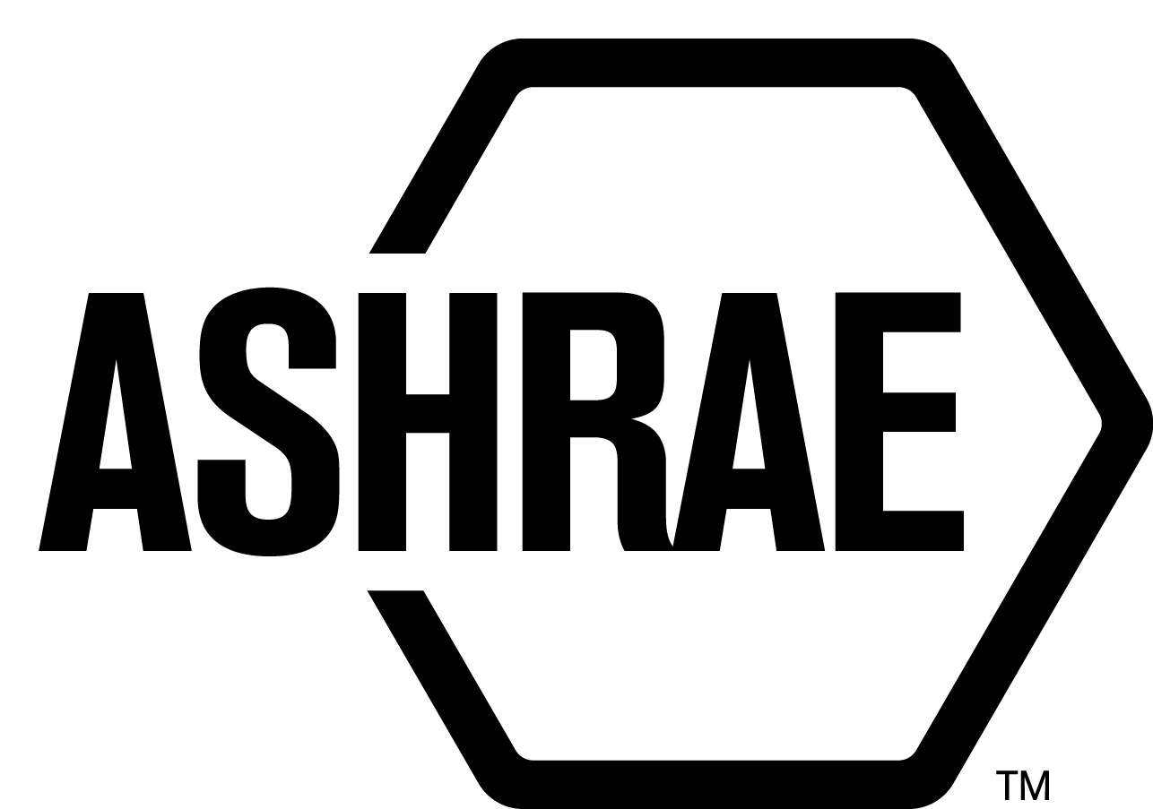

STANDARDS REAFFIRMATION SUBCOMMITTEE (SRS)

MINUTES

Palmer House Hilton
Chicago, IL
Meeting of January 27, 2015

NOTE: These draft minutes have not been approved and are not the official, approved record until approved by SRS.

TABLE OF CONTENTS
1. Call to Order/Introductions and Review of Agenda 4
2. Chairman’s Report 4
3. Staff Report 4
4. Approval of Minutes 4
5. Review of Action Items/ Unfinished Business 4
6. Drafts for Reaffirmation Publication Public Review 5
7. Drafts for Revision 5
8. Drafts for Publication 5
9. Drafts for Withdrawal 5
10. New Business 6
11. Next Meeting 6
12. Adjournment 6

MAJOR MOTIONS PASSED
MOTION # | PAGE | MOTION
2 | 5 | It is recommended that SRS committee agenda item 6, be approved for reaffirmation publication public review.
3 | 5 | It is recommended that SRS Committee consent agenda item 7, be approved for revision publication public review.
4 | 5 | It is recommended that SRS Committee consent agenda item 9A, be approved for withdrawal publication public review.
5 | 6 | It is recommended that SRS Committee consent agenda item 9B, be approved for withdrawal publication public review.

ACTION ITEMS ASSIGNED CHICAGO, IL
AI# | Action | Assigned to | Status
 | None

1. Call to Order/Introductions and Review of Agenda

Call to Order

The Standards Reaffirmation Subcommittee (SRS) meeting was called to order on Tuesday, January 27, 2015, in Montrose 4 (7).

Introductions

Chairman Dug Reindl greeted members and guests.

SRS Members  Doug Reindl, Chair  James Aswegan  Dennis Knight  Rick Larson  Arsen Melikov  Cyrus Nasseri | SRS Members Absent  Guests | Staff  Tanisha Meyers-Lisle, Procedures Administrator

2. Chairman’s Report
There is an ongoing action item to get standards in mandatory language. When the TC recommends a standard for reaffirmation, it is reviewed by Staff and feedback is provided to the TC. There seems to be a cycle of standards that are recommended for reaffirmation but should be recommended for revision. To fully enforce the inclusion of mandatory language in all standards would place a tremendous load on SPLS. SRS will continue to work with Staff to get TCs to revise their standards and bring it in line with ASHRAE’s mandatory language requirement.

3. Staff Report
None.

4. Approval of Minutes
The SRS Minutes from the 2014 Seattle Annual Meeting were presented to members for approval.

It was moved by Rick Larson and seconded by Dennis Knight:

1 That the SRS Minutes from the 2014 Seattle Annual Meeting be approved as written.

MOTION 1 PASSED: 5-0-0, CNV

5. Review of Action Items/ Unfinished Business
A list of Action Items was presented to SRS members for review and is updated on page iii.

6. Drafts for Reaffirmation Publication Public Review
It was moved by Doug Reindl and seconded by Dennis Knight

2 That ANSI/ASHRAE Standard 118.2-2006, Method of Testing for Rating Residential Water Heaters be approved for reaffirmation publication public review.

BACKGROUND: SPC 118.2-2006R voted to reaffirm this standard “as is” to avoid losing the ANSI designation. They are in the process of revising the standard to meet the latest US Department of Energy final test procedures for rating residential (and light commercial) water heaters.

MOTION 2 PASSED: 5-0-0, CNV

7. Drafts for Revision
It was moved by Doug Reindl and seconded by Jim Aswegan:

3 That items 7A-7F be approved as consent agenda for revision publication public review.

7A ANSI/ ASHRAE Standard 64-2011, Methods of Laboratory Testing Remote Mechanical-Draft Evaporative Refrigerant Condensers

7B ANSI/ASHRAE Standard 146-2011, Methods of Testing and Rating Pool Heaters: TC 6.6 Service Water Heating Systems

7C ANSI/ASHRAE Standard 158.2-2011, Method of Testing Capacity of Refrigerant Pressure Regulators

7D ASHRAE Guideline 29-2009, Guideline for the Risk Management of Public Health and Safety in Buildings: TG2 HVAC

7E ANSI/ASHRAE Standard 182-2008 RA 2013 (R), Method of Testing Absorption Water-Chilling and Water-Heating Packages

7F ANSI/ASHRAE Standard 194-2012 (R), Method of Test for Direct-Expansion Ground-Source Heat Pumps

MOTION 3 PASSED: 5-0-0, CNV

8. Drafts for Publication
No action taken.

9. Drafts for Withdrawal
It was moved by Jim Aswegan and seconded by Cyrus Nasseri:

4 That item 9A be approved for withdrawal public review.

9A ASHRAE Standard 74-1988, Method of Measuring Solar-Optical Properties of Materials

BACKGROUND: TC 4.5, Fenestration, voted 4-0-0 to withdraw this standard, Guideline 25 P was created to replace Standard 74, but there was little to no activity in GPC 25 and the committee was disbanded in June 2014. Standard 74-1988 is no longer ANSI designated.

MOTION 4 PASSED: 5-0-0, CNV

It was moved by Rick Larson and seconded by Dennis Knight:

5 That item 9B be approved for withdrawal public review.

9B ASHRAE Guideline 26-2012, Guideline for Field Testing of General Ventilation Filtration Devices and Systems for Removal Efficiency In-Situ by Particle Size and Resistance to Airflow

BACKGROUND: C 2.4, Particulate Air Contaminants and Particulate Contaminant Removal Equipment, voted to withdraw this standard. International Standards Organization (ISO) Standard 29462 on in-situ testing of particle filters was published September 2013. It is technically and procedurally identical to ASHRAE GPC 26, and ASHRAE has decided to adopt the ISO document. ASHRAE has asked TC 2.4, the parent committee of this Guideline, to vote to withdraw GPC 26. The motion recommending withdrawal of GPC 26 and its replacement with ISO 29462 was proposed by Mike Corbat, seconded by Tim Johnson, and carried by a vote of 10-1-1-5-18 (CNV). Al Veeck voted against the motion on the grounds that the ISO process is likely to be a lot slower than ASHRAE, and that if changes are made to the document in future, the USA would lose control of the document’s contents. While ASHRAE will lose sales revenue with discontinuation of GPC 26, it should be noted that it supports the concept of international standards, and also holds the Secretariat for ISO TC 142 which produced Standard 29462.

MOTION 5 PASSED: 5-0-0, CNV

10. New Business
None.

11. Next Meeting
Annual Meeting 2015
Atlanta, GA

12. Adjournment
The SRS meeting adjourned at 5:30 p.m.

