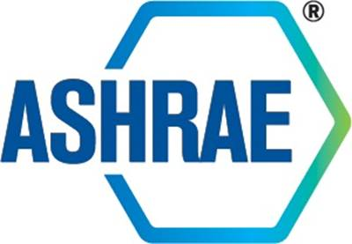

STANDARDS COMMITTEE
MINUTES

ASHRAE Fall Meeting 2017
October 3, 2017

Approved by Standards Committee January 20, 2018

TABLE OF CONTENTS

1. Call to Order and Introductions 1
2. Adoption of the Agenda 1
3. Chair’s Report 1
4. Sr. Manager of Standards Report 1
5. Approval of Minutes 2
6. Review of Action Items 2
7. Publication Drafts 2
8. SPLS Report 2
9. PPIS Report 3
10. SRS Report 4
11. Standards Committee MBOs 4
12. Standards Committee Strategic Plan 4
13. New Business 4
14. Next Meeting/Closing Items 5
15. Adjournment 5
16. Attachments 5

Standards Committee Action Items
As of October 3, 2017
Updated Items Noted in Red

January 2017 Las Vegas Winter Meeting
AI# | Action Item | Assigned | Status
1 | Action item to staff, SPLS and PPIS to review the Standards Achievement Award process and point system to more clearly identify the goals of the award and to evaluate the point allocation criteria and its limitations.  Steve Ferguson will draft a proposal for the Chicago meeting | Staff, SPLS, PPIS | Open

1. Call to Order and Introductions

The Standards Committee Fall Meeting was called to order on October 3, 2017 at 1:00 pm ET via webinar.

Introductions

Chair Steve Emmerich welcomed members of the committee, staff and guests. The attendees were as follows:

Members Present  Steven Emmerich  Donald Brundage  Niels Bidstrup  Michael Corbat  Drury Crawley  Vinod Gupta  Julie Ferguson  Michael Gallagher  Walter Grondzik  Susanna Hanson  Roger Hedrick  Rick Heiden  Jonathan Humble  Srinivas Katipamula  Larry Kouma  Lee Millies  Karl Peterman  Erick Phelps  Peter Simmonds  Dennis Stanke  Wayne Stoppelmoor  Richard Swierczyna | Members Not Present  Kwang Woo Kim  Dave Robin  Arsen Melikov  Jack Zarour  Staff Present  Connor Barbaree, MOS-Codes  Steve Ferguson, Sr. MOS  Susan LeBlanc, SA  Stephanie Reiniche, DOT  Tanisha Meyers-Lisle, PA  Guests Present  Travis English  Mick Schwedler

2. Adoption of the Agenda

The agenda was adopted as presented. A reference and brief review the ASHRAE Code of Ethics was made.

3. Chair’s Report

No report.

4. Sr. Manager of Standards Report

The Senior Manager of Standards reported on the following three items:
- Appeals on addenda a and b to Standard 100, and addendum as to Standard 189.1 are complete. The appeal on addendum a to Standard 100 was upheld and sent back to committee for further action. The appeal on addendum b to Standard 100 was denied. The appeal on addendum as to Standard 189.1 was denied without a hearing.

- Connor Barbaree had been promoted to the Manager of Codes (from the Assistant Manager of Standards – Codes position), effective October 2, 2017, and that a review of applications for the vacant AMOS-C position would begin in short order.

- The ASHRAE Staff has been meeting with the contractor on the update to the online comment database which will include processing CMPs, balloting, and expanded reporting capabilities. It is expected that a staff testing environment will be available Dec/Jan, further testing (including members and committee chairs) will be held in Jan/Feb, and the update will hopefully go live in March/April 2018.

5. Approval of Minutes

It was moved by Dennis Stanke and seconded by Don Brundage:

1 That the StdC Long Beach 2017 Annual Meeting Minutes be approved as presented.

MOTION PASSED. 19-0-2 Chair not Voting (CNV)

6. Review of Action Items

See the updated status of Action Items beginning on page 2.

7. Publication Drafts

It was moved by Roger Hedrick and seconded by Jonathan Humble:

2 That the following be approved by consent agenda for publication:
- BSR/ASHRAE Addendum c to ANSI/ASHRAE Standard 34-2016, Designation and Safety Classification of Refrigerants (for immediate publication)
- BSR/ASHRAE Addendum f to ANSI/ASHRAE Standard 34-2016, Designation and Safety Classification of Refrigerants (for immediate publication)

MOTION PASSED. 21-0-0, CNV

8. SPLS Report

The SPLS Report was presented by SPLS Chair, Roger Hedrick. For more information regarding this report please see Attachment A.

It was moved by Roger Hedrick:

3 That the proposed TPS for SPC 207, Laboratory Method of Test of Fault Detection and Diagnostics Applied Commercial Air-Cooled Packaged Systems, be approved as shown in Attachment B.

MOTION PASSED. 21-0-0, CNV

It was moved by Roger Hedrick:

4 It is recommended that the Las Vegas motion for a waiver of PASA 7.8.1, Project Discontinuation Due to Lack of Membership, for SPC 113, Method of Testing Room Air Diffusion, for six months ending July 30, 2017, be reconsidered.
MOTION PASSED. 21-0-0, CNV

It was moved by Roger Hedrick:

5 It is recommended that a waiver of PASA 7.8.1, Project Discontinuation Due to Lack of Membership, for SPC 113, Method of Testing Room Air Diffusion, until December 1, 2017, be approved.

MOTION PASSED. 21-0-0, CNV

9. PPIS Report

The PPIS Report was presented by PPIS Chair, Wayne Stoppelmoor. For more information regarding this report please see Attachment C.

It was moved by Wayne Stoppelmoor:

6 That the following Title, Purpose and Scope (TPS) and that a new Guideline Project Committee be formed:

TITLE: Commissioning of Data Centers

1. PURPOSE:
This guideline provides technical support for the application of the commissioning process to data centers.

2. SCOPE:
This guideline:
2.1 Provides assistance in the application of ASHRAE Guideline 0 or ASHRAE
Standard 202 to data centers;
2.2 Addresses commissioning process issues that are particular to data centers;
2.3 Provides technical support for the commissioning of data centers;
2.4 Is intended for use with new and existing buildings;
2.5 Applies to data center support infrastructure – not to data equipment networks.

MOTION PASSED. 20-0-1, CNV

Secretary’s note: SSPC 300, Commissioning, will be assigned as cognizant committee responsible for the development of this project.

10. SRS Report

The SRS Report was presented by SRS Chair, Don Brundage. For more information regarding this report please see Attachment D.

It was moved by Don Brundage:

7 That ANSI/ASHRAE Standard 105-2014, Standard Methods of Determining, Expressing and Comparing Building Energy Performance and Greenhouse Gas Emissions, be approved for revision and that a new project committee be formed.

MOTION PASSED. 20-0-1, CNV

11. Standards Committee MBOs

The StdC MBOs were referenced with no action taken (see Attachment E).

12. Standards Committee Strategic Plan

The StdC Strategic Plan was referenced with no action taken (see Attachment F).

13. New Business

It was moved by Don Brundage and seconded by Dennis Stanke:

8 That the draft StdC response to a Complaint of Action or Inaction against SSPC 170, filed by Travis R. English be approved as amended (see Attachment G).

MOTION PASSED. 20-0-0, CNV

Secretary’s note: Standards Committee was informed of a request from Members Council regarding a referral to SPC 180 and proposed changes to ASHRAE Standard 180-2012R, Standard Practice for Inspection and Maintenance of Commercial-Building HVAC Systems. No action was required of Standards Committee, but the response from ASHRAE Staff is shown in Attachment H.

EXECUTIVE SESSION

It was moved and seconded:

9 That Tech Council reconsider the motion to postpone the motion to withdraw as a co-sponsor of ICC 700.

MOTION PASSED.

END OF EXECUTIVE SESSION

14. Next Meeting/Closing Items

Next Meeting:
- ASHRAE Chicago Winter Meeting, January 20 and 24, 2018

15. Adjournment

The Standards Committee conference call adjourned at approximately 3:00 PM ET.

16. Attachments

Attachment A
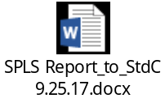

Attachment B
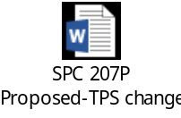

Attachment C
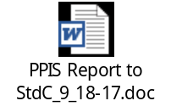
Attachment D
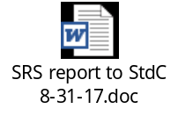
Attachment E
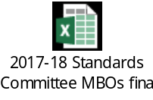

Attachment F


Attachment G
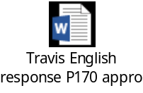

Attachment H
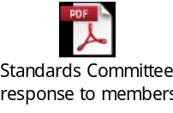

Mike Corbat and Jonathan Humble abstained because they did not attend the meeting.
Walter Grondzik abstained because he is a proponent of the project.
Don Brundage abstained because is a proposed member of the SPC.

