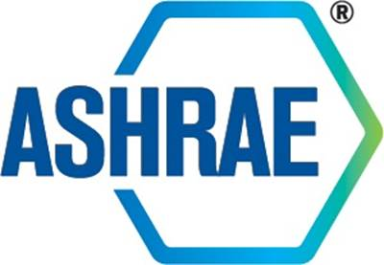

**STANDARDS COMMITTEE**

**MINUTES**

**September 13, 2021 Meeting**

*Approved by StdC October 19, 2021*

# 1. Call to Order and Introductions

The Standards Committee meeting was called to order on September 13, 2021 at 2:00 pm EDT via conference call.

**Introductions**

StdC members and staff were greeted, and new members welcomed. The attendees were as follows:

|  |  |
| --- | --- |
| **Members Present**  Rick Heiden, *Chair*  Susanna Hanson  Charles Barnaby  Robert B. Burkhead  Thomas Cappellin  Douglas D. Fick  Mike Gallagher  Patricia Graef  Srinivas Katipamula  Gerald Kettler  Jay Kohler  Cesar L. Lim  Paul Lindahl  Jim Lutz  Julie Majurin  Larry Markel  Gwelen Paliaga  Justin Prosser  Dave Robin  Lawrence Schoen  Steven C. Sill  Rusty Tharp  Bill Walter  Craig P. Wray  Jaap Hogeling, ExO | **Members Not Present**  Essam E. Khalil  Dennis Knight  Margaret Mathison  Christian Taber  **Staff Present**  Connor Barbaree, *Sr MOS*  Susan LeBlanc, *SA*  Tanisha Meyers-Lisle, *PA*  **Guests Present**  None |

# 2. Adoption of the Agenda

The agenda was adopted as presented and a review of the ASHRAE Code of Ethics and Anti-Trust Guidelines was made.

# 3. Training

Chair, Rick Heiden presented a condensed version of the Standards Committee training deck as shown in Attachment A.

# 4. New Business

Standards Committee addressed the Complaint of Action or Inaction regarding SSPC 62.2 (Attachment B), which was brought forward to StdC for a response in accordance with procedures set forth in PASA Annex C: *Complaints of Actions or Inactions by the StdC, its Subcommittees or PCs*. As partof the complaint StdC reviewed materials related to the pending request for SPLS approval for publication public review of addendum 62.2j (*unvented combustion space heaters*). Item 3 of the complaint stated the following: “*Violation of PASA 6.0 – by concealing the underpinning technical paper and supporting documentation for this latest proposal, [addendum j] which violates the ANSI Essential Requirements (ER), clause 1.8, affording due process of the technical issues.”*

It was moved by Larry Markel and seconded by Jim Lutz:

1 That references cited in the balloting responses dated 7-2-2021 be included in the background information when addendum 62.2j is published for public review along with additional publications.

It was moved by Craig Wray and seconded by Larry Markel:

2 To amend the motion to strike out the last section as follows: The committee recommends that references cited in the balloting responses dated 7-2-2021 be included in the background information when addendum 62.2j is published for public review ~~along with additional publications~~.

Vote to Amend Passed: 20-0-0 CNV

Vote to Approve Amended Motion Passed: 20-0-0 CNV

StdC reviewed a draft response to the complainant and agreed to send it out for to StdC members to approve via letter ballot. Once approved, the final response letter will be sent to the complainant.

# 5. Next Meeting

Next Meeting:

* StdC Fall Meeting – October 19, 2021

# 6. Adjournment

The Standards Committee meeting adjourned at approximately 4:30 pm ET.

Attachment A Attachment B

 