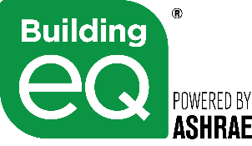

Building EQ Energy Genius Award
SY 22-23 Nomination Submission Form

Submission deadline: January 15, 2023
Send nominations to: buildingeq@ashrae.org

- Project Information:
- Project Name:
- Project Type: □ In Operation □ As Designed

- Project Team Member Name(s):
- Submitter (Include qualifying credential):
- Non-Student Team Member(s):

- Student Team Member(s):

- Has this project previously been nominated for the Energy Genius Award?
□ Yes □ No

4. Please attach the following documentation to this submission form.
- In Operation projects: an ASHRAE Standard 211-compliant Level 1 Energy Audit narrative report and a narrative that addresses, at a minimum, the bulleted items below.
- Expected improvement of building performance as a result of a Building EQ Assessment
- Additional documentation that addresses, at a minimum, the bulleted items below.
  - Most innovative way to include students in the Building EQ submission process
  - The complexity of the building and systems that were audited
  - References to ASHRAE Standards, Guidelines, and publications, as appropriate in method and analysis descriptions.

