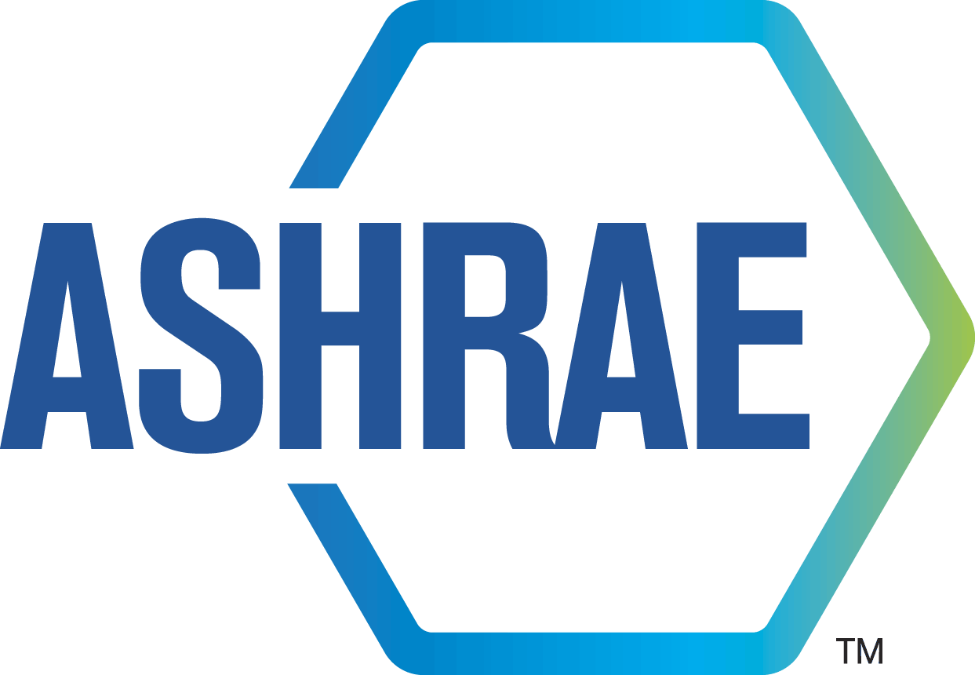
ADVANCED ENERGY DESIGN GUIDE FOR MULTIFAMILY BUILDINGS: ACHIEVING ZERO ENERGY

February 21, 2020

Dear Reviewer:

A partnership of ASHRAE, AIA, IES, USGBC, and the U.S. DOE has embarked on the preparation of an Advanced Energy Design Guide for Multifamily Buildings: Achieving Zero Energy (AEDG-MF-ZEB) targeted at how to achieve a zero energy office building. As part of this development process the Project Committee for the Guide is soliciting peer review input at various stages in the development of the document.

The final opportunity for input is the 90% Technical Refinement Draft of the Guide where the committee requests your feedback on specific details and recommendations in the draft document.

Please also note:
- Typos and other editorial issues will be addressed in the final editing process that occurs prior to publication.
- All acronyms used in the guide will be added to the list at the beginning of the document.
- Graphics are NOT final and are currently being professional redrawn for the final publication.
- The numbering for the graphics and tables has no particular rhyme and reason at this time and will be updated to a continuous numerical numbering per chapter prior to publication.

Instructions for providing feedback:
- A form is provided on the next page for your review remarks in Microsoft Word format. Information from the form will be cut and pasted into an integrated document for use by the committee.
- Please include all of your input on the form provided.
- Specific input with line number references is the most helpful
- Please identify the line numbers in the document for any specific feedback provided. .
- A place for general comments is also provided on the form. Specific questions from the committee are included at the beginning of the review draft document.
- Please provide your contact information (name, company/organization, phone number, and e-mail address) in case there are questions from the committee about your feedback.

This review period begins on Saturday, February 22, 2020 and closes on Sunday, March 1, 2020. Please submit your feedback to: lpratt@ashrae.org by 12:00 noon on Monday, March 2, 2020.

Please note that this is not an ASHRAE standard or guideline and is therefore not a consensus-based document. This peer review process differs in that you will not receive an individualized reply indicating how the Project Committee chose to deal with your recommendations. The Project Committee will carefully consider all comments. Responses to the comments received during this review will be grouped together and summarized and will be available upon request.

Thank you for taking the time to provide constructive input on our current review draft.

Project Committee
AEDG-MF: Zero Energy

Additional information on the Advanced Energy Design Guide series of documents and copies of previously published guides are available at www.ashrae.org/freeaedg.

Peer Review Remarks –Technical Refinement Review
Advanced Energy Design Guide for Multifamily Buildings:
Achieving Zero Energy

Submit remarks to: lpratt@ashrae.org
Deadline: 12:00pm EST on March 2, 2020

Reviewer: ___________________________________________________

Company or organization: _____________________________________

Phone: ______________ E-mail: _________________________________

(A) General remarks on the overall document:
(Please provide answers to the “questions to reviewers” at the beginning of the draft in this section of the form.)

Line # | Reviewer | Remarks
General
General
General
(Note: Add more rows as needed.)

(B) Specific remarks on a particular chapter:
(Please provide the line number or numbers from the draft on which you are providing your remarks to assist the project committee.)

Line # | Reviewer | Remarks
(Note: Add more rows as needed.)

